 | ATLAS SCT – End-cap Grounding and Shielding
ATLAS Project Document No: | Institute Document No. | Created: CREATEDATE \@ "dd/MM/yy" \* MERGEFORMAT 04/01/06 | Page: 1 of 17
ATL-IS-EN-0014 |  | Modified: 15/10/077 | Rev. No.: K

Engineering Note
ATLAS SCT – End-cap Grounding and Shielding,
Actual Engineering Implementation

This document describes the ACTUAL grounding and shielding scheme implemented within the context of the ATLAS SCT End-Cap construction.
This note is the realisation of the proposals contained in earlier versions of the note.

Colour coding:
Questions to be answered
Prepared by:  Stephen Haywood, RAL  Jason Tarrant, RAL  Ian Wilmut, RAL  Alan Durbin, RAL  Tommy Farr, RAL  Ned Spencer, UCSC  Jose Bernabeu, Valencia | Checked by:  Ned Spencer, UCSC  Tim Jones, Liverpool  Jan Kaplon  Didier Ferrere, Geneva  Jose Bernabeu, Valencia | Approved by:
Distribution List
ATLAS SCT End-cap Engineering Working Group

History of Changes
Rev. No. | Date | Pages | Description of changes
A  B  C  D  E  F  G  H  I  J  K | 13/02/06  17/02/06  28/02/06  01/03/06  06/03/06  09/03/06  14/03/06  23/03/06  20/07/06  23/04/07  15/10/07 |  | First draft  Comments from Jason & Ian  Comments from Tommy, Alan & Jason  Comments from Tim  Additions from Ned  After Meeting on 8 March with Ned, Pepe, Didier, Jason & Stephen  Improve text with Jason’s help  Additions from Ned concerning Segmented Plate at PPF1 and Jason concerning services from STFT to PPF1  Remove reference to foil wrapping around LMTs in CCTs.  Add reference to insulation of outside of CCTs to TRT Services by Kapton.  Update after all changes to Detector.  Comments from Pepe

Table of Contents
1 Introduction 5
1.1 Executive Summary 5
1.2 Nomenclature etc 5
2 Module Interface 5
3 Discs 6
3.1 Grounding Foils 6
3.2 PPF0 6
3.3 Other Metal on the Disc 6
4 Support Cylinder and Accompanying Services 6
4.1 Ground Sheet 7
4.2 Low-Mass Tapes (LMTs) 7
4.3 OptoHarness 7
4.4 Cooling Pipes (Interconnects) 7
4.5 LMT Cooling 7
4.6 Nitrogen Exhaust 7
4.7 Fixtures 8
4.8 OTE Rails 8
5 Other Support Structural Components 8
6 Disc Shunt Shields 8
7 Thermal Enclosures (TE) 9
7.1 Solder Joints 9
7.2 OTE 9
7.3 ITE 10
7.4 Rear Thermal Pad 10
7.5 Front G&S Membrane 10
7.6 Rear G&S Membrane 10
7.7 STFT 10
7.8 Heater Pads 10
8 Services between the End-cap and PPF1 10
8.1 Overview 11
8.2 In the STFT 11
8.3 LMTs between the STFT and the RCT 12
8.4 Evaporative Cooling Pipe Assemblies 12
8.5 Other Services 12
8.5.1 N₂ Tubes 12
8.5.2 Monophase cooling for LMs 12
8.6 Radial Cable Tray (RCT) 12
8.7 Master Ground Ring 13
8.8 Cryostat Cable Tray 13
8.8.1 LMT Cable Trays 13
8.8.2 Thermal Enclosure Heater Pad Wires& Nitrogen Supply Cable Trays 15
9 PPF1 15
9.1 PFF1 for LMTs 15
9.2 PPF1 for Cooling 15
10 Segmented Plate 16
11 Safety Earth Bonding Conductor 16
12 Electrical Isolation Verification 17

Introduction
This document aims to describe the actual implementation of the grounding and shielding scheme which is being used for the ATLAS SCT End-cap.
This note follows from an original note ATL-IS-EN-0014 written by Tim Jones and Debbie Greenfield – this was the result of extensive discussions with Ned Spencer and Tony Smith in 2002 and 2003.
At the time of writing (Jan 2006), much of what is written here has already been incorporated (i.e. on the Discs) or is in the process of being incorporated (i.e. on the Cylinder). Some of the ideas have yet to be incorporated, and while there is an expectation that the ideas described in this document will be followed broadly, there may be some flexibility in their actual implementation if some features need to be modified. These remarks apply in particular to the electrical closure of the Thermal Enclosure and the routing of services from the End-cap to PPF1.
For information about the ID G&S implementation, see ATL-IC-ES-0011.

Executive Summary
All conducting objects in the SCT End-cap, up to PPF1, will be “commoned”, in particular, with good conductive connections between metal objects in the vicinity of the Modules and signal-carrying services. The Radial Cable Tray (RCT) (see Section 8.5) acts as the grounding node for the SCT End-cap. In turn, the RCT is connected to the Segmented Plate to which the PPF1s are mounted. The Segmented Plate is the conductor to which the Safety Grounding Cable is connected.
The one exception to the above are the Evaporative Cooling Pipes which are isolated at the Services Thermal Feed Through (STFT) and are electrically connected to the outside world by a path through PPF1 (where they are insulated from PPF1) to PP2 etc.
A schematic of the G&S connections can be found at:
http://hepwww.rl.ac.uk/atlas-sct/engineering/g+s/sketch_EC.doc
This is linked within this EDMS folder.

Nomenclature etc
In this doc, the phrase “electrically connected” should be taken to mean a connection with low resistance – this may be referred to by others as “bonded”.

Module Interface
The baseline K5 Module does not include a shunt shield
The K5 Module has a number of existing features to limit the stray capacitance of the detector backplane to the two cooling heat sinks. Primarily, the backplane AC referencing conductor is routed to a large bypass capacitor on the hybrid, which couples the backplane to the ABCD AGND node. The capacitor is of order ten times larger than the detector stray capacitance to the metallic cooling sink.
The module is separated from the cooling block by thermal grease (DC340) – this is electrically insulating, with a resistance >XXX KΩ. (Resistance not known; if we want it (without finger), must ask Nikhef.) Is the grease known to be insulating in every module (say, above 1 kΩ)?
In order to limit noise currents in the ABCD front-end, the cooling tube DC references to the Module at the power supply Module entry region.

A DC electrical connection from AGND on the Module to the cooling tube is implemented in the following way:
- A solder pad is provided at the Module-end of the Wiggly Low-Mass Tapes. This is connected to AGND via a track on the Wiggly Tape-end.
- A small Kapton Finger with a copper trace is soldered to the solder pad. The other end of the Finger terminates in a ring with the copper continuing around the ring.
- The Module Nut presses down on the copper ring.
- The electrical path continues via the Module Nut, through the Module Pin to the Cooling Pipe.
This procedure induces more of the cooling system noise currents to pass through the power entry AGND area, reducing noise current flow in the front-end region.

Discs
The completed Discs (EC-C) can be seen at:
http://hepwww.rl.ac.uk/atlas-sct/engineering/ec/disc_services/completed/

Grounding Foils
The Foils are: Kapton (25 μm), glue (25 μm), Al (50 μm), Ni (12 μm), Au (2 μm).
There are two Foils; one on the Front & one on the Back of the Discs which cover approximately 6% and 19% of the Disc surface area respectively.
They are constructed in quadrants and soldered together.
On the Front of the Discs, there are two rings 10 mm wide. These rings go between the Disc Pads and the Blocks – there is no solid electrical connection at the Block positions; but coming off the rings are tabs which are soldered to the Cu-Ni Cooling Pipes, each tab is 10 mm wide and connects to the pipe about 15 mm in front or behind each block. The rings are connected by 10 mm wide radial sections. There are four tabs per quadrant which come from the Front Foil, through the Wiggly Tape apertures in the disk and connect to the nearest available foil on the rear of the Disc (about 100 mm inboard in R).
On the Rear of the Disc, there is only one 10 mm wide ring for the Middle Modules. In addition, there is a wider 3.3 cm ring which goes under the Patch Panels at the outer Disc radius.
The Grounding Foils are connected to the Ground Sheet by 8 tabs.
The carbon-fibre skins of the Discs (both Front and Rear) are electrically connected to the Grounding Foils via four contacts on each side. The contacts were implemented by attaching a copper pad in the form of two interconnected discs. The larger circle of 20 mm diameter was glued to an abraded area of the skin using silver-loaded epoxy. The smaller circle of diameter 10 mm was bent away from the Disc for soldering, after which it was bent back onto the Disc surface and secured. The exact locations of these are given on NIKHEF’s working drawings.

PPF0
For each of the 16 electrical PPF0 Patch Panels on a Disc, there are up to three 50 mm long lengths of Litz wire, corresponding to the locations of the installed power tapes. These fingers started on the Foils on the Disc, were routed through the Patch Panel bracket area and were terminated on the DGND pad on the three PPF0 interfaces on the ends of the Wiggly Power Tapes.
For each pair of PPF0s belonging to a cylinder aperture, there is a foil link 25 mm wide extending 15 cm from the PPF0 Grounding Ring on the Disc, through the aperture and onto the Ground Sheet on the Support Cylinder. The connection between the two Foils was made using solder. The length-to-width ratio of the foil is 6:1.
There is no electrical break in the cooling pipes at PPF0. The electrical connection between the Cooling Pipes and the PPF0 ring is via the Patch Panel Bracket which supports the Cooling Pipe Connectors. In addition, the Cooling Patch Panel is electrically connected to the PPF0 Ground Ring on the Disc with a screw-clamp mechanism.

Other Metal on the Disc
There is foil wrapping on the Opto-Harnesses – this is not explicitly electrically connected to anything.

Support Cylinder and Accompanying Services
The completed End-cap before the Outer Thermal Enclosure has been added can be seen at:
http://hepwww.rl.ac.uk/Atlas-SCT/engineering/photos/EC_assy_Lpool/DSCF0074.JPG
The intention is that none of the services on the Support Cylinder should be in electrical contact with the OTE, except at the high-|z| end, where electrical contact is made, as described later. This should be ensured by the Rails which hold the OTE above all the services on the Support Cylinder. Furthermore, the services, in particular the LMTs, Optofibres in their Al wrapping and the Capillaries, should be held down to give clearance when the OTE is added. There is a chance that the Capillaries may be less well controlled, however if any of the services do touch the aluminised inner surface of the OTE, this should not be a problem.

Ground Sheet
There is a semi-continuous 18 μm copper on 25 μm Kapton (hereafter simply referred to as Cu-Kapton) sheet loosely laid on the outer surface of the cylinder with holes cut in it to match the apertures in the Support Cylinder. It covers ~80% of the cylindrical surface area – the apertures accounting for most of the deficit. The primary aim of this sheet is to augment the annular conductivity of the PPF0 grounding rings on the Disc.
The ground pads which are in contact with the face-skins of the carbon-fibre Support Cylinder are electrically connected to the Ground Sheet by Litz wires.
Close to each aperture (on the side away from the incoming LMT bundles) there is a copper tab soldered to the foil to which a jumper tape from the PPF0 ring on each Disc was seam-soldered following the insertion of the Disc.

Low-Mass Tapes (LMTs)
DGND in the LMT connects to the End-cap node through the PPF0 Litz wires described in Section 3.2. All other LMT conductors have an earthing path through the respective detector module. The PCB end of the LMT is electrically connected at PPF1 through the Ground Plane Extension – a Cu-Kapton wrap which makes contact with the PPF1 Tray.

OptoHarness
These are wrapped in Al foil which is not explicitly connected to anything.

Cooling Pipes (Interconnects)
Within the Cooling System on the Support Cylinder, there are two types of Interconnect: those which carry exhaust vapour from the Discs and those which cool the LMTs. For the Disc cooling, the incoming capillaries connect to the Disc PPF0; for the LMT cooling, the capillaries connect directly to the Interconnects.
The Interconnects are referenced by connection to PPF0 by a compression fitting (PPF0 being referenced to the Ground Sheet). All the Interconnects have an electrically insulating break at the connectors in the Service Thermal Feed Through (STFT) – see Section 7.7. These breaks isolate the Interconnects to the End-cap section, tightly referenced to the End-cap shield node, and the ID section, referenced to the general ATLAS earthed conductors.

LMT Cooling
The LMT Cooling heat sink consists of alochromed foils of 50 μm aluminium, wrapped around the LMTs and the corresponding Interconnects, i.e. those not associated with the Disc cooling. The Foils are held tightly to the Cu-Ni Interconnects by Cu-Be clips. The foils and clips are referenced by contact with the Interconnects and by being forced down onto the copper surface of the Ground Sheet.

Nitrogen Exhaust
There is an aluminium manifold at the front end – this is a tubular ring which will be connected to the Ground Sheet. The gas will move along the SC along a set of Peek tubes.

Fixtures
The Disc Fixations are not explicitly grounded, although they are connected to the Discs. The connection to the Support Cylinder is only by (non-conducting) adhesive to the aluminium inserts. The Discs are held by pins which are attached to Cu-Be springs which are attached to the inserts.
The Disc Cooling Interconnects are held to the Support Cylinder by aluminium brackets with which they are in electrical contact. (The brackets are not alochromed.) Since they are metal objects of significant size, they need a guaranteed path to shield node ≤ 10 kΩ.
There are thin aluminium clips which hold the LMT Cooling Interconnects to the Support Cylinder. These are actually insulated from the Interconnects by Kapton tape to avoid any possible galvanic corrosion. The clips will be connected to the Ground Sheet by blobs of conductive glue.
There is Al foil wrapping on the Opto-Harnesses – this is gripped by some clips which will be connected to the Ground Sheet by blobs of conductive glue.

OTE Rails
The Rails are carbon-fibre composite structures, connected to the Peek inserts on the Support Cylinder by sets of posts consisting of aluminium and titanium pins with Peek fixtures. These will be referenced to the Ground Sheet by wires attached with conductive glue.

Other Support Structural Components
The carbon-fibre structures (SC – discussed in Section 4.1, RS, FS and ITE Cylinder) all have grounding pads which will be electrically connected by Litz wires (or Cu-Kapton tabs) to the nearest available grounded surface. The SC has grounding pads on the outside, but not on the inside (probably a design error). There is probably some electrically connectivity provided by the aluminium inserts for the Disc Fixations, although this is likely to be poor. (Resistances O(1) Ω have been measured between different Fixations, implying some connectivity through the SC.)

Disc Shunt Shields
Shields are proposed for both the Front and Rear of the End-cap, where they will be < 10 mm from the Modules. The intention of the Shields is to absorb noise which may be around the ends of the End-caps, near the Modules. The Shields reduce the stray capacitance of the Modules to the Front and Rear Support G&S Membrane by several orders of magnitude.
Tests in the Clean-room at Liverpool show some reduction of noise on the Modules, even in an electrically quiet environment.
The Shields consist of 3 mm Airex foam discs laminated on both sides with Cu-Kapton foil (the double layer is to balance the composite so that it is not distorted by differential contraction when cooled). Radially, the Shields extend from just inside the radius of the Outer Modules’ Hybrid to close to the inner diameter of the Support Cylinder.
The Shields will be held above the Discs by insulating Peek caps on the Upper Module Main Pins. They will be electrically connected to the Disc Grounding Foils somewhere on the ring associated with the Inner Modules (for which there are actually no Modules on Discs 1 and 9). This connection will be by a Cu-Kapton tab, where the bonds will be copper-to-copper using electrically conducting adhesive or solder (preferably).
The Shields will be held at the outer radius to the Support Cylinder by a line of (non-conducting) RTV (Techsil).
The outer surface of the Shields will be referenced to the Ground Sheet on the Support Cylinder by Cu-Kapton tabs.

Thermal Enclosures (TE)
The Thermal Enclosure consists of
- Outer Thermal Enclosure (OTE)
- Inner Thermal Enclosure (ITE)
- Front Support with associated G&S Membrane
- Rear Support with associated G&S Membrane
The TE is important since it provides the RF Shield for the End-cap (this is an approximation to a Faraday Shield). The RF Shield will be electrically connected to the Main Ground Ring, just beyond the Services Thermal Feed-through (STFT).
In summary: The TE has an outer layer of 18 μm copper on Kapton film which is electrically connected everywhere by solder seams. The assembly of the TE, in particular illustrating the connection of the copper, can be seen in drawings of TD-1012-400 which are available at:
ftp://ftp.eng.rl.ac.uk/pub/john_noviss/end_cap_thermal_enclosures/assembly_therm_enclosures_G&S/
not_released_drawings/
The drawings are supplemented by notes in:
http://hepwww.rl.ac.uk/atlas-sct/engineering/ec/endcap/TE/G&S.doc

Solder Joints
All joints are soldered. These will either be made with a solder “bump”:

or where it is important to reduce the height of the joint, a copper “bridge”:

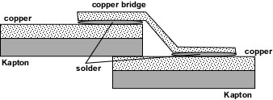

More details can be found from:
http://hepwww.rl.ac.uk/atlas-sct/engineering/ec/endcap/TE/solder_tests.doc
To reduce the mass of solder, soldering will be done in strips ~1 cm long with gaps of ~1 cm. To make connections between cylindrical and planar surfaces, the Cu-Kapton foil will need to be slit, making tabs.

OTE
This consists of 8 mm of Airex foam with Cu-Kapton on the outside and aluminised Kapton on the inside. The Cu-Kapton is in several sheets which will be electrically connected by soldering.
The inner layer of aluminised Kapton have 0.2 μm aluminium – this is not conductive enough to provide significant RF referencing and shielding, so connections are primarily for ESD and DC capacitance control. Ideally this should be isolated form the insides of the End-caps, however since it is in physical contact through the Rails and there will inevitably be some electrical contact, it was considered better to make a definitive connection at the STFT, since at the rear of the SCT region, everything is connected anyway. The inner layer comes as two separate sheets (due to width of sheet) – these sheets should be connected by conducting tabs; however this was only done in the case of EC-A. To reference the lower-z sheet for EC-C, four Cu-Kapton tabs were added with electrically conductive adhesive to connect the sheet to the Cu-Kapton on the outside of the OTE. Further tab connections were inserted between the inner and outer skins of the OTE at the STFT. Finally an electrical connection was made between the inner layer and the Ground Sheet in the region of the STFT.
There should not be an electrical connection between the OTE and the Support Cylinder. There are carbon-fibre flanges on the OTE and SC; the Front Gas Membrane is sandwiched between these. Since the Membrane is made of Kapton without any metalisation, this should be an insulating connection.

ITE
This consist of a 0.5 mm carbon-fibre cylinder on to whose outer surface is glued 5 mm of Airex, with Cu-Kapton glued to this.

Rear Thermal Pad
This consists of 12 mm of Airex foam with aluminised Kapton on all surfaces. It is attached to the Rear Support. The aluminised Kapton will be electrically connected to the Cu-Kapton on the STFT by four Cu-Kapton tabs attached with electrically conductive adhesive.

Front G&S Membrane
This is an 18 μm Cu-Kapton sheet which is between the Disc 1 Shunt Shield and the carbon-fibre Front Support. It is 50% seam soldered to the foil at the ITE flange and the foil on the curved surface of the OTE. It is constrained by the clamping action of the Front Support on the Support Cylinder.

Rear G&S Membrane
This is an 18 μm Cu-Kapton sheet which is between the thermally insulating Rear Thermal Pad and the carbon-fibre Rear Support. It is soldered to the foil on the ITE as it emerges from the Rear Support and the foil on the front surface of the STFT. It is not constrained by the clamping action of the Rear Support on the Support Cylinder in order to allow stress-relief at a higher radius.

STFT
The STFT is the feed through at the end of the End-cap where the services exit the Thermal Enclosure.
The front surface of the STFT is covered with Cu-Kapton foil, and at the rear, the closure is provided by the Rear G&S Membrane. There are some cut-outs to accommodate the cooling pipes, and these cut-outs are lined with Cu-Kapton. The front part of the STFT, attached to the OTE, has an aluminised Kapton layer on the back side – this will be electrically connected either to the inner cylindrical surface or to the Cu-Kapton on the front surface using Cu-Kapton tabs (one per quadrant) and conducting adhesive.

Heater Pads
The outside of the OTE and Front & Rear Supports are covered in Heater Pads to ensure that the TRT is not cooled and avoid cold areas on which water vapour could condense, should it be present. The Pads consist of 8 mm copper foil tracks sandwiched between layers of Kapton. They contain no heat-spreaders, instead relying on the Cu on the outside of the OTE. They are not explicitly grounded.

Services between the End-cap and PPF1
See talks and pictures therein from the RCT/CCT Review at
http://agenda.cern.ch/fullAgenda.php?ida=a06740

Overview
The Barrel services are supported directly from the Cryostat. However the End-cap services cannot be supported from the Cryostat and must be free-standing; hence a rigid, self-supporting system of cable trays is required.
The Radial Cable Tray (RCT) is the Main Ground Ring. This is linked via Ground Sheet Extensions to the Ground Sheet on the SCT Support Cylinder, to which all the Discs are referenced. Also the RCT is electrically connected to the RF Shield of the Thermal Enclosure. The RCT, Cryostat Cable Tray (CCT) & PPF1 are electrically isolated from all surrounding metalwork. The RCT will be electrically connected to the CCTs, which in turn will be electrically connected to the PPF1s and then the Segmented Plate, which is connected to the Safety Grounding Cable. The CCT is electrically connected to the RCT, as well as being electrically connected to PPF1.
The Cable Trays will be manufactured from aluminium alloy. To allow good electrical connections, the aluminium will be either nickel-plated at the appropriate contact points or alochromed (natural silver 1200 type) to be used in conjunction with a conducting gasket/braid – where possible, the latter approach is preferred.
The Cable Trays will be isolated from the rest of the components of the Inner Detector (ID). To ensure there is no electrical contact, the parts of the trays in close proximity to other parts of the detector will be covered with a double layer of thin polyimide sheet.
The Cable Trays will enclose the services passing through as much as possible, especially electrical services. This will enable the trays to act as RF shields, preventing the radiation or pick-up of electrical noise on the electrical services of the SCT EC. Where material is to be kept to a minimum or complete enclosures are impractical, more flexible solutions such as foils (supported or unsupported) will be used to wrap services. These too will need to be electrically very well connected, potentially using copper foils.

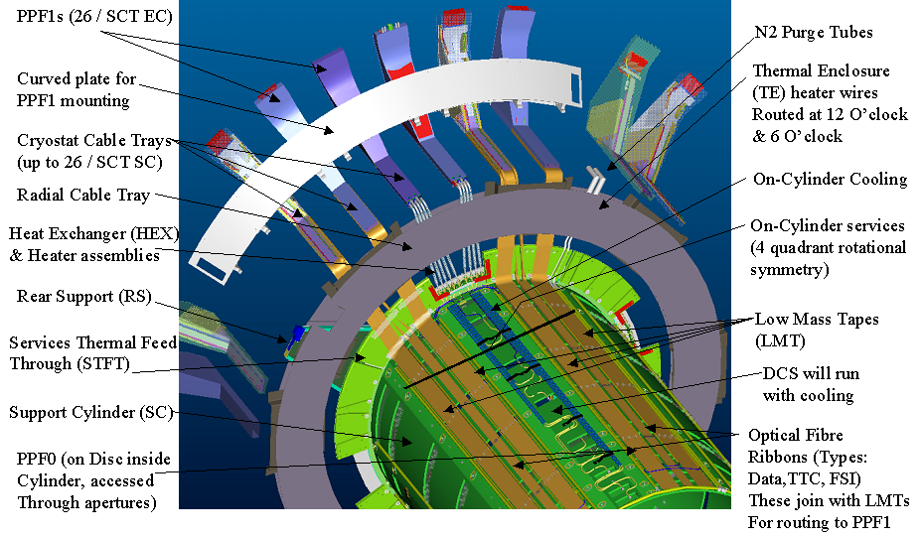

In the STFT
The Evaporative Cooling Pipes have an electrical break at the connectors which lie within the STFT, and have thermal insulation.

LMTs between the STFT and the RCT
Approx 6 cm of LMT length will be exposed between the STFT and the RCT. These lengths will be wrapped in Al foil to provide shielding, and this foil will be trapped under the guides in the RCT.

Evaporative Cooling Pipe Assemblies
The pipe assemblies from the STFT outwards include the HEX, the so-called near pipes and the Heaters. The HEX and the part of the near pipes up to the PP1F region will be free-standing (no cable tray). They do not use the Cryostat or Radial Cable Trays, and are thermally insulated, so they are well shielded from the LMTs and the trays. The HEX will be mechanically connected at the STFT, possibly with Peek cable-ties where they meet the Cryostat to provide extra support. The HEX and the near pipes assemblies up to the ends of the Heaters will be covered with 5 mm of Armaflex thermal insulation, which will also isolate them from the Cable Trays and PPF1 (need to check Armaflex resistance). Hence the assemblies will be isolated from the End-cap grounding node and instead are referenced to the ATLAS grounding node. The Heaters will be located in the cryostat flange, so outside from the Inner Detector Volume and thus without any risk of shorting to the SCT EC Ground. The pipes are continuous from the electrical perspective from the STFT to PP2 and beyond. They will bond to ATLAS ground at the PP3 platform.

Other Services

N₂ Tubes
Either these will be made of non-conducting plastic or they will have either an isolating joint at the STFT and/or at PPF1 (electrically isolated from cable trays, if only the latter).

Monophase cooling for LMTs
These will be made from copper tube with an isolating connection at PPF1. They are loosely electrically connected to the CCT in several places (and hence they are in electrical contact with the Segmented Plate) because they are wrapped tightly in heat-spreading foil (along with the LMTs) which is pressed down under the lid of the CCT.

Radial Cable Tray (RCT)
The RCT is the Master Ground Ring. It will be on the high-|z| side of the Rear Support at a radius just larger than the STFT. It will be mechanically connected to the Rear Support Panel, introducing an electrical connection which is not well defined. The RCT will consist of 1.6 mm annular Al plates, about 21.5 cm wide in ΔR. Electrical connections will be made to this ring from:
- The Cu-Kapton foil on the outside of the OTE.
- The Cu-Kapton foil of the Ground Sheet on the Support Cylinder.
- The Cryostat Cable Trays.
The different plates of the RCT will be electrically connected by use of cadmium-plated fingerstock gaskets (Laird 550). The RCT aluminium plates will be treated with Alochrome 1000. To prevent large eddy currents circulating in the RCT during a possible Solenoid quench, there is an insulating break between two of the front plates and a capacitive break between two of the rear plates.
The services are constrained in the RCT by guides – these will be electrically connected to the RCT plates by cadmium-plated fingerstock gaskets.
The Cable Trays will be electrically connected within the SCT EC ground system; this will allow all metallic or conducting parts to be electrically referenced.
Connections from the Support Cylinder Ground Sheet are shown below. It should be noted that the sheet comes out of the STFT at a higher |z| position than the services; also that the conductive copper side faces z=0. These Extensions will be fixed to the high-|z| side of the RCT. This will be done by dedicated mechanical clamps using two external M4 C-sink screws in special cups. The copper side of the Extensions will be electrically connected to the alochromed RCT plates by cadmium-plated fingerstock gaskets.
Soldered tabs will be taken off the TE and electrically connected to the Ground Sheet Extensions before they are clamped.
The HEX Assembly (Evaporative Cooling Assembly) does not go in the RCT, following recent changes required for stress-relief.
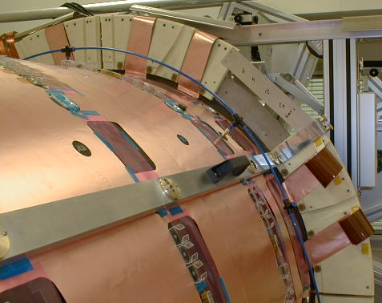
Ground Sheet
Extensions

Master Ground Ring
See Radial Cable Tray.

Cryostat Cable Tray
The Cryostat Cable Trays will be mechanically connected to the Radial Cable Tray at one end and the PPF1s at the other end. A good and consistent (unvarying) electrical connection will be made both with the RCT and the PPF1 metal work, and between different sections of the CCTs by use of cadmium-plated fingerstock gaskets. The aluminium CCT bodies will be treated with Alochrome 1000.
The CCTs will be wrapped in two layers of Kapton to isolate them from the TRT Services.

LMT Cable Trays
The trays will form an enclosed RF shield for the LMTs – this requires the seams of the lids to be well connected electrically to the main tray to prevent long gaps in the shield.
The lower covers of the CCTs will clip over the upper cover with mating surfaces of both being nickel-plated. Electrical connection to the RCT and the Back-Spine of PPF1 will be by screws/bolted joints, with both mating surfaces being nickel-plated.
The LMTs will be cooled by mono-phase cooling. The corresponding pipes and wrapping foil will be electrically connected to the cable tray, but the pipes coming in from PP2 will have an electrically isolating break adjacent to PPF1.
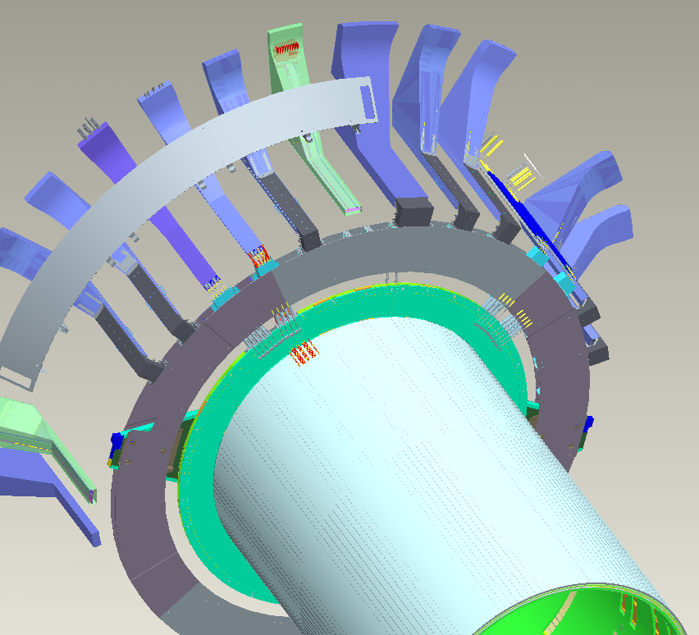
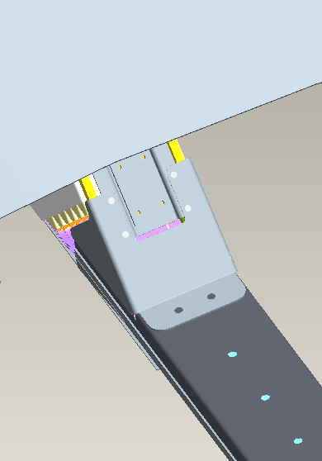
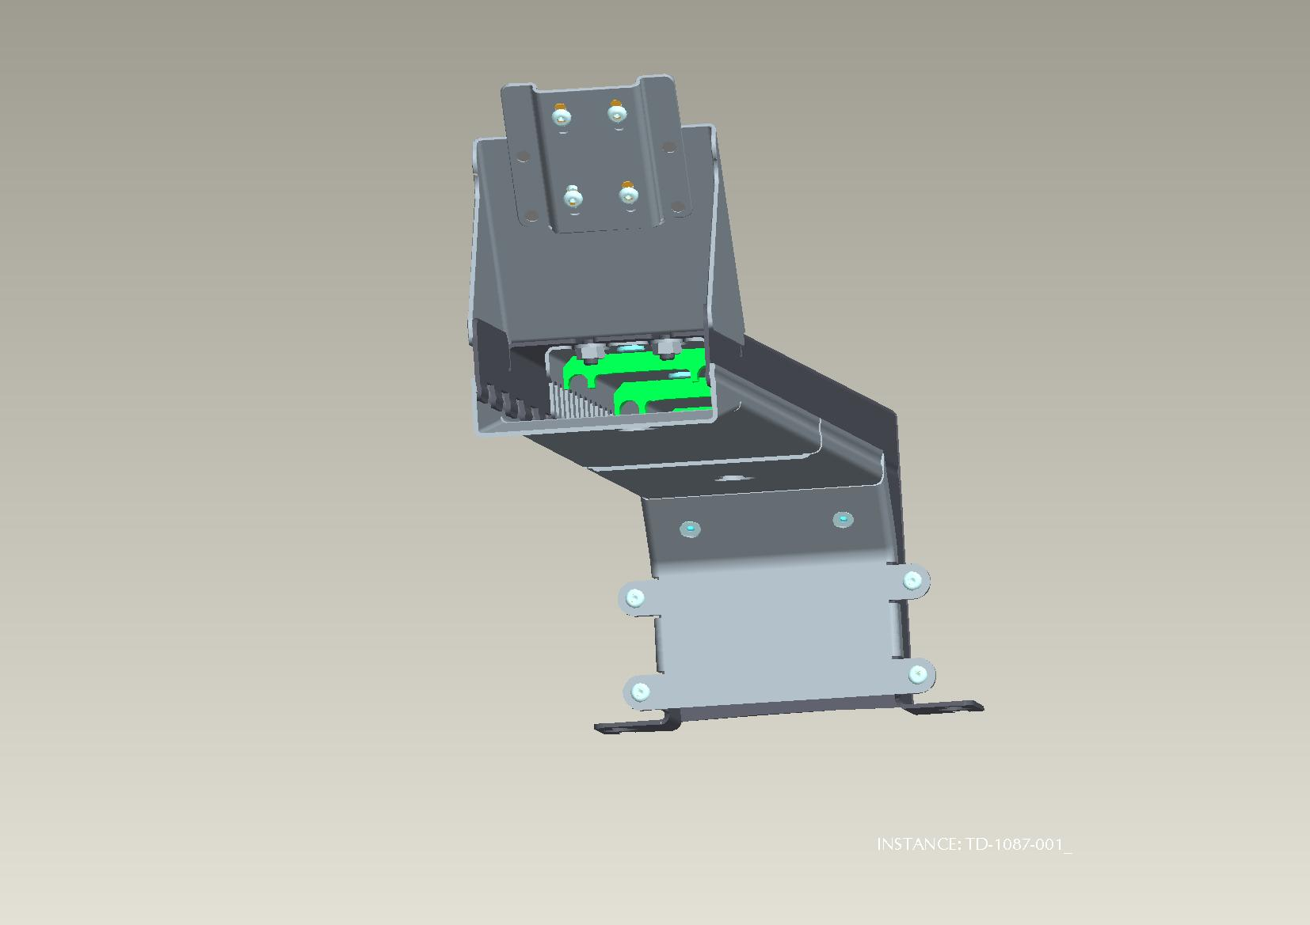
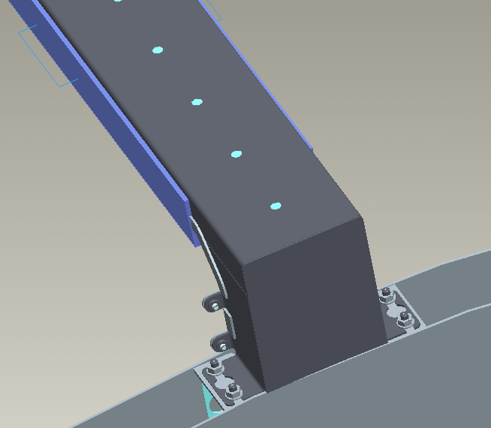
LMT Cable Tray
Connection to RCT
Attachment of PPF1 to Segmented Plate

Thermal Enclosure Heater Pad Wires & Nitrogen Supply Cable Trays
The trays will form an enclosed RF shield for the TE Heater Pad Wires – this requires the seams of the lids to be well connected electrically to the main tray to prevent long gaps in the shield, as for the LMT CCTs.
A foil wrap will be used to form an enclosed RF shield for the N₂ tubes – this requires closed seams as per the rigid cable trays. As the N₂ tubes are part of the ATLAS ground and they will be in the cable tray, which belongs to SCT EC ground. In order to avoid a short at that level the tubes will be electrically protected with shrink tube. The outside will be non-conducting to isolate from all other ID & SCT EC parts.

PPF1
The PPF1s will be mounted on the Segmented Plate (SP) (see Section 10) and will be safety grounded by bonding to the SP.

PFF1 for LMTs
There are sixteen LMT PPF1 chassis locations mounted at the end of the Cryostat using electrically insulating components. Each PPF1 chassis contains the PPF1s for a single PPF0’s worth of tapes from the nine Discs. The LMTs will terminate in two- or three-way PPF1 PCBs. There will be up to 15 full length (3 Module) boards and up to 12 short (2 Module) boards. The total number of Modules in a PPF1 Chassis is limited to 69; however, the maximum number used is 66.
Three PPF1 PCBs will be mounted side-by-side in a nickel-plated aluminium tray. There are 6 full length trays and 3 short trays. The cards are held in the tray at one end by a nylon button and at the other by a screw clamp mechanism. As well as holding the PCBs in place in the tray, the screw in the clamp will clamp down the Ground Plane Extension (tinned copper) soldered on to the PCB, creating the electrical connection between the PCB and the tray.
The trays will have sprung tabs at either side which fit into slots in the Chassis wall and which electrically connect (all will be nickel-plated Al or Cu-Be). The tabs, whether part of the tray or a component fixed to it, will be stiff enough to ensure reliable contact over time.
The Chassis will consist of a rigid Back-Spine and 1 mm thick housing in which the slots for locating the trays will be machined. Attached to the back-spine will be a clamping area for retaining the incoming Type-II cables.
The sheath of the Type-II cables will be clamped in an array in a 4-layer clamp. Heatshrink will be used to prevent these cables pulling through the clamps. The unscreened conductor cables will pass to the FCI and JST connectors which mate with the receptacles on the PPF1 PCBs.
There are drain wires in the cables, between the sheaths and the shielding foils (with which they are in electrical contact). These drain wires electrically connect to grub screws in the clamps. The drain wires are less than 25 mm long from cable foil cut edge to grub screw contact. The drain wires are grouped in four or five from different Type II cables. These drain wires are inserted in a ferrule, crimped by a special tool, the ferrule is connected to the cable clamp with a grub screw.
Once all the electrical connections have been made, a Cu-Kapton sheet will be placed over the whole assembly and will be electrically connected to the Back-Spine. A window will be cut in the Cu-Kapton to enable electrical contact to be made with the Segmented Plate.
The Chassis Back-Spine will be electrically connected to the CCT supporting the LMTs on their way to the Master Ground Ring. This electrical connection will be made using fingerstock gaskets.

PPF1 for Cooling
Each Heater has 3 connectors (15 in total on the 5× Fluid PPF1), these are literally 'stuffed' into a triangular space between the Heaters and the Segmented Plate. To prevent shorts, this section of Segmented Plate will be fitted with 2 layers of 25 μm Kapton when the cables are installed.

Segmented Plate
The Segmented Plate (SP) is mechanically attached to the Cryostat and will support the PPF1s. The SP is part of the End-cap Shield, and will have a single safety tie to ID/ATLAS ground. Otherwise it will be electrically isolated from the ID, Cryostat, and TRT, by means of a 200um G10 foil on its lower surface. The following schematic shows the position of the EC, cable trays, SP and the safety tie to ID/ATLAS ground.
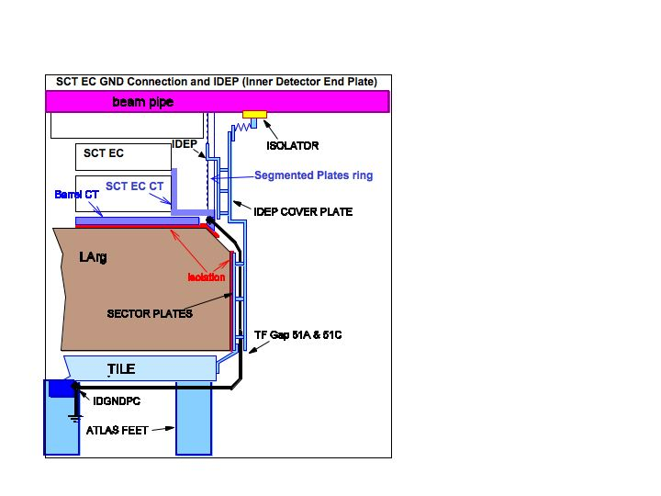
The four SPs in a quadrant will receive supplemental bonding using plated thin BeCu fingerstock in the plate joints. The nominal compressed thickness of the EMI gasket is 250 μm. The SP will need four Litz wire jumpers, 10 AWG equivalent, between the quadrant groups of SPs. Soldered ring terminals on the wire ends will use tapped holes on the SP. The SP will electrically RF bond the PPF1 filters in a ring, supplementing the RF referencing function of the Master Ground Ring.
The End-cap SCT will be isolated at all points from the End-cap TRT including at the mounting points on the Squirrel Cage: the so-called Mechanisms have an insulating plastic sleeve around the crucial cylindrical bearing.

Safety Earth Bonding Conductor
The End-cap will have a single earth bonding conductor to ID/ATLAS using the tapped hole on the Segmented Plate. This provides an earth path for the EC shield, the associated tubes, and all the cable shields bonding at PPF1. This grounding conductor is actually already installed. The bonding conductor item for the Master Ground Ring will not be used. Since the EC tray paths are redundant, no devoted grounding conductors in them are required to safety reference the EC shield structures.

Electrical Isolation Verification
Once the EC is installed in the cavern, the grounding conductor should not be removed if at all practical. A fault detection device is installed on the EC to monitor whether an unintentional earth fault path has developed. Here is a schema of the system and a picture:

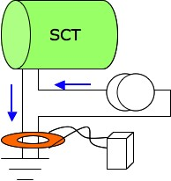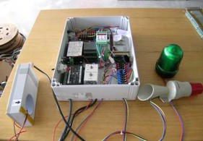

A test current (500mA) is injected into the SCT EC. In the absence of a fault, all current is flowing to the ground point and returning back. If a fault develops part of the current will flow from the SCT to ground following another path.
The Bergoz IPCT, Integrated Parametric Current Transformer (http://www.bergoz.com/) is the core device in the monitor. This will allow full direct safety earth bonding while detecting any new earth path from an erroneous connection. The monitor is in place since March 2006, and it will be installed up to the end of the installation and commissioning. It will be removed just before the cavern is closed.
The IPCT is an ultra high gain transformer using active circuits. The toroidal transformer has the safety earth and a ~200 mA reference current conductor threaded through it. The return path for the reference current should be entirely in the safety earth conductor. If as little as 10 μA of current should be diverted through a fault path, then the monitor will detect the event. For a safety ground resistance of 100 mΩ, the monitor can detect fault paths with resistances lower than 1 KΩ - 2 KΩ. While work is being done on the services of an installed EC, the Bergoz Monitor should be active, so that connection mistakes can be corrected as they occur. If several mistakes pile up without correction, faults are much more difficult to clear on the large assembly. The monitor has been very useful as it was connected to a visual and sound alarm. The intention of it was to warm immediately the installation person of a fault, and thus avoiding the pile up of faults. The threshold alarm was set to trigger if a fault connection was lower than 100 Ω. For faults longer than 2 minutes an email and SMS text was sent to the Grounding expert. The system also detects connection to an active circuit injecting current into the EC (threshold 0.5mA).

Strictly speaking, it is polyimide.

