 | Installation of SCT End-Cap C inside EC Area of SR1
ATLAS Project Document No: | Institute Document No. | Created: 10/01/06 | Page: 1 of 8
None | None | Modified: | Rev. No.

Installation of SCT End-Cap C inside EC Area of SR1

Abstract
This document gives a precise procedure for the unloading of SCT End-Cap C from the delivery lorry outside SR1 and its location inside the SCT end-cap area of the clean room.

Prepared by:  Paul Bell | Checked by:  No one | Approved by:
Distribution List
No one

History of Changes
Rev. No. | Date | Pages | Description of changes
1 | 10/1/06 | 1-8 | P Bell: First draft with input from R. French.  .

Table of Contents

1 step 1: unloading of transport box from lorry 4
2. Step: 2 removal of palette in unloading area 6
3. STEP 3: entering the clean room 7
4. Step 4: installation in end-cap area 8

Step 1: Unloading of Transport Box from Lorry at SR1
The end-cap will arrive in the transport box as shown in figure 1. The palette accepts a forklift which must be inserted from the rear (services) end, where the weight is concentrated. The unloading of the EC from the lorry will be performed by Danzas representatives and observed by the same Liverpool responsibles who observed the loading, plus the responsibles at CERN. Danzas will supply their own forklift truck for this operation.

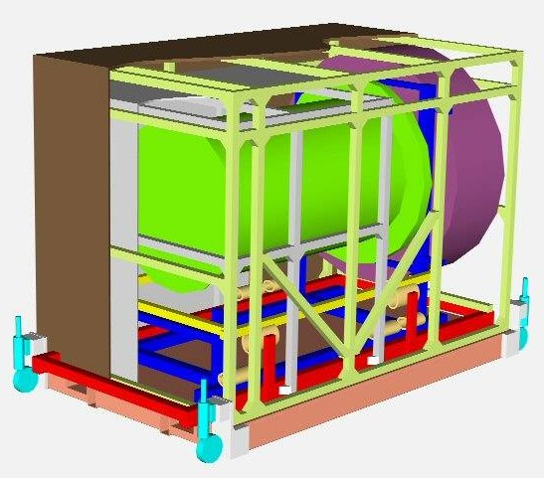
Figure 1. The SCT end-cap (green) plus services (purple) on assembly frame (blue). The assembly frame is supported on the transport frame (red) and sits inside an inner transport box (grey frame and panels). A lifting palette (light brown) is located underneath the assembly frame to take a forklift. The dimensions of the outer transport box (panels in brown supported by a frame in lime green) are: length 3.7m, width 2.2m, height 2.6m, with the wheels lowered. The total weight will be approximately 2.8 T, dominated by the pallet and the frame.

The location of SR1 is shown in figure 2a. Figure 2b shows the proposed position for parking the lorry for unloading. Inside the lorry the wheels on the transport box should be lowered and placed in the correct orientation, allowing box to be rolled to the end of the lorry. Using the forklift under the palette, the box will then be removed through the back doors of the lorry.

A 90degree turn is made by the forklift truck and the box brought through the 4m wide folding door into the SR1 unloading area. With forks under the rear of the end-cap, it passes through the doors front end first. During the procedure many photos should be taken of the end-cap, transport box and lorry as evidence in case of damage.

If it is raining, the transport box should be covered in some sacrificial cling-film. Note that due to a small incline across the asphalt up to the loading doors a forklift truck cannot be operated if there is any snow or ice on the ground.

(a)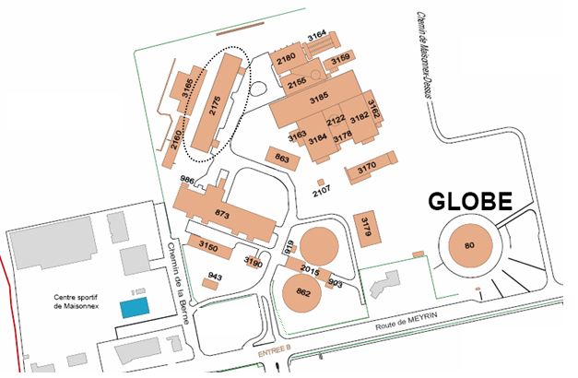(b)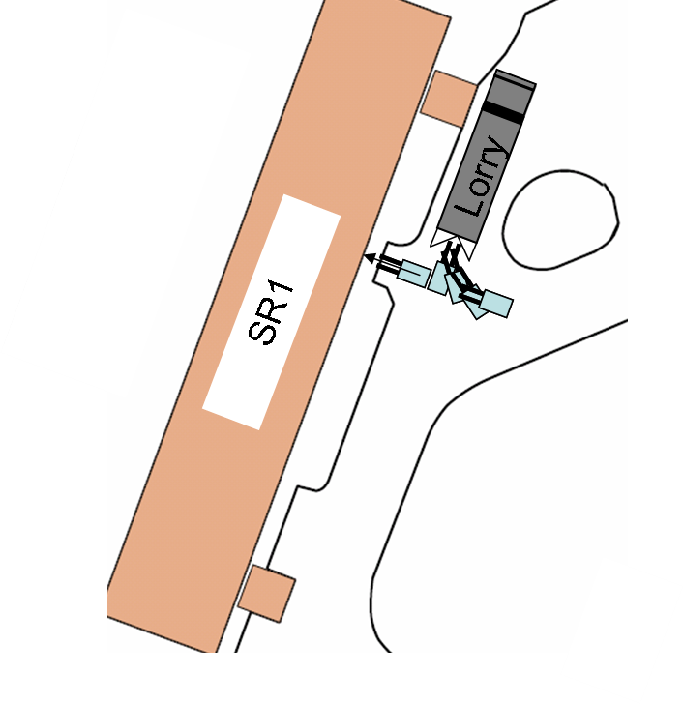
(c)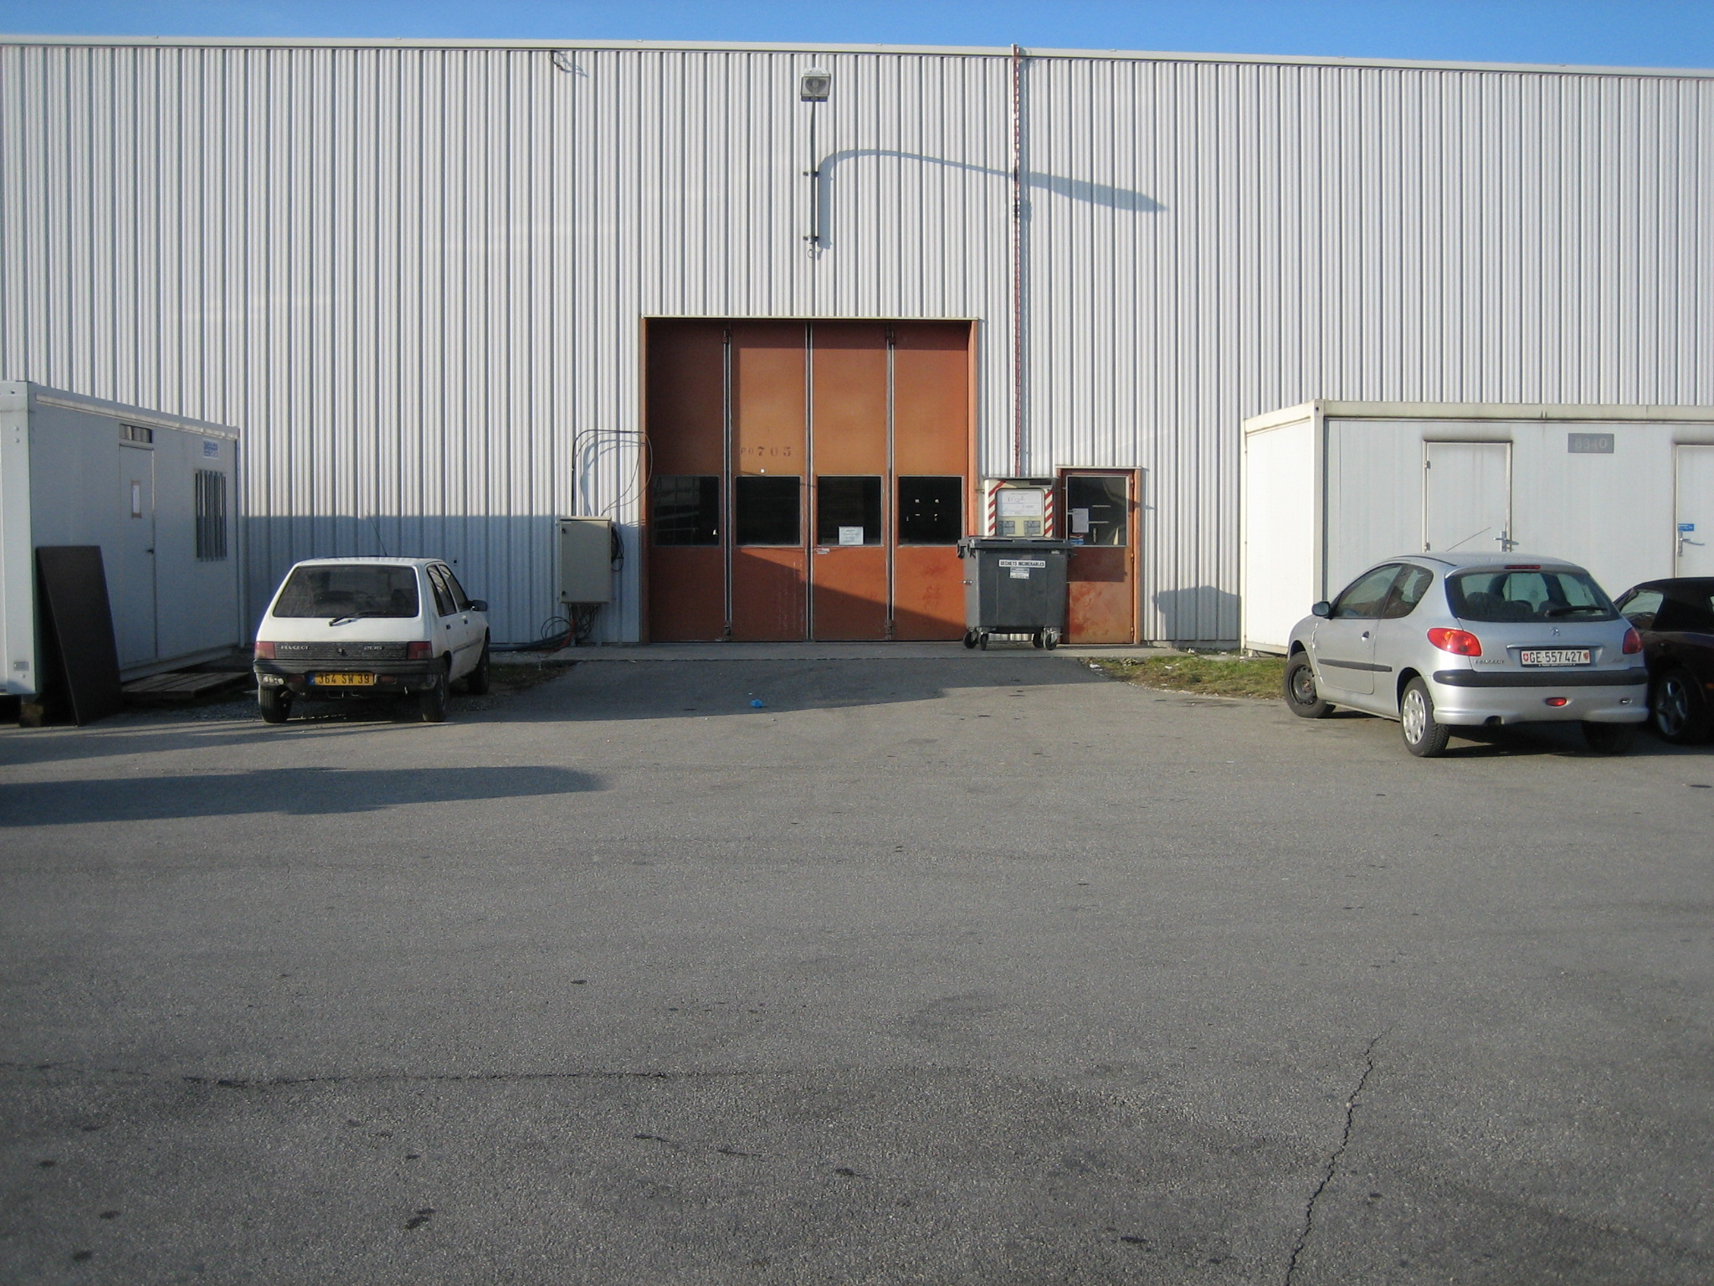(d)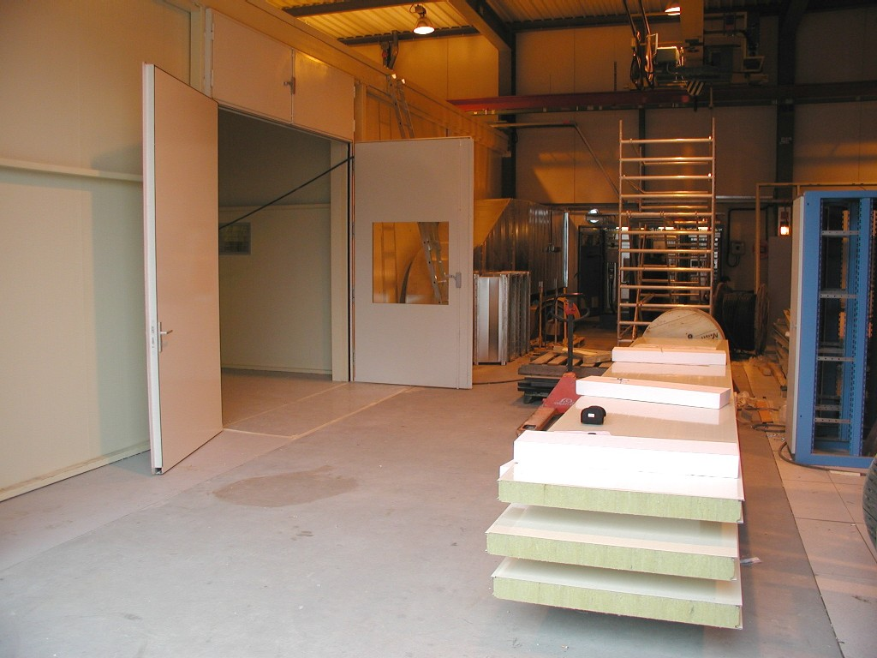
Figure 2. (a) Location of SR1 building. (b) Zoomed map of SR1 showing unloading of transport box from rear of lorry by forklift. (c) Photo of folding loading bay doors leading into (d) the unloading area with concrete floor.

Before setting the box down, it should be grounded via a 1 MΩ lead connected to the front of something or other.

The work of Dansas is concluded once the transport box is lowered to the ground and the fork lift truck safely retracted.

At this stage any cling film covering the transport box is removed. The shock log located on the outer frame should be retrieved and the data examined immediately. The Liverpool responsible should be available with the lap top. What if we find a problem – do we let the Dansas rep go?

Step 2: Removal of Palette and Outer Transport Container
The unloading area has a 4m wide strip of concrete floor running its full length. The area is not enclosed and is not clean.

The weight of the palette and the space needed to remove it means that this operation must be performed in the unloading area as shown in figure 3.

(1)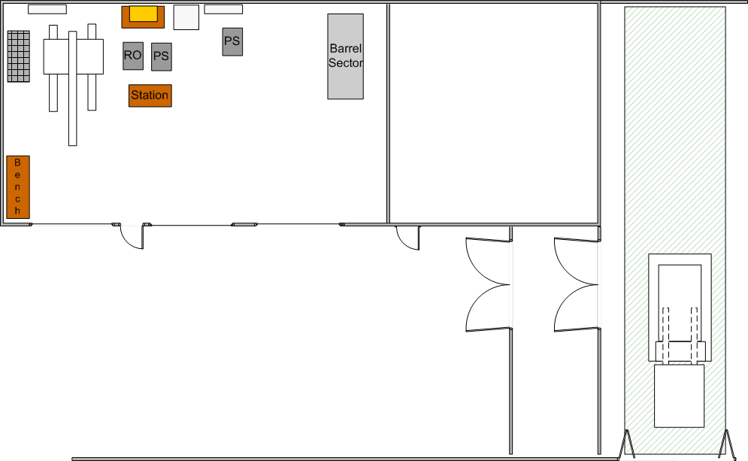(2)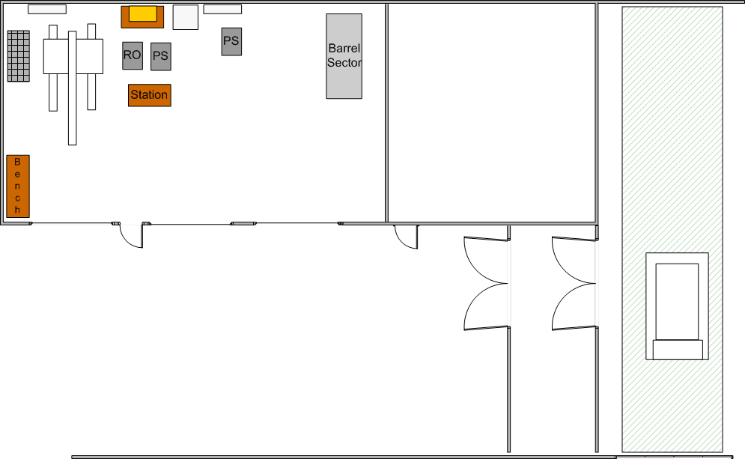
(3)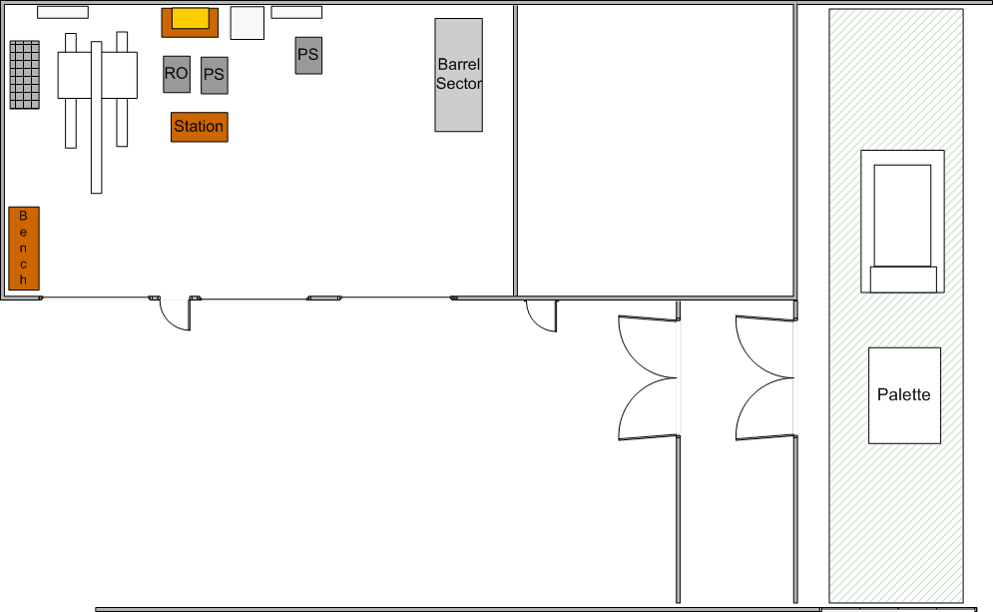
Figure 3. The removal of the palette in the unloading area. The shaded strip shows the concrete floor area.
(1) Forklift enters through folding doors and deposits box on front half of concrete area
(2) Forklift reverses back through folding door and doors are closed (concludes Dansas responsibility, see step 1)
(3) The transport box is rolled forwards off the palette

To remove the palette the wheels are raised so that the palette rests on the floor. The wheels are then removed from the palette and added to the transport frame. The wheels are then lowered again to raise the box off the palette, and the box rolled forwards.

One panel of the outer box is then removed to retrieve the shock log from inside and the data examined.

The remainder of the outer transport box is dismantled while still inside the unloading bay. These parts are removed to building 192 for storage.

Step 3: Entering Clean Area
With the outer transport box removed, the end-cap is passed through the doors into the clean room area as shown in figure 4.

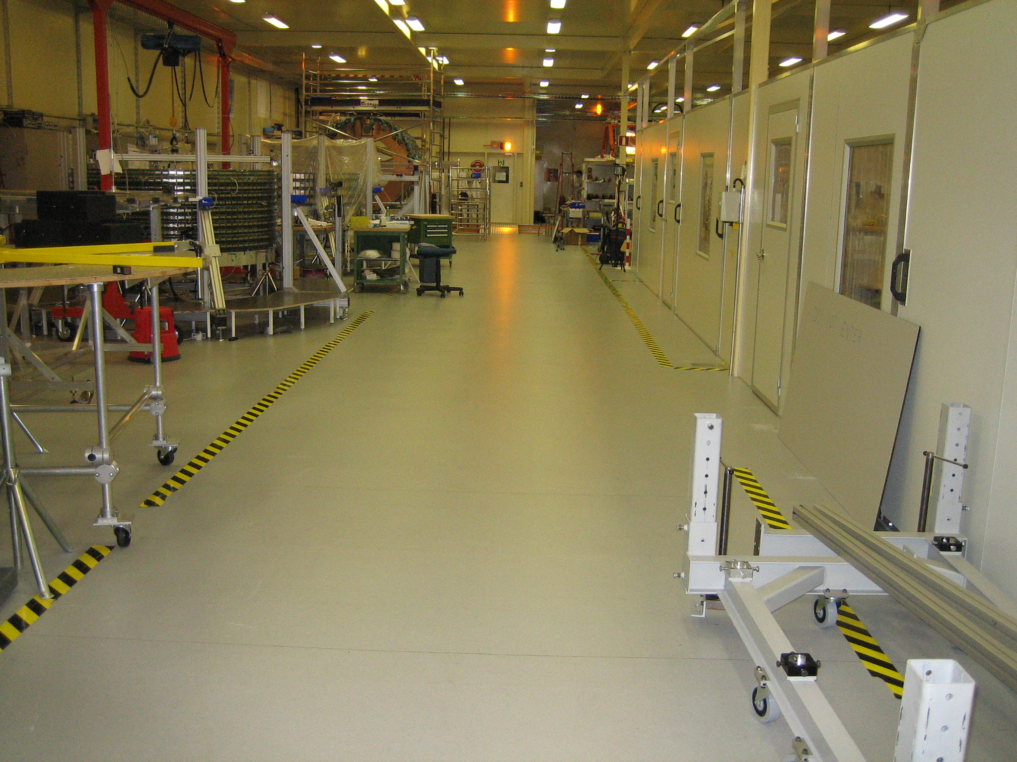
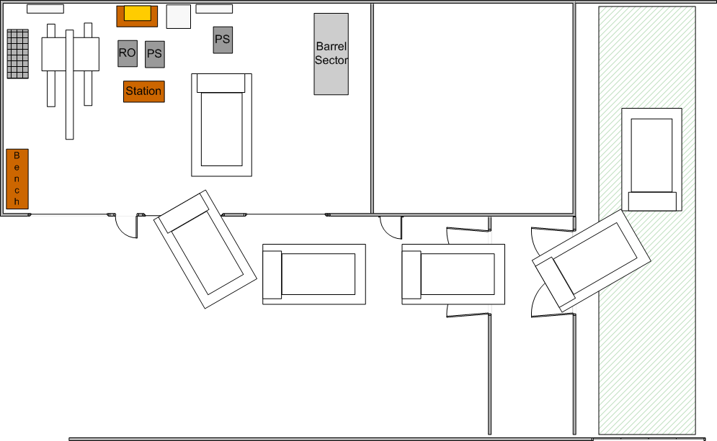
Figure 4. Left: Moving the end-cap into clean area. Right: view along corridor.

The corridor area of SR1 has a loading limit of 2000kg per square metre. With the outer transport box removed, the mass of the end-cap plus services in the inner transport box and assembly frame is approximately xxx kg so there is no risk when moving along this zone.

The end-cap is pushed along the corridor and into the end-cap area through the removable 3m panel as shown in figure 6, travelling rear end first.

Step 4: Setup in End-Cap Area
The loading limit of the floor in the end-cap area is 500kg per square m. Again, the mass of the system will be xxx kg so it can be moved into this area safely. However, in its final position spreader plates should be placed under the feet to prevent local deformation of the floor tiles.

The insulating floor (AFX 28) is added under the frame. This part will have been shipped in advance. Using the jacks on the wheels the base frame is lowered to the floor to sit on its feet on the spreader plates. The plates will be located approximately above the existing floor beams.

The wheels and the inner transport box and the transport frame are then dismantled. The parts no longer required are taken to B192 for storage. The other parts are reused in the low trolley for moving the EC on to the beam.

The ESD film covering the services is removed last allowing the visual inspection to begin. If significant damage is identified, it should be photographed and Stephen Haywood should be informed immediately.

The assembly of the test box can now begin.

