LOI Identification Nº…. [ * obtained from the FAIR project team] FAIR- PAC:

APPA [ * ]
NUSTAR [ X ]
QCD [ * ]

Date: 15 January 2005

Technical Proposal for the Design, Construction, Commissioning and Operation of the HISPEC/DESPEC experiment at the Low-Energy Branch of the Super-FRS facility

Abstract:

HISPEC/DESPEC deals with a versatile, high resolution, high efficiency spectroscopy set-up to address questions in nuclear structure, reactions and astrophysics using radioactive beams with energies of 3-150 MeV/u or stopped and implanted beam species. The radioactive beams, which will be delivered by the energy buncher of the Low Energy Branch (LEB) of the Super-FRS or from the NESR, will be used for γ-ray, charged particle and neutron spectroscopy. The HISPEC (High-resolution in-flight spectroscopy) set-up will comprise beam tracking and identification detectors place before and behind the secondary target, the AGATA Ge array, charged particle detectors, a plunger, a magnetic spectrometer and other ancillary detectors. The DESPEC (Decay spectroscopy) set-up will comprise Si based implantation and decay detectors, a compact Ge array, neutron detectors, fast BaF₂ detectors, a total absorption spectrometer and equipment for g-factor and quadrupole moment measurements. DESPEC will use the same suite of particle identification and tracking detectors as HISPEC. The two set-ups can be combined for recoil decay studies, with the DESPEC detectors placed at the end of the magnetic spectrometer.
The approximate space needed for the HISPEC/DESPEC set-up is 20×20 m², with an additional 10×6 m² for the beam detectors.

HISPEC Name E-Mail Telephone Number
Spokesperson Zsolt Podolyák Z.Podolyak@surrey.ac.uk +44-1483-686811
Wolfram Korten w.korten@cea.fr +33-16908-4272
Deputy: Jan Jolie jolie@ikp.uni-koeln.de +49-221-4703456
Project Manager Jürgen Gerl j.gerl@gsi.de +49-6159-712643

DESPEC
Name E-Mail Telephone Number
Spokesperson Berta Rubio Berta.Rubio@ific.uv.es +34-963543500
Deputy Phil Woods pjw@ph.ed.ac.uk +44-1316505283
Project Manager Magda Gorska m.gorska@gsi.de +49-6159-712917

HISPEC/DESPEC
GSI contact: Jürgen Gerl j.gerl@gsi.de +49-6159-712643
Magda Gorska m.gorska@gsi.de +49-6159-712917

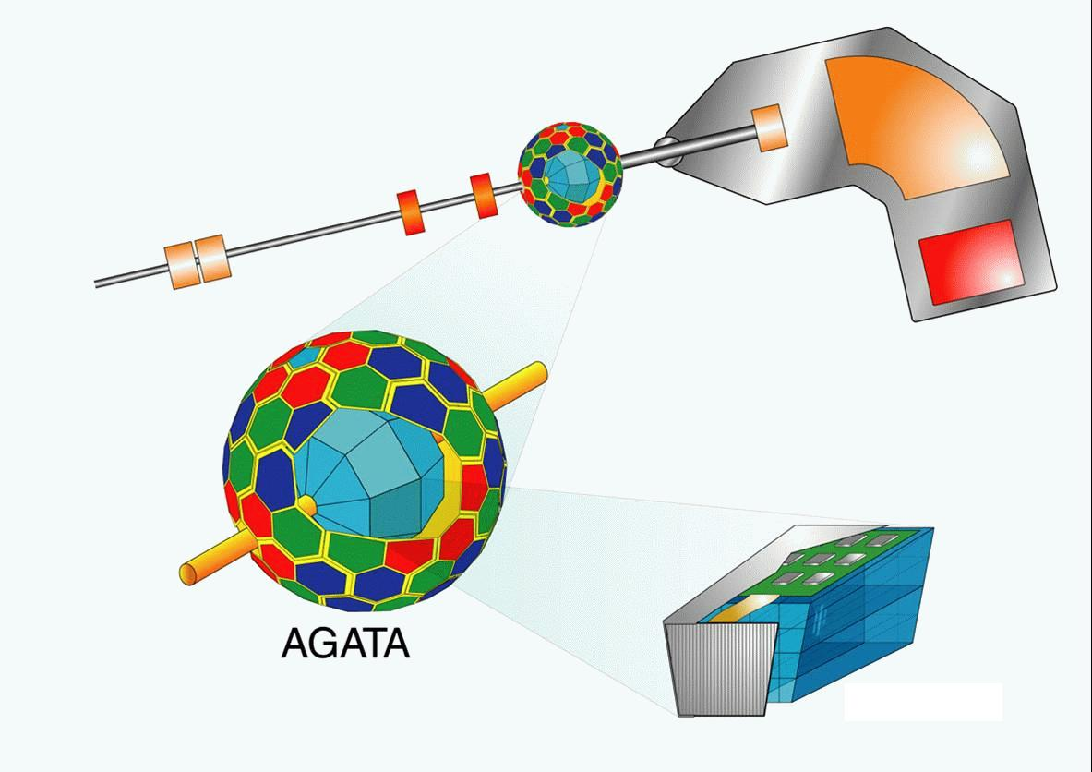
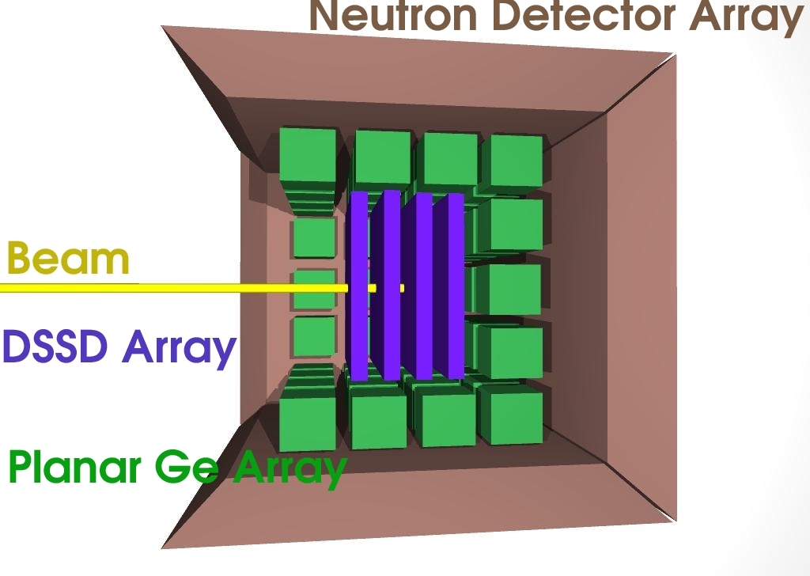

Members of the HISPEC Collaboration

Basel, Switzerland, Univ. Basel, K. Hencken
Bergen, Norway, Univ. Bergen, J. Vaagen
Berlin, Germany, HMI, W. v. Oertzen et al.
Bochum, Germany, Univ. Bochum, W. Gloeckle
Bonn, Germany, K.H. Speidel et al.
Bruxelles, Belgium, Univ. Brussels, I. Borzow
Bucharest, Romania, IFIN-HH, N.V. Zamfir, D. Bucurescu, G. Cata-Danil, A. Petrovici et al.
Buenos Aires, Argentina, CNEA, A. Kreiner
Camerino, Italy, Univ. Camerino, D. Balabanski
Canberra, Australia, ANU, G. Dracoulis
Copenhagen, Denmark, NBI Copenhagen, G. Sletten
Daresbury, UK, CCLRC Daresbury, J. Simpson, R. Lemmon et al.
Darmstadt, Germany, GSI, D. Ackermann, F. Becker, P. Bednarczyk, H. Feldmeier, J. Gerl,
M. Górska, S. Mandal, N. Saito, T. Saito, Ch. Scheidenberger, M. Tomaseli et al.
Darmstadt, Germany, TU Darmstadt, D. Redondo
Debrecen, Hungary, ATOMKI, Zs. Dombradi, A. Krasznahorkay, D. Sohler, A. Algora
Edinburgh, UK, Univ. Edinburgh, P. Woods
Gatchina, Russia, PNPI, Y. Novikov
Giessen, Germany, Univ. Giessen, H. Lenske, M. Petrick et al.
Groningen, Netherlands, KVI, H. Woertche
Heidelberg, Germany, MPI Heidelberg, H. Scheit
Huelva, Spain, Univ. Huelva, I. Martel et al.
Jülich, Germany, FZJ, G. Baur
Jyvaskyla, Finland, JYFL Jyvaskyla, J. Aysto, R. Julin, M. Leino, P. Greenlees et al.
Köln, Germany, Univ. Köln, J. Jolie, P. Reiter, A. Dewald et al.
Krakow, Poland, IFJ PAN Krakow, A. Maj, J. Styczen, W. Meczynski, G. Grebosz et al.

Leuven, Belgium, KU Leuven, P. v. Duppen, M. Huyse, G. Neyens
Lisboa, Portugal, Univ. Lisboa, R. Crespo
Liverpool, UK, Univ. Liverpool, P. Nolan, A. Boston, E. Paul
Louvain-la-Neuve, Belgium, CRC, C. Angulo
Lund, Sweden, Univ. Lund, D. Rudolph, C. Fahlander et al.
Madrid, Spain, IEM-CSIC, O.Tengblad, M.J.G. Borge
Madrid, Spain, Univ. Autonoma de Madrid, A. Jungclaus, O. Tengblad et al.
Manchester, UK, Univ. of Manchester, D. Cullen, B. Varley, A. Smith
München, Germany, TU München, R. Krücken et al.
New Delhi, India, NSC, S. Muralithar
Osaka, Japan, Univ. Osaka, Y. Fujita
Padova, Italy, Univ. Padova, A. Vitturi
Paisley, UK, Univ. Paislay, B. Chapman, K. Spohr, M. Labiche et al.
Rehovot, Israel, Weizman Inst. Rehovot, M. Haas et al.
Saclay, France, CEA Saclay, W. Korten et al.
Santiago de Compostela, Spain, Univ. Santiago, P. Benlliure
Sevilla, Spain, Univ. Sevilla, J. Gomez-Camacho, J. Espino

Stockholm. Sweden, Royal Inst. of Technology, B. Cederwall, A. Johnson et al.
Studsvik, Sweden, Univ. of Uppsala, H. Mach
Strasbourg, France, Univ. Strasbourg, J. Dudek
Surrey, UK, Univ. of Surrey, J. Al-Khalili, Zs. Podolyák, P.M. Walker, P.H. Regan et al.
Uppsala, Sweden, Uppsala Univ., J. Nyberg
Valencia, Spain, IFIC, CSIC, B. Rubio et al.
Warsaw, Poland, Univ. Warsaw, J. Kownacki et al.
York, UK, Univ. of York, M. Bentley, D. Jenkins, R. Wadsworth et al.
AGATA collaboration, 40 institutions of 12 countries

Members of the DESPEC Collaboration
Aarhus, Denmark , H. Fynbo
Barcelona, Spain, Univ.Politécnica Cataluña, F. Calviño
Bordeaux, France, B. Blank
Bucharest, Romania, IFIN-HH, N.V. Zamfir, M. Ionescu-Bujor et al.
Camerino, Italia, Univ. Camerino, D.L. Balabanski
Daresbury. UK, CCLRC, J. Simpson, D.Warner, I.Lazarus, V.Pucknell and Daresbury engineers
Darmstadt , Gremany, GSI, D. Ackerman, M. Górska, J. Gerl, I. Kojouharov ,
C. Scheidenberger et al.
Debrecen, Hungary, Institute of Nuclear Research, A. Algora
Edinburgh , UK, Univ. Edinburg, P.J. Woods, T. Davinson
Gatchina, Russsia, PNPI, L. Batist
Giessen, Germany, W. Plass
Guelph, Canada, Univ of Guelph, P.Garrett
Jyväskylä , Finland, Univ. of Jyväskylä , J. Äystö, A. Jokinen, P. Jones, R. Julin, M. Leino, H. Penttilä., J. Uusitalo , C. Scholey
Leuven, Belgium, Univ. of Leuven, M. Huyse, G. Neyens, P. van Duppen
Liverpool, UK, Univ. of Liverpool, R. D. Page
Louvain-la-Neuve, Belgium, C. Angulo
Lund, Sweden, Univ. Lund, D. Rudolph
Köln, Germany, Univ. Köln, J. Jolie, P. Reiter
Krakow, Poland, IFJ PAN, A. Maj et al.
Madrid, Spain, CIEMAT, D. Cano-Ott, E. González, T. Martínez
Madrid, Spain, Univ. Autónoma, A. Jungclaus
Mainz, Germany, Univ. Mainz, K.-L. Kratz
Manchester, UK, Univ. Manchester, D. Cullen
Munchen, Germany, T. Faestermann, R. Krücken
Oslo, Norway, P. Hoff
Sofia, Bulgaria, G. Rainovski, S. Lalkovski, M. Danchev
Swierk, Poland, SINS, E Ruchowska, S. Kaczarowski
St. Petersburg, Russia, RI, I. Izosimov
Stockholm, Sweden, B. Cederwal, A. Johnson
Strasbourg, France, IRES, G. Duchêne
Surrey, UK, University of Surrey, W. Gelletly, Zs. Podolyak, P. Regan, P. Walker
Tennessee, USA, ORNL, R. Grzywacz
Uppsala, Sweden, Uppsala University, H. Mach, J. Nyberg

Valencia, Spain, IFIC, CSIC-Univ. Valencia, B. Rubio, J.L.Taín
Warsaw, Poland, University of Warsaw, W. Kurcewicz, M. Pfutzner

Table of Contents

A. Introduction
B. Systems
1.1. Subproject 1 HISPEC
- a) Simulations
i) of the detectors
- ii) of the beam
b) radiation hardness
c) and d) design and construction
beam detectors before the secondary target or catcher
AGATA Ge tracking array
plunger devices
charged particle detector arrays
for reaction studies (HYDE)
for nuclear structure
magnetic spectrometer
e) acceptance tests
f) calibrations
g) requests for test beams
1.2. Subproject 2 DESPEC
a) Simulations
- i) of the detectors
- ii) of the beam
b) radiation hardness
c) and d) design and construction
beam tracking detectors before the catcher
implantation decay detector (DSSD)
modular high resolution gamma-detection array
modular high-efficiency fast-timing array
neutron detectors
total absorption spectrometer (TAS)
setup for electromagnetic moment measurement
e) acceptance test
f) calibrations
g) requests for test beams
2. Trigger , DACQ, Controls, On-line/Off-line computing
3. Beam/Target Requirements
4. Physics Performance
C. Implementation and Installation
- Cave and Annex Facilities
- Detectors – machine interface
- Assembly and installation
D. Commissioning
E. Operation
F. Safety
G. Organisation and responsibilities, planning
H. Relations with other projects
I. Other issues
A Introduction and Overview:

The HISPEC (High-resolution in flight spectroscopy) and DESPEC (Decay spectroscopy) collaborations are part of the NUSTAR collaboration. Due to the large overlap in physics, instrumentation and participants, the two collaborations present here a common Technical Proposal, with HISPEC and DESPEC treated as two subprojects.

The physics case for the HISPEC/DESPEC experiments is part of the overall NUSTAR physics programme and shares the common goals of attempting to understand nuclear structure and nuclear reactions and related questions in nuclear astrophysics. The collaboration will concentrate on those aspects of nuclear structure, reactions and astrophysics investigations which can be exclusively addressed with the proposed high resolution spectroscopy set-up using the beams unique to the NUSTAR facility.

The experimental programme proposed at NUSTAR-FAIR is complementary to planned next generation radioactive beam facilities such as RIA (USA), the upgraded RIKEN facility (Japan) and the next generation European ISOL facility (EURISOL). The HISPEC/DESPEC collaboration will address, in particular, the spectroscopy of very short-lived nuclei and refractory elements which are not available at ISOL based radioactive beam facilities. None of the other facilities will be able to provide beams of heavy, short-lived radioactive species. Figure 1 shows a nuclear chart with the beam intensities expected from the Super-FRS facility. Nuclei with short lifetimes are the particular domain of the NUSTAR facility.

The HISPEC/DESPEC experiments will be located at the low energy branch of the Super-FRS facility which is unique in several aspects:
- several thousands of isotopes between uranium and hydrogen can be prepared as beams with energies ranging from about 3 MeV/u to 150 MeV/u with intensities appropriate to nuclear research studies by means of gamma and particle spectroscopy,
- after implantation the decay properties (α, β, γ, conversion electrons, p, n) of the same exotic isotopes can be studied,
- the gain in beam intensity compared with the present FRS beams will be of the order of 10³ for fragmentation and 10⁴ for fission products,
- exotic nuclei (both in their ground states or in isomeric states) with lifetimes down to a few 100 ns can be studied,
- ion beams composed of several isotopes, mono-isotopic beams and beams in high spin isomeric states will be available,
- the beam quality enables high-resolution γ-ray spectroscopy,
- in addition to slowed-down beams obtained from the Super-FRS, the NESR provides beams with an energy definition of 10⁻⁴, which will allow combined high resolution particle and γ-ray spectroscopy at energies around the Coulomb barrier,
- electro-magnetic transition probabilities and static moments can be measured as well as particle and gamma ray energies and intensities.

Table 1: Experimental opportunities for high-resolution spectroscopy at the low-energy branch.
Research field | Experimental method  (beam-energy range) | Physics goals and observables | Beam int.  (particle/s)
Nuclear structure, reactions and astrophysics | Intermediate energy Coulomb excitation, In-beam spectroscopy of fragmentation products  (E/A ~ 100 MeV)  Multiple Coulomb excitation, direct and  deep-inelastic, fusion evaporation reactions  (E/A ~ 5 MeV; Coulomb barrier)  Decay spectroscopy  (E/A = 0 MeV) | Medium spin structure,  Evolution of shell structure and nuclear shapes, transition probabilities, moments,  high spin structure, single particle structure,  dynamical properties, transition probabilities, moments,  half-lives, spins, nuclear moments, GT strength, isomer decay, beta-decay, beta-delayed neutron emission,  exotic decays such as two proton, two neutron. | 10¹...10⁵  10⁴...10⁷  10⁻⁵...10³

The experimental techniques to be used can be grouped together in relation to three different energy regimes (see Table 1).

The technique for spectroscopy experiments at intermediate beam energies has been and still is being developed at Riken, MSU, Ganil and GSI. Common to all these efforts is the tracking and mass and charge identification of the incoming beam particles on an event-by-event basis. High energy resolution of the gamma rays emitted by fast moving nuclei is achieved by appropriate Doppler correction using composite and/or segmented Ge detectors. The outgoing particle is identified behind the secondary target by means of ΔE, ToF, Bρ or total energy measurements. For example the CATE (R. Lozeva et al., Nucl. Instrum. Meth. B204 (2003) 678; Acta Phys. Pol. B (2005) in press) array within the RISING (H.-J. Wollersheim et al., Nucl. Instrum. Meth.
A, in press) set-up has been employed in the ~100 A.MeV regime, to derive Coulomb scattering angles and identify secondary fragments by proton number Z and mass A in coincidence with prompt γ-ray radiation.

Nuclear structure studies performed at Coulomb barrier energies have benefited largely from 4π Ge detector arrays such as Euroball, JUROGAM, GASP, Exogam or Miniball in Europe or Gammasphere in the USA combined with efficient, ancillary charged-particle arrays. The main experimental considerations are related to: reaction channel selection to enable the search for weakly produced exotic nuclei or structures, and exclusive determination of the reaction kinematics for improved γ- and particle energy resolution.

Besides the spectroscopic information which is obtained from gamma-ray and particle spectroscopy, transition probabilities are of crucial importance for nuclear structure investigations. These are very sensitive observables, well suited to the detection of different nuclear structure phenomena and to enable stringent tests of theoretical models. In order to determine absolute transition probabilities, aside from direct (electronic) fast timing measurements and Coulomb excitation, the Doppler shift techniques are very well established. Therefore, it is of great interest to perform lifetime measurements using the recoil distance Doppler shift (RDDS) as well as the Doppler shift attenuation methods (DSAM) with reactions induced by the rare isotopes made available at FAIR, especially at intermediate or relativistic energies.

Decay spectroscopy with implanted radioactive beams will offer new and complementary information both on nuclear structure and the astrophysics of exotic nuclei. Decay studies lie at the frontier of our understanding of nuclei far from stability, since once the existence of an isotope has been demonstrated, the next elementary piece of information we seek is how it decays. Experiments can be performed with very high sensitivity and key physics information such as particle decay branching ratios, half-lives, first excited states, isomeric decays can be gleaned from a relatively small number of events. On the other hand the intense beams provided by the SFRS will allow complete decay studies where not only delayed particle and gamma emission branching ratios can be extracted but also detailed spectroscopic information, such as ß-strength functions, nuclear moments and spins as well as electrom-magnetic transition probabilities. This will allow one to extract matrix elements far away from the stability line where a large part of the strengths will be determined for the first time.

The collaboration envisages initiating the physics programme in several steps. The first stage of the FAIR project, involving the upgrade of the SIS-18 synchrotron and the construction of the Super-FRS, is expected to be completed in 2009. Commissioning experiments with beams from the low-

Fig.1. Nuclide chart with the predicted yields at the FAIR facility (K,H, Schmidt et al, www.gsi.de).
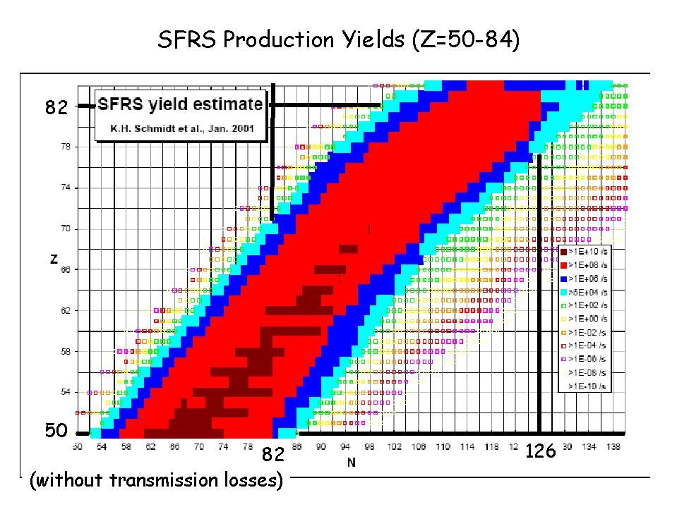
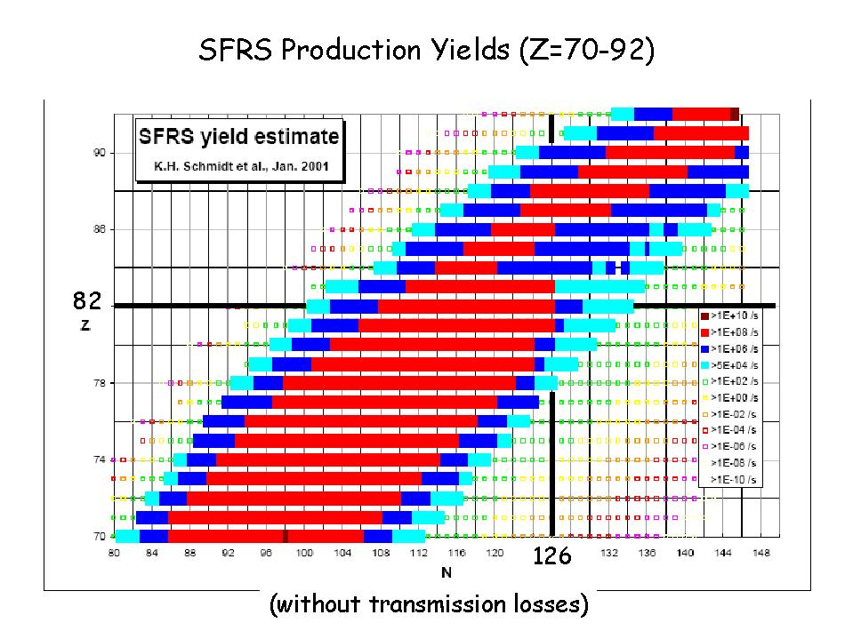
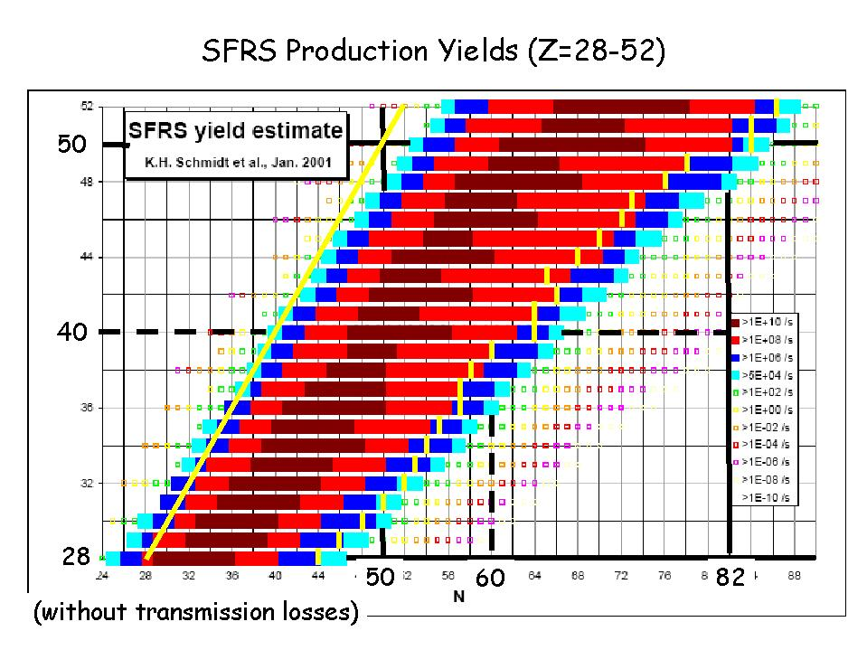
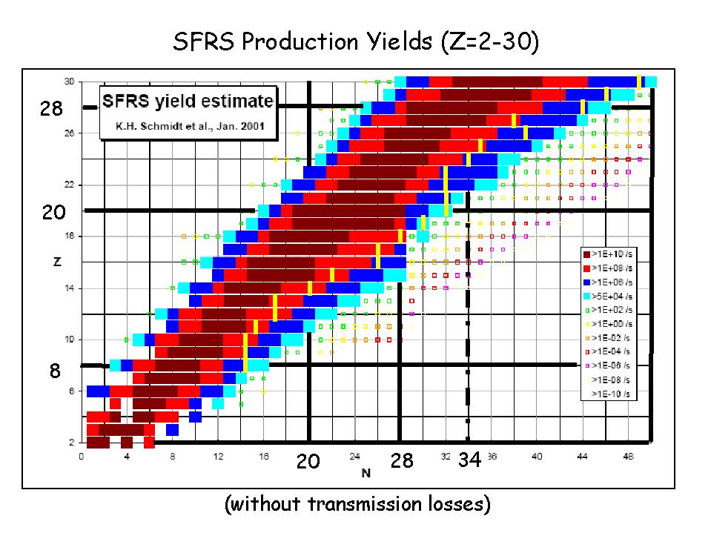
The yellow (light vertical ) line shows the lifetime limit of 1s (courtesy of R. Krücken).

spectroscopy at the low-energy branch

energy buncher can be expected for 2010. At this stage a 6-12 months physics programme with beams at intermediate energies (50-150 A.MeV) is envisaged, as well as inelastic excitations at lower energies. For this campaign we aim for a 1π sub-array of the AGATA spectrometer (together with all its ‘ancillary’ detectors) to be available as well as all the detectors needed to track and identify the beam and outgoing charged particles. In parallel, decay studies using implanted beams will be performed. Most of the neutron and gamma detectors as well as the implantation detector will be ready in the first phase, including the magnet for the TDPAD (Time dependent Perturbed Angular Distribution) measurements. Other experiments using beams at Coulomb barrier energies are planned from 2012. At that time the full equipment, including a new large acceptance spectrometer, will be operational.

In the following parts we describe separately the experimental set-ups for HISPEC and DESPEC.

B Systems
  - Sub Projects 1:

HISPEC
HISPEC

Taking into account all of the considerations outlined above led us to the design of a spectrometer aimed at complete spectroscopy of all the particles and gamma rays which are emitted, as well as event-by-event identification of the nucleus of interest.

The following detector systems will be used for the HISPEC experiments.
- Detectors for beam tracking and particle identification.

- The AGATA gamma-ray spectrometer.
- Devices for precision lifetime measurements (plungers, BaF₂ arrays).
- Several charged-particle Si detector arrays optimized for reaction and structure studies.
- A large acceptance magnetic spectrometer with “tagging” detectors in the focal plane.

R&D, prototyping and tests of these detector systems will be carried out by different sub collaborations in charge of building the various detectors.

The beam tracking and identification detectors described here are also used for DESPEC. In addition, the detectors described within the DESPEC collaboration will be used in some experiments in conjunction with HISPEC.

The AGATA collaboration is currently pursuing the final R&D studies and the construction of a demonstration array. The Technical Design Report for the AGATA project should be completed in 2007 in order to start constructing the full array in 2008.

Several Si detector arrays will be built, which need to be optimized for different energy regimes and for use in conjunction with AGATA. No specific R&D for Si detectors is needed, but highly integrated front-end electronics will be developed in collaboration with other NUSTAR projects (R3B, EXL, etc.). A Technical Design Reprort for these systems will be available at the end of 2006.

Further details of all detectors to be used in the HISPEC set up are given below (sections c and d).

a) Simulations
i) Detectors

Experiments similar in type to those proposed with the HISPEC set up are already being performed at the present SIS-FRS complex. Experiments at intermediate energies have been successfully performed within the RISING programme. Other experiments, using plunger devices or combining active stoppers with gamma-ray detection are expected to run within the RISING project. Therefore, the collaboration can rely on the experience that will be gained in those experiments, and extrapolate to the beam intensities expected from the new super-FRS facility. In particular, different background sources and their contribution to the energy spectra have already been studied which cannot be predicted by simulations a priori. Experience has also been obtained in the use of Si detector arrays and the ALADIN spectrometer, since these devices are the results of the ongoing development of existing detectors. Finally, a proof of principle experiment using a (slowed-down) beam at Coulomb barrier energies will be proposed to the GSI PAC.

Extensive simulations have been performed for the AGATA gamma detector array where efficiency, background, pulse shapes and tracking have been considered. The AGATA collaboration also simulates the effect of ancillary detectors (charged particle arrays, plunger) to be used in conjunction with it. Special emphasis is being given to the uncertainties in energy, position and angle of the gamma-ray emitting particles (see fig. 2). In order to preserve the best possible energy resolution for gamma-ray detected with AGATA the requirements with respect to the beam tracking detectors given in table 2 have to be obtained.

Table 2: Requirements for the beam tracking at different velocities. The quoted values correspond to an increase of 10% in the FWHM of the gamma peak, with respect to those calculated assuming a perfect knowledge of the kinematics.

Uncertainty (sigma) on: | Beta=5% | Beta=20% | Beta=50%
Position (cm) | 1.5 | 0.5 | 0.3
Direction (degrees) | 2 | 0.6 | 0.3
Velocity module (%) | 2.4 | 0.7 | 0.3

This performance can, in principle, be reached with existing technology. However, dedicated detector systems have to be realized.
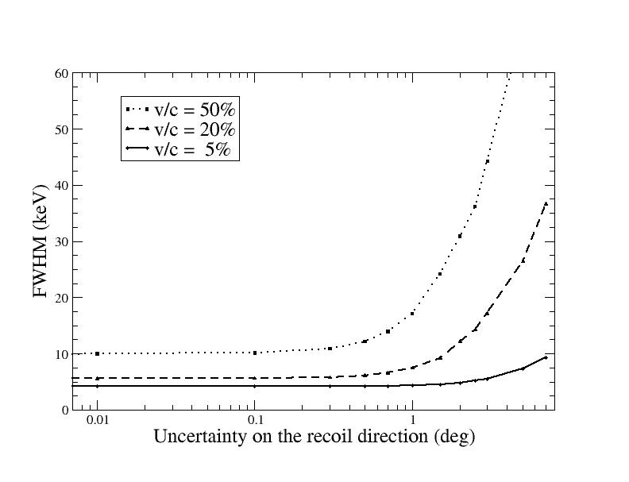
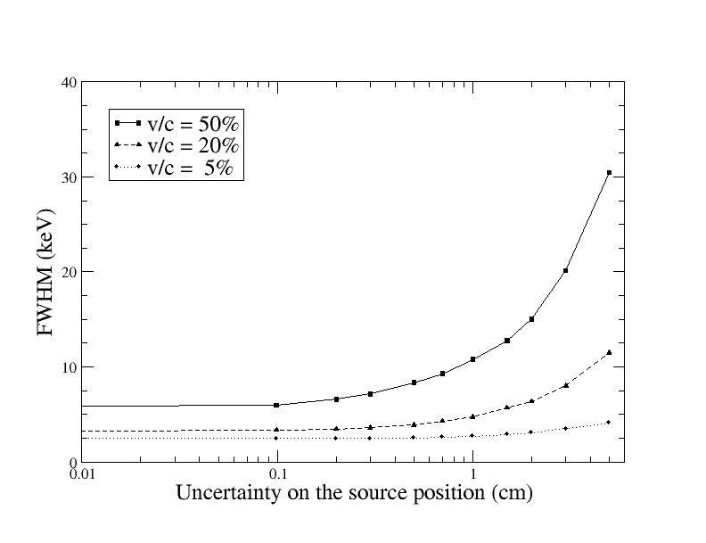
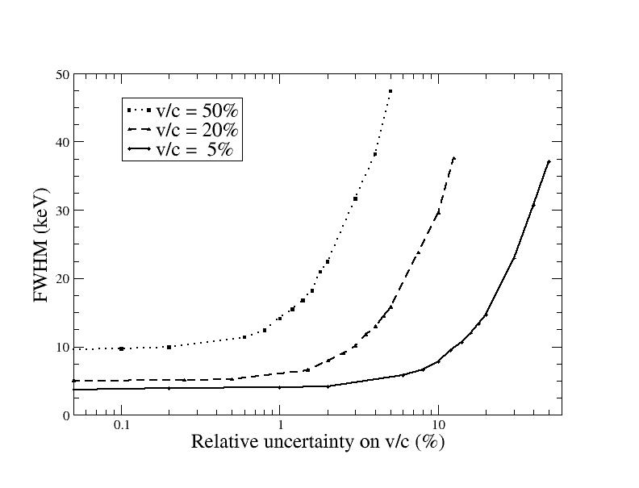

Fig. 2: The performance of AGATA as a function of the beam tracking accuracy.
(E.Farnea et al, LNL-INFN Ann. Rep 202/2004 p.158 and F.Recchia LNL-INFN Ann. Rep. 202/2004 p.160)

It is also important to simulate the effect of the beam detectors on the beam itself. This is particularly
true in the case of particle spectroscopy (HYDE and other charged particle detectors) which depends much more on precise event-by-event determination of the kinematics than the gamma spectroscopy.

- Beam [ X ]

Detailed simulations of the beam characteristics from the energy buncher have been performed and are summarized in the introduction to the low-energy beam-line. At intermediate energies a much better beam profile is expected than that available today for the RISING project. The simulated characteristics of the beam at low energies after the energy buncher are shown in figure 3, i.e. energy and angular spread as well as size. The principal of the energy buncher has been tested at the FRS and the characteristics of the slowed beam were found to agree very well with the simulations (Ch. Scheidenberger et al., NIM B 204 (2003) 119). The achievable beam quality requires event-by-event energy determination in addition to the conventional tracking used at higher energies. The final precision of the beam tracking needed in order to perform high resolution gamma-ray spectroscopy is given in table 2.

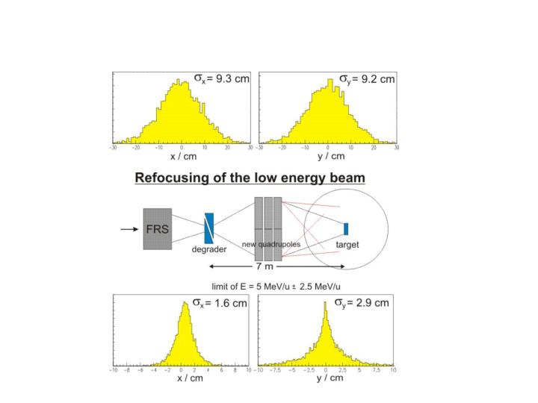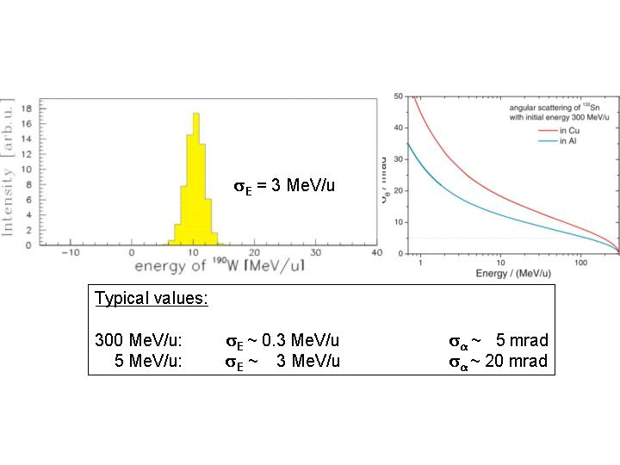
Fig. 3: Simulation of the beam characteristics after the energy buncher for low energies. The figure shows both the energy spread and beam size (courtesy of H. Weick).

- Radiation Hardness

No specific measures have to be taken in this respect, since the beam intensities will not exceed 10⁷ particle/s. Extrapolating from intermediate energy experiments performed with RISING such intensities will not result in radiation levels damaging the gamma detectors. In addition, shielding of upstream radiation is foreseen to reduce background events. Concerning the particle detectors segmentation is necessary to be able to run the electronics at rates of 10⁷ particle/s. The particle dose on each segment will be comparable to those suffered by detectors in current experiments.

The Si detectors will have to be considered as consumables. It is expected that they will have to be replaced every 1-5 years.

- Design,
and
- Construction

The different detectors to be used in the HISPEC setup are described below.

Beam detectors before the secondary target or catcher

For a large number of experiments it is essential to determine the kinematics of the individual beam particles: energy and path. In addition the beam particle needs to be identified behind the energy buncher, since during the slowing-down process 10-20% of the beam is destroyed in reactions.

The beam identification and tracking detectors have to provide on an event-by-event basis the mass, charge, energy, position and direction information. For mass and energy determination a Time-of-Flight measurement is necessary. The time resolution should be <100 ps (FWHM), and the position resolution needs to be <1 mm. Moreover, the detectors have to run at rates of up to 10⁷ particle/s. To avoid excessive energy and angular spread of the incoming particles all detectors need to be very thin and the whole set-up needs to run in vacuum. In addition, the layout needs to be optimised to minimise the background radiation reaching the γ detector array from upstream of the secondary target.
In order to determine the velocity of the ions a flight path of 8 m length is considered necessary both before and behind the secondary target. The position sensitive detectors (in x and y) for flight path determination have to be installed after the last quadrupole magnet of the beam line. The suggested set-up is shown in figure 4. Preferably the same detector should be used for x,y, ToF and dE determination before the secondary target. Further R&D is needed to investigate the use of active targets to replace some of these detectors.

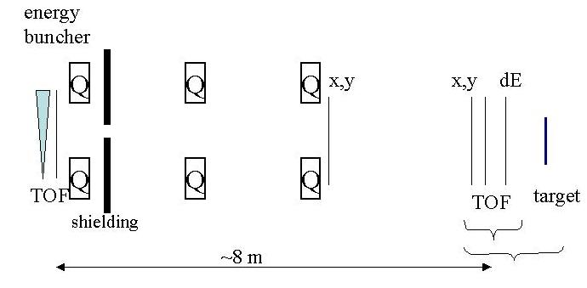
Fig. 4: Schematic set-up of the particle tracking up-stream of the secondary target.

Particle tracking is easier at intermediate energies than at Coulomb barrier energies, mainly because thicker detectors can be used. Tracking at 50-100MeV/u energies is currently performed in several laboratories although at relatively low rates.

It is expected that diamond detectors and segmented scintillators are suitable for these tasks. Work is going on within the NUSTAR collaboration to develop suitable diamond detectors, which are fast and able to give both position and energy loss measurements. Presently the main problem is the limited size. The biggest CVD (chemical vapor deposition) diamond detector (used at GSI) has the following characteristics: time resolution FWHM=70 ps (measured for 650 MeV/u ⁵²Cr), rate >10⁷ pps (particles per second), thickness 200 μm, area 60x40 mm², 1.8 mm x 38 mm strips. The thickness can be reduced by a factor of 10.

At Coulomb barrier energies very thin detectors (<1μm) must be used. It is not yet known whether diamond detectors with suitable characteristics (thickness) can be developed. Another option is the use of electron emitting carbon foil detectors coupled to multi-channel plate detectors. These are fast (FWHM~100ps) and can give sub-millimeter position resolution. They can also be made very thin (for ex. 1 μm thick foils are used in the GANIL superheavy elements programme ). Large area gas detectors (15x40cm²) for secondary electron detection have been developed for the VAMOS spectrometer at GANIL. They combine good time resolution (~100ps) with sufficient position resolution (1-1.5mm). More recently, tracking detectors based on the electron emission from carbon foils are in use in the PRISMA project. Here the products of the deep-inelastic reaction are tracked, at energies of a few MeV/u.

AGATA Ge tracking array

AGATA (Advanced Gamma Tracking Array) (www-w2k.gsi.de/agata; AGATA Tehnical Porposal (ed. By J.Gerl and W. Korten, 2001.) is designed to be a 4π detector consisting of 180 germanium detectors. Each detector crystal will be segmented 36 ways giving a total of over 6600 electronics channels. The detector crystals will be assembled into 60 triple cryostats. Within each detector pulse shape analysis will be used to determine the interaction positions of the gamma rays to an accuracy of ~2 mm. Tracking algorithms are being developed by the collaboration to reconstruct the paths of gamma rays passing through the detectors. The AGATA detector crystals will have a length of 90 mm and a hexaconical shape based on an 80 mm diameter cylinder. When AGATA is completet the detectors will be 23.5 cm from the target and will cover a germanium solid angle of 78.4%. The expected performance of AGATA for different gamma-ray multiplicities and a stationary source has been calculated (see table 3).

Table 3: AGATA characteristics
Multiplicity | 1 | 10 | 20 | 30
Efficiency (%) | 38.8 | 29.6 | 27.0 | 25.1
Peak to total (%) | 53.2 | 48.4 | 47.3 | 46.1

This performance will provide a very significant improvement over all existing gamma-ray devices and for high multiplicity events, in particular, will result in an improved sensitivity of several orders-of-magnitude (depending on the experiment).

Prototype gamma-ray tracking detectors have been developed by the collaboration and are currently being tested. The energy resolution of individual detector segments is typically 0.9 to 1.1 keV for 60 keV gamma-rays and 1.9 to 2.1 keV for 1332 keV gamma rays. The crosstalk between segments has been measured to be less than 10⁻³. The ability to determine the interaction positions very accurately will result in the array (and parts of the array) being particularly suitable for experiments where the gamma-emitting nuclei have a large recoil velocity.

Within the present R&D phase the AGATA demonstrator is being built, which will consist of 5 triple cryostats containing 15 detectors. This should be available in 2007 and will be a powerful detector in its own right.

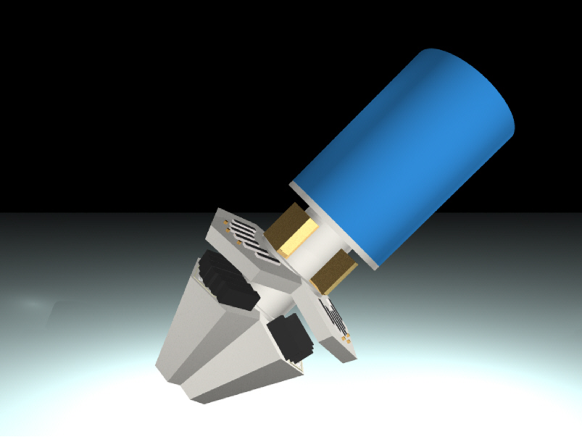

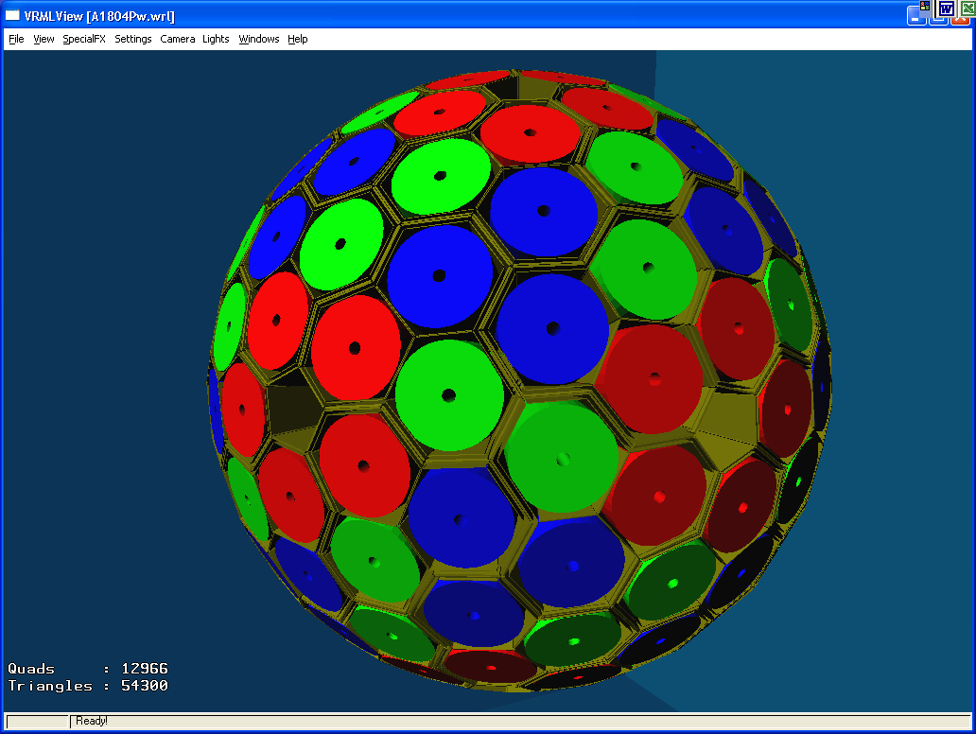
Fig. 5: AGATA triple-cluster unit and schematic view of the complete 4π array comprising 60 modules.

The whole array can then be built up over a period of time with the full array being available ~2011. In the period while the array is being built the design is such that part of it will be available from 2007 onwards with its size and hence performance improving continuously. It is expected that AGATA will be provided together with a number of ancillary detectors.

More details can be found in the AGATA Technical Proposal and on the AGATA web page (www-w2k.gsi.de/agata).

Plunger devices

Special experimental conditions which are present at facilities where short-lived radioactive isotopes can be investigated, have to be considered in the design of dedicated Plunger devices for lifetime measurements. Thus the usual stopper foils have to be replaced by degrader foils to enable the detection of the nuclei of interest downstream of the degrader foils needed to clean the spectra from strong background radiation. The beam energy and the kinematics of the reactions used, e.g. in fragmentation and Coulomb excitation, will have a large impact on an optimized plunger design. In the following we will distinguish three different energy ranges for which different plunger devices have to be constructed.

Energy range 100-200 MeV/u:
Due to the high energies thick targets of the order of 200-300 mg/cm2 can be used. A typical beam waist is about 2-3 cm in diameter. As a consequence the size of the target and degrader foils has to be about 5cm in diameter. Because of the high recoil velocities and correspondingly large target-degrader separations (0.1-20 mm) an accuracy of the target-degrader separation of about 0.01 mm will be sufficient. The use of multi-degrader set-ups becomes possible. The design should allow for beam tracking as well as for the identification of the nuclei of interest downstream of the target and degrader foils.

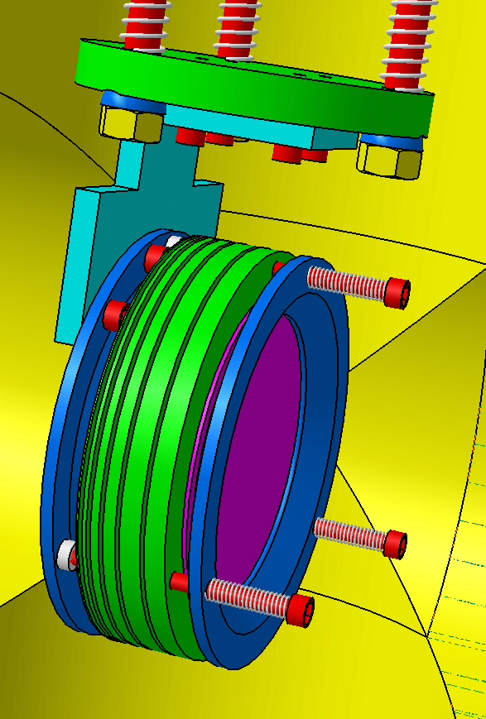
Fig. 6: Plunger device for relativistic beam experiments

A first set-up of this type is shown in Fig. 6. The target-degrader separations are realized with rings of a thickness equal to the desired separation. It is planned to build a similar set-up but with the possibility to adjust the target-degrader separations by means of a motor. The development of foil holders, which allow the adjustment of 300 mg/cm2 thick foils parallel to each other over an area of about 20 cm², is necessary for this purpose. A plunger type experiment has been approved to measure lifetime in Mg isotopes at RISING.

Energy range 20 -100 MeV/u:

The main difference compared to higher energies is the thickness of target and degrader. For this energy regime a thickness of about 50 mg/cm² is typical. This allows the use of target holders similar to those of a standard plunger set-up employed in the low energy regime (~ 5 MeV/u). Such foils cannot be glued on rings and stretched over a conical frame. Foils of rather soft materials like aluminium or gold can be clamped between two solid rings and then stretched.
Fig. 7 shows such conical frames and clamp rings attached to a movable tube with an inner diameter of 5 cm. It is planned to use such a set-up at the NSCL at MSU in 2005 with radioactive beam of 50 MeV/u (a test has already been performed). The construction work is underway.

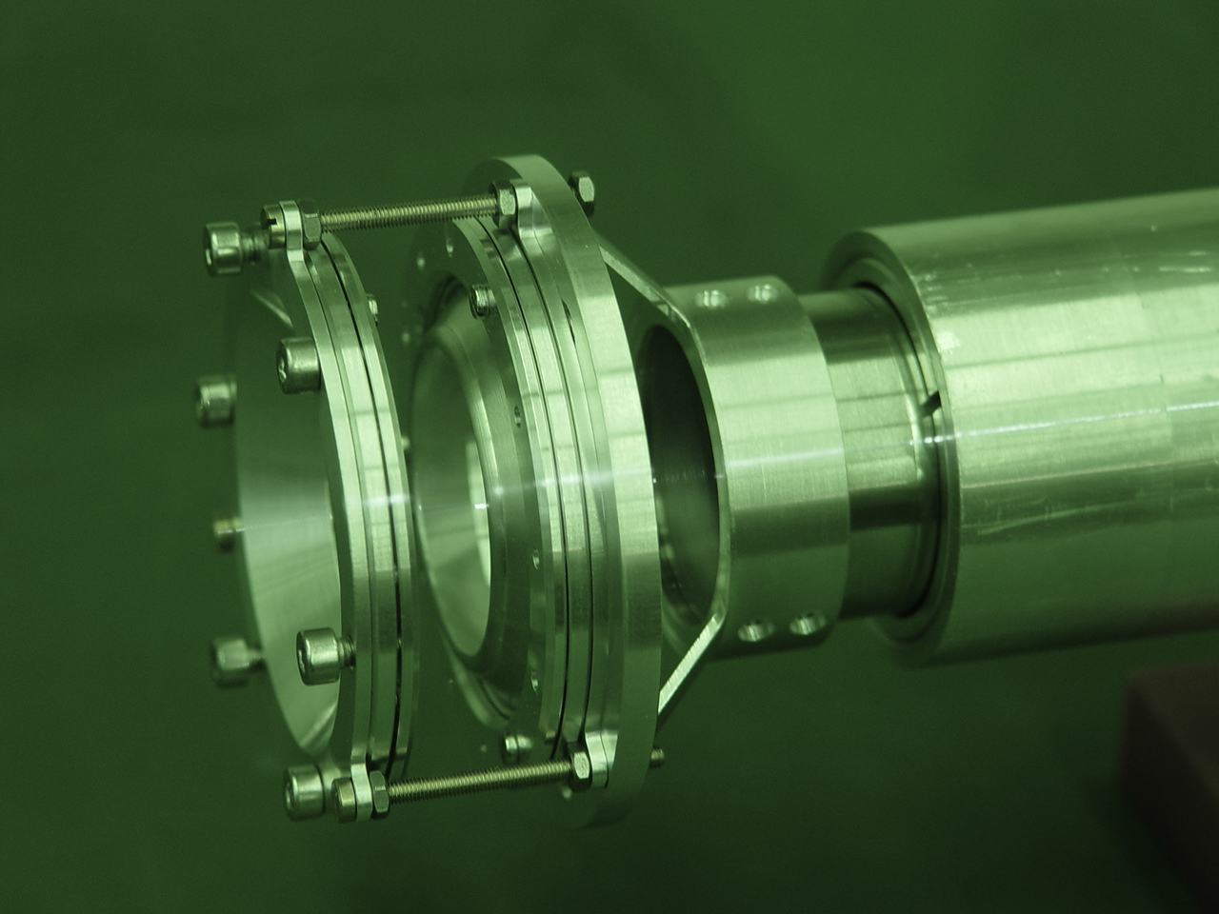
Fig. 7: Example of a plunger apparatus to be used at the NSCL at MSU.

Energy range 2-20 MeV/u:
This energy range is the standard regime where Doppler shift techniques have frequently been used. Therefore, there is a lot of experience available on how to build a dedicated plunger device. The only difference in the case of radioactive beams is the use of degrader foils instead of a stopper foil because it is necessary to track and identify the nuclei of interest with downstream detectors. Also the sizes of the target and degrader foils have to be larger (5-7 cm in diameter) than the standard foils used with stable beams. A first design for such a dedicated plunger device is shown in Fig. 8.
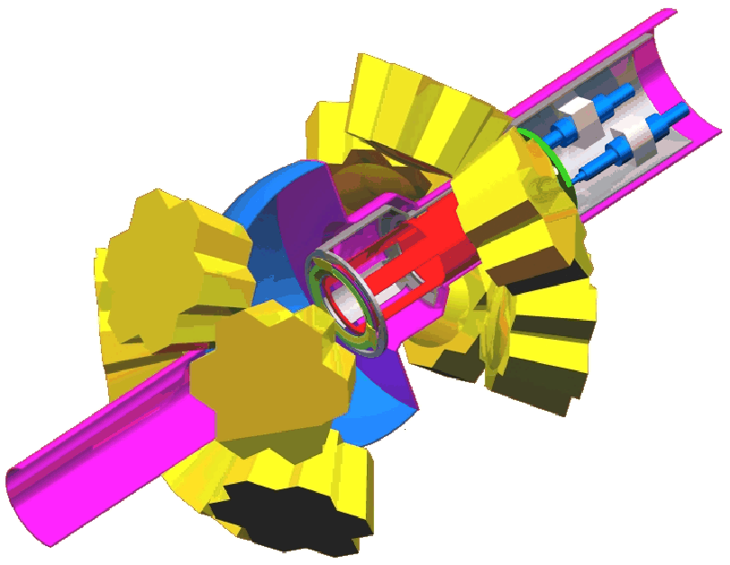
Fig. 8: Plunger set-up for low beam energies. The yellow part represents the EUROBALL cluster detectors used in RISING.

For the final design of the plunger devices all experimental conditions such as beam conditions, detector set-up and beam tracking detectors have to be known. Test measurements have to be performed in order to check the expected features.
With beams from the NESR the existing Cologne plunger used in stable beam experiments can be employed.

Fast timing using scintillator detectors

The ultra fast timing method using fast response scintillation detectors will allow the measurement of level lifetimes in HISPEC in the range from several picoseconds to several nanoseconds. For in-beam spectroscopy at HISPEC, this method is supplementary to Coulomb excitation and plunger techniques, and will be applicable in selected cases, for example to measure short lifetimes below long-lived isomers or when multiple isomeric states are present in the decay paths. The optimal setup will include a mixed Ge-BaF2 array in a 50% to 50% ratio, as well as ancillary detectors. Such measurements will utilize fast timing gamma detectors described in more detail in the DESPEC section.

Charged particle detector arrays for nuclear reaction and structure studies

For nuclear reaction studies a specific HYbrid DEtector array (HYDE) will be developed from gas and silicon detectors. The proposed design will fit the experimental conditions imposed by the beam properties in the Low-Energy Branch of the Super-FRS. To meet the needs of the physics involved in such a study the HYDE detector array will incorporate both gas detectors and very compact and highly segmented silicon strip detectors, based on the Double-Sided Silicon Strip Detector (DSSSD) technology. These devices have successfully been used by nuclear physics groups. However, the conceptual design of the HYDE array relies on improving the quality of the low energy beam with respect to the present situation, especially in the low energy range. The beam diameter should be around 2 cm, and the energy resolution, for energies below 5 MeV/u, should be about 5% of the energy of the beam.

R&D for the project will be carried out during the period 2005-2006. This development will mainly concern design studies for the detector setup and (front-end) electronics. In particular, some effort will be devoted to the development of:
- compact electronics and fast readout with low noise/signal ratio;
- thin gas detectors for the front face of the telescopes;
- development of thin solid state position sensitive detectors (down to 10μm)
- specific beam tracking systems
Research efforts in all these domains are currently being carried out in the collaboration; at Saclay an ASIC chip containing a full spectroscopic chain for 16 channels has been developed (for the MUST-2 Si detector array), at GSI thin diamond films are being used for particle detection and research on dedicated beam tracking systems is being organized in a broad collaboration between GSI, University of Huelva, University of Seville and Centro Nacional de Aceleradores (Seville).
More details are given below in section G “Organisation and Responsibilities”.
The HYDE array can be composed of several detector units, arranged over a barrel configuration of hexagonal cross section and 300mm diameter around the reaction target. Two end caps of 300 mm outer diameter and 50mm inner diameter will cover backward and forward scattering angles. A possible configuration might comprise 12 square detector units of 150 mm x 150 mm to be mounted on the barrel walls, together with 8 sectors on each end cap.
Each detector unit might be composed of a Gas Detector, able to detect low energy reaction fragments, and two silicon detector units, one DSSSD of 40 μm thickness (Energy Loss Detector) and another silicon back counter of 2 mm thickness (Stopping Detector). Gas Detector units may be replaced by thin solid state detectors developed during the R&D stage of the project.
Each silicon DSSSD device is a highly segmented device, composed of 16 strips of 5 mm width at the front side (X direction), and another 16 strips at the back (Y direction). This results in a total of 16x16 discrete detector elements, providing energy and position information for every scattered ion and from each detector unit.

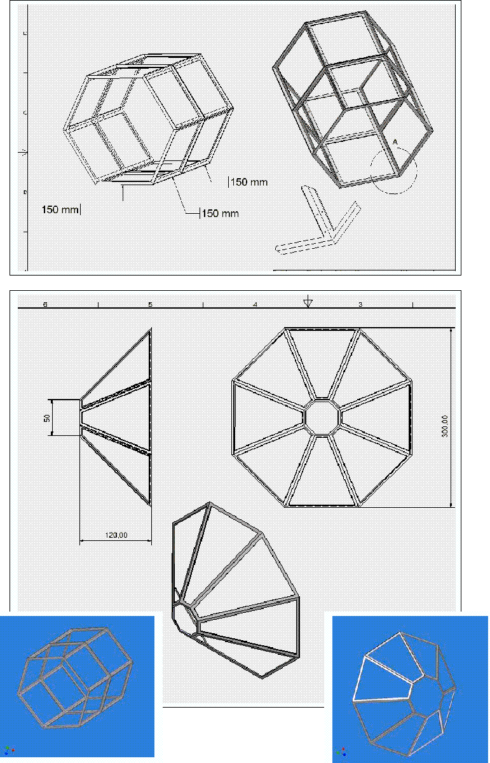
Fig. 9: Mechanical studies of the HYDE detector support.

In this way it is possible to extract information on the angular distribution of particles, with an angular range between 10º to 70º (forward), 110º to 170º (backward) and angular resolution of Δθ <2.0º . For low energy scattering events, the combination of the Gas Detector and the Energy Loss detector will provide particle position, charge and mass identification. Higher energy events should be identified using the same technique in combination with the Stop Detector. DSSSD silicon detectors of different widths and shapes fitting the required specifications are currently produced by several companies (Micron Ltd-UK, Camberra, etc) and used in several experiments at RIB facilities elsewhere. In figure 9 we show some preliminary mechanical studies using octogonal and hexagonal shapes.

Charged particle detectors for nuclear structure studies

For nuclear structure studies at both intermediate (E/A ~ 100 MeV) and Coulomb barrier (E/A ~ 6 MeV) energies, versatile charged-particle detector arrays with different geometries must be constructed. They will operate as ancillary devices for AGATA and in conjunction with other devices such as the plunger described in the previous section and the magnetic spectrometer described in the following section.

Intermediate beam energies:
For experiments at intermediate energies (50-100 A.MeV) a design based on the experience with the existing CATE system detector at RISING will be developed. It will enable event-by-event Z and A identification as well as energy and position information for the fragments reaching the detector systems. At the same time, the system will be sensitive to light-charged particles produced in the secondary reactions at the target or emitted from the secondary fragments. At this time a solution based on (ΔE-) ΔE-E telescopes is favored, comprising one or two layers of single- or double-sided silicon strip detectors backed by an array of CsI elements. The strip detector(s) account for proper positioning of the fragments and particles, the (ΔE-) ΔE-E measurements provide Z, while the total energy, timing, and tracking information of the event will yield A. Experience from RISING plus CATE experiments shows that high-quality beam tracking is crucial to achieve optimal mass resolution.

Using 32x32-strip double-sided silicon detectors of size 6cm x 6cm and a thickness of 500 μm which are readily available today, an opening angle per pixel of ~0.06º can be reached at a distance of 2 m from the secondary target. The silicon detector(s) can be backed by nine 2cm x 2cm square and 3 cm thick CsI detectors. Hydrogen, nickel, and lead ions of 100 A MeV would then leave about 0.7, 500, and 4000 MeV in the silicon layer, respectively, with the corresponding rest energy detected in the CsI modules (see also discussion on electronics below), the thickness of which is determined by the ability to stop 100 MeV protons.

Nine (like for CATE) or thirteen (an additional one on each side) such telescopes will form a wall of ~18 or ~25 cm corner length, i.e., it will cover laboratory angles up to ±2.6º and ±3.6º respectively, when placed at 2 m distance. The central element could be removed if the array were to be used in conjunction with the magnetic spectrograph.
It is envisaged to use different types of silicon detector depending on the type and mass regime of the experiment, while the CsI set-up would remain the same. In connection with a Ge detector array this detector system is expected to meet the criteria for fragment-γ (Coulomb excitation and secondary fragmentation) and fragment-particle-γ coincidences.
It should finally be noted that the CsI elements are (probably) very similar to those used in the EXL project (see there), which will allow joint or coordinated detector (and electronics) developments.

Coulomb barrier energies:

From the past decade there is ample experience from stable-beam experiments of the use of (near) 4π charged-particle detection systems in conjunction with 4π Ge-detector arrays and other ancillary detector systems. The new but central issue for HISPEC will be the event-by-event position determination of the nuclear reaction via beam tracking and possibly kinematical information from the set-up around the target.

a) Coulomb excitation:
The beam-spot size of the decelerated ion beams (at E=5.0±2.5 MeV) has been simulated to be approximately 2.5 cm in diameter. The use of active targets, i.e, silicon or diamond detectors, is probably not feasible, as a typical (heavier) beam is either going to stop or straggle considerably even in the thinnest possible detector layers. If the position of the incoming beam can be defined externally, i.e. in the course of the deceleration process to about 2mm in x and y, Coulomb scattering experiments will be feasible. The position and energy of the (backward) Coulomb scattered beam particles are to be measured in a set of double-sided silicon strip detectors: A CD-type 32x64 detector covering angles from 170º to 150º and a box of four square 32x32 detectors for the angular range from 150º to 90º.

b) Fusion-evaporation reactions:

The use of a sequence of two or three CD-type 32x64 detectors at forward angles will allow for the tracking of evaporated light charged particles. Assuming the particle to come from a well-defined z-position in the direction of the beam, the x and y positions can be estimated for a given event. The significance of this tracking will increase with the number of tracked particles. Alternatively, reactions on carbon or silicon can be quite interesting for the study of neutron-deficient nuclei at or beyond the proton drip line (see above). This may allow the possibility of using the respective position sensitive detectors as targets. The CD-type 32x64 detectors are to be complemented with blocks of 3 to 5 mm thin CsI detector elements for full-energy measurements of the evaporated particles and at backward angles for the largest possible efficiencies.

Note that set-ups similar to those described here are presently being constructed for advanced Coulomb excitation and fusion-evaporation type experiments at stable and radioactive beam facilities (i.e. Rex-Isolde, TIARA/MUST-2 for SPIRAL). Data are expected to be obtained in the near future, which will provide significant practical input into the simulations. In any case, the latter will have to focus on the influence and significance of event-by-event positioning of the incoming radioactive beam.

During 2005 further simulations will be performed for each class of experiments. It is also planned to realize some of the detector elements during 2005 and to test them under real conditions in 2005 or early 2006. The final design and construction will take place over the period 2006--2008.

Electronics:
For experiments at intermediate energies one can expect some ~800 channels for Si and ~120 channels CsI, for Coulomb barrier energies ~300 channels Si and ~200 channels CsI. These numbers clearly call for the use of ASICs, which should process some 32 channels each and comprise at least the appropriate preamplifiers, and eventually shapeing, timing, or pulse-shape circuits (but no advanced logic!). The final designs will also depend on the global data acquisition scheme. The preamplifiers could either be switchable between, for example 25 MeV, 100 MeV and 1 GeV ranges, or different chips with different gains could be used. The other circuits could either be on the same chip with the option of being bypassed in case the preamplified signal is the one of interest, or on a separate chip.

Similar ASIC developments are foreseen for other experiments (DESPEC, EXL etc.) and a common solution will be chosen whenever possible.

Magnetic spectrometer

The experimental techniques implying the use of a magnetic separator are listed below.
- RDT - Recoil Decay Tagging has proven to be one of the most powerful tools to study the nuclear structure of exotic species. Here the reaction product is identified by its decay after a separator. Additional A/q information could improve the background reduction.
- RT- Recoil Tagging uses the Z and A information of the reaction product provided by a spectrometer set-up to obtain spectroscopic information in coincidence with the detected γ-rays in flight.
- DT – Decay Tagging provides spectroscopic information on the decay products of long lived nuclei or isomeric states after separation.
All these methods are proved to be powerful in the study of neutron-deficient exotic nuclei.

Z and A identification after the target can be obtained using dE-E detectors (similar to CATE, R. Lozeva, et al., Nucl. Instrum. Meth. B204 (2003) 678; Acta Phys. Pol. B (2005) in press). Z identification can be obtained by relative energy loss measurements in the dE detector. The mass can be determined by a sufficiently high resolution, time-of-flight measurement. The ΔE/E calorimeter described earlier, together with a transmission/tracking ToF detector system with a time resolution of 50 ps and a flight path length of 8 m, provides these features for low-to intermediate-masses. For higher mass species an additional momentum dispersion ∆p/p provided by a magnetic device is necessary to achieve the desired mass resolution. For background suppression (electro-) magnetic separation is mandatory. At high energies fully stripped ions provide an unambiguous charge state definition. At lower/intermediate energies (5-100MeV/amu) an ionic charge state distribution has to be determined in addition. The ultimate solution is the combination of an ion-optic device providing A/q separation and possibly magnetic focusing in combination with tracking- and ΔE/E detectors.

Various detection schemes are envisaged for the spectrometer/separator at the FAIR low energy branch in conjunction with AGATA for the various reactions to be studied (see Table 1).

- .

For RDT and DT only a separator is needed in most cases as A and Z are fixed by characteristic decay information, although additional information on Z and A of the nucleus under investigation could be helpful for further background reduction. For RT the set-up has to provide A and Z. The reaction schemes used to produce the nuclei of interest are listed in table 1. Forward focused reactions like Coulomb excitation and fusion/evaporation ask for the separator to function at 0°. For binary reactions, such as elastic scattering or transfer reactions the access to angles other than 0º and the possibility to rotate the set-up is required. Exotic beams of high quality in energy definition and in spatial properties provided by the NESR can also be used to employ e.g. high-spin isomeric states for both nuclear structure investigations as well as reaction studies. For the latter in particular separation and/or A/Z identification are essential.

Set-ups like VAMOS at GANIL and PRISMA at LNL operate as tracking spectrometers in combination with γ-arrays (EXOGAM, CLARA) for in-flight spectroscopy. The gas-filled separator RITU at Jyväskylä is used for RDT in conjunction with JUROSPHERE as well as for DT together with the focal plane set-up GREAT. At the velocity filter SHIP decay spectroscopy is performed detecting γ-rays emitted from nuclei implanted into the focal plane detector. The principles of those set-ups are well established. The ingredients needed for tracking spectrometers are sufficient A/q dispersion, a well defined particle trajectory through the device and an efficient and high resolution ΔE/E measurement with an energy resolution of typically 1%.
As an example fig. 10 shows the separation in A/q of the projectile like fragments for the reaction ⁹⁰Zr + ²⁰⁸Pb at 6 MeV/amu and reconstructed masses at PRISMA. The ToF versus position plot shows the various masses well separated in groups for different charge states.

Fig. 10. A/q separation and mass reconstruction for ^{A}Zr produced in the reaction ⁹⁰Zr + ²⁰⁸Pb at 6 MeV/A at PRISMA/LNL (private communication from A. Stefanini).

For intermediate energies (50 MeV/A – 100 MeV/A) the charge state distribution will be reduced by the cut-off at the totally stripped state. Magnetic tracking spectrometers like PRISMA and VAMOS use the high momentum dispersion realized by a rather high deflection angle (e.g. PRISMA ≈ 70°). For the tracking the trajectory reconstruction relies on a precise position and angle definition which requires a position resolution of the order of 1 mm and a precise field mapping of the ion optical elements. In the case of the beam provided by the energy buncher with its relatively wide spatial properties, angle and position of the incident particle, transmission detectors will be used for the beam particles and the species studied . There are various possible solutions. For a small area of the order of a few cm² thin Si-strip-, diamond or even foil detectors with channel plates can be used. For a larger spatial distribution plastic detectors or foil detectors with a multi-wire gas counter for the secondary e⁻ detection, like the SED detectors developed at Saclay (private communication E. Pollaco) can be employed.

In the first stage the existing ALADIN magnet can be used as magnetic spectrometer at intermediate energies. I will be available with minimal additional cost. Its older tracking detectors will be replaced with new more powerful ones.

- Acceptance Tests

Not applicable.

- Calibration (if needed),

No particular problems are foreseen. Gamma-ray detectors will be calibrated with standard gamma-ray sources. Beam detectors (positions and time of flight) will be calibrated at the beginning of the individual experiments, as part of the setting up process of the SuperFRS (as is done at the present FRS).

- requests for test beams [X]

Some parts of the setup will be tested with beams available from the current SIS-FRS complex. Tests might also be performed at stable beam facilities (beam detectors).
B1.2
Sub Project 2

DESPEC : overview

All of the experiments anticipated within this section involve implantation prior to the decay. In most cases this will involve active DSSD systems. There is a need for such a system to correlate implanted ions and subsequent generations of charged particle decays where high rates can be expected. In general such a system will also require high resolution, both for signal to noise discrimination and because the physics (eg 2p decay studies) demands such precision to compare with theory. Decay experiments will be performed using Si detectors in the case of charged particle decay studies, i.e. p, 2p, alpha decay, etc., and different Ge detector set-ups for gamma decay studies.

In nearly all of the setups it will be sensible to incorporate high efficiency and highly segmented Ge detectors in close-packed geometry around the stopping volume for the ions. The segmentation is necessary to compensate for the gamma flash and for ray tracing capability in the case of isomeric decays where correlations with the implanted position are difficult.

In order to avoid the “Pandemonium effect” (caused by the low efficiency of Ge detectors at high gamma-ray energies) in decay studies with high Q values and large beta-delayed gamma branching ratios, complementary measurements with a Total Absorption Spectrometer are foreseen.

A specially important requirement will be the development of modern high efficiency neutron detector arrays for measurements of beta delayed or direct one or two neutron emitters.

Complementary measurements of transition probabilities based on half life measurements will be possible with the fast timing technique using BaF detectors and dedicated electronics.

Electromagnetic moments of isomeric states will be measured using the TDPAD method.

Lastly, it is important to emphasise that the varied nature of these experiments means that a flexible, modular approach is desirable to devote the experimental setup in an optimum manner to the requirements of individual experiments. Another advantage of the modularity is the possibility to install part of the set up at the focal plane of the magnetic spectrometer for decay tagging purposes.

a) Simulations
- of the detectors

The following detector systems will be necessary:

- Implantation Decay Detector. Double-sided silicon strip detector (DSSD). As mentioned before there is already considerable experience in using this kind of implantation detectors in combination with Ge detectors.
- A modular high resolution γ-detection array (simulations in progress)
- A modular neutron detector array (there are plans to test these detectors at several neutron facilities in Europe)
- A fast timing set-up (realistic tests at the beam line in Studsvik are foreseen)
- A Total Absorption Spectrometer (simulations are in progress)

- A TDPAD set-up including a magnet up to 2.2 Tesla with homogeneity of better than 10⁻⁴ over a surface of 5x5 cm² (along the beam axis). Simulations for the optimal detection set-up with high-purity Ge- cluster detectors are in progress for g-factor and Q-moment measurements. First measurements of g-factors are expected to be run in the RISING stopped beams campaign starting late 2005, while first fragment Q-moments will be measured at GANIL in the near future.

Simulations or plans for realistic tests are already in progress for most of the components of the DESPEC set-up. On top of that, as in the case of HISPEC, the DESPEC collaboration has plans to participate in the stopped beam campaign of RISING to perform experiments which, apart from the intensity factor, will be very similar to the future S-FRS experiments.

ii) Beam

The DESPEC setup will use the same set of beam tracking detectors as in HISPEC (see corresponding HISPEC section).

  - Radiation Hardness (of detectors, of electronics, of electrical components nearby) [ X]

The only part of the proposed equipment that will suffer from the accumulated radiation is the
DSSDs

We would expect detector performance degradation at doses of ~5x10⁷/cm² and irreversible damage at doses of ~5x10⁸/cm². With a dose rate of 10⁴ pps uniformly distributed across an area of 300cm² we could expect a lifetime ~ 5x10⁸ x 300 / 10⁴ ~ 1.5x10⁷ s ~ 173 days which would probably correspond to experiments performed over a 3-5 year period.

Performance degradation can be minimised by operating the detectors at -20 deg C. The DSSDs would need, in any event, to be housed in a light tight, EMI/RFI screened metal enclosure: this enclosure could be filled with dry, inert gas to prevent condensation on the DSSD surfaces.

Modern CMOS production processes are generally considered intrinsically radiation hard (especially in comparison to older >1μm CMOS processes) and ASICs should have lifetimes comparable to the DSSDs. Some degree of radiation shielding for the instrumentation will also be considered.

  - Design
and
  - construction,

The beam tracking detectors described within HISPEC will be used for DESPEC before the implantation detector. The main goal is to identify the implanted ions, since about 10-20% of the ions are destroyed in the slowing down process within the energy buncher. In addition, full control of the implantation process can be achieved by knowing the energies and paths of the individual ions.

Implantation Decay Detector: Double-sided silicon strip detector (DSSD)

Technical Overview
We propose to directly implant exotic nuclei, produced by fragmentation or fast fission, from the Super FRS into a stack of highly segmented, large area, thick DSSDs arranged in close geometry.
Subsequent radioactive decays (beta-delayed gamma, beta-delayed neutron, beta-delayed proton, 1 proton, 2 proton, alpha) will be measured and position-correlated with previous implants.

The high segmentation of the DSSDs minimises the effects of random correlations between successive implants and decays, and between implants and the decay of long-lived activities.
In addition, the detectors would be used to tag gamma decays from short-lived isomers.

The image plane is up to 24cm x 8cm (width x height) and implantation rates of <10⁴ pps are expected. The stopping detectors will be surrounded by gamma (Germanium, NaI, BaF2 etc.) and/or neutron detectors in close geometry for maximum efficiency and to minimise the cost of these detectors.

Detectors
The largest silicon strip detectors currently available are manufactured from 6" diameter wafers, thus implying a maximum detector size of ~ 10cm x 10cm. Commercially available silicon strip detectors manufactured from 6" wafers are currently limited to thicknesses ~ 0.3mm. However, Micron Semiconductor Ltd (UK) are currently (2004/Q4) processing the first development batch of 1mm detectors using 6" wafer technology: on the timescale of this project we can reasonably expect that 1mm detectors manufactured using 6" wafer technology will be commercially available. Thick detectors will provide a measurable energy loss for high energy betas and the stack of thick detectors the stopping power to measure the energy deposited by the betas. We envisage 24cm x 8cm detectors comprising three 8cm x 8cm detectors within a common PCB support structure. y-axis strips of adjacent silicon wafers would be daisy-chained together to minimise the number of channels and the spacing between adjacent silicon wafers.

A stack of eight 24cm x 8cm DSSDs in close geometry would be used: the energy of the implants being adjusted to achieve implantation within the stack. The close geometry and stopping power of the stack would be used to measure the energy deposited by the beta particles with high efficiency.
In addition to the DSSDs, we would envisage additional upstream and downstream detectors comprising single elements of 24cm x 8cm of 2mm thickness which would provide dE, veto functionality and additional stopping power for high energy betas (see fig.11).
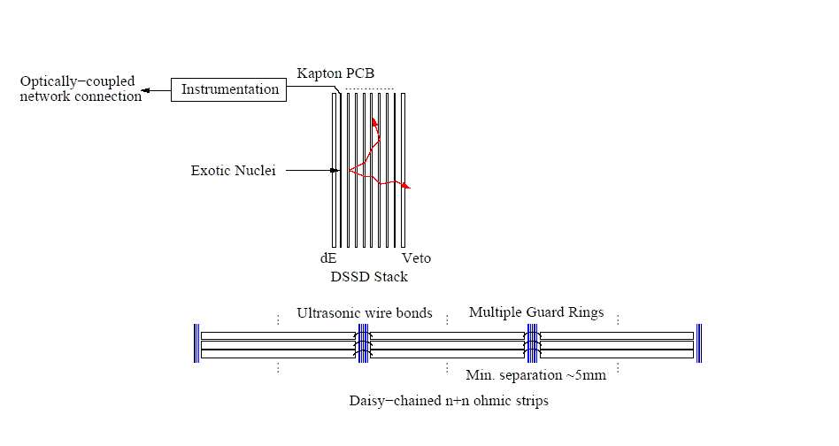

Fig. 11: Schematic of DSSD & stack

The required segmentation of the silicon strip detectors is determined by the implantation rate, the maximum half-lives of interest and the need to reduce the input loading (capacitance and leakage current) of the instrumentation to achieve good noise (low threshold) performance. We assume each DSSD consists of 128 p+n junction and 128 n+n Ohmic strips which means that each 24cm x 8cm detector comprises 3x128x128=49152 quasi-pixels.

The number of electronic channels are counted in the following way
The number of p+n junction strips would be 8x3x128=3072 and
the number of n+n ohmic strips would be 8x128=1024: total 4096 channels.

Instrumentation
Very high energies (~GeV) are deposited by the radioactive ions as they stop in the DSSD stack.
Subsequently we wish to measure decay events with energies ~MeV for protons and alphas and an energy loss (dE)
of a few hundred keV in the case of betas. This represents an extremely large dynamic range and demands a very low energy threshold, of the order of a few tens of keV.

We propose to instrument the DSSD stack with a.c. coupled, bipolar, transistor-reset preamplifiers (see fig.12). The preamplifier outputs are connected to Schmitt triggers which reset the preamplifier when energies (>50MeV say) are detected. This provides a practically achievable dynamic range and rapid recovery to detect subsequent short-lived (> ~μs) 1p, 2p and alpha decays. This means that the DSSD stack will not measure the energy deposited by the high energy implants: the Schmitt triggers will be used to provide a hit pattern for the high energy implants so that they may be tracked into the DSSD stack.

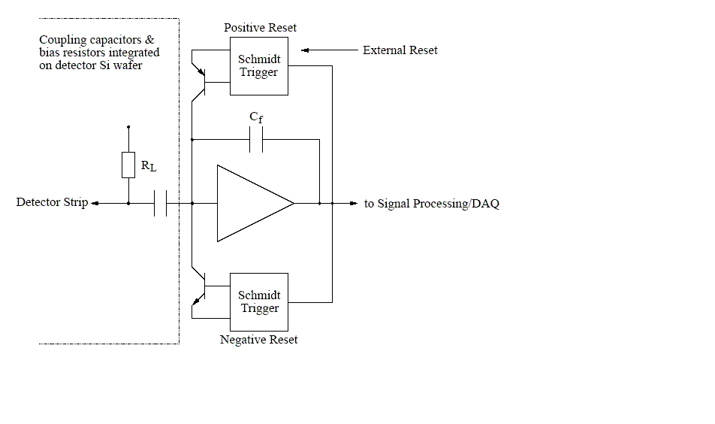
Fig. 12: schematic of DSSD instrumentation

To achieve good noise performance the instrumentation needs to be located close to the DSSDs.
The space available for the instrumentation is very restricted by the gamma and/or neutron detectors.
The number of channels required mandates integrated instrumentation with integrated readout on space, power and cost grounds. We propose to develop an application specific integrated circuit
(ASIC) for this application. This implies that bias resistors and a.c. coupling capacitors will need
to be integrated onto the DSSD silicon wafers - this capability is already well established for 6" wafer technology.

Connections between the DSSDs and the instrumentation will be via high-density, flexible kapton PCBs which can integrate ground/screening planes and exploit ultra-low profile, high-density PCB connections.

A modular high resolution γ-detection array for DESPEC

Technical overview

We propose a highly flexible and modular high-resolution γ-ray detection array consisting of 24 stacks of planar double-sided Ge strip detectors (see table 4). These modules can be arranged in different geometries optimized to the different types of experiments envisaged at DESPEC. The high granularity of the Ge detectors is important in order to assure high efficiency of the array during the "prompt flash" of radiation associated with the implantation of high energy ions into the focal plane catcher and thus to allow the study of decays with very short lifetimes. In addition the granularity allows us to track the origin of the detected γ-ray. This tracking allows us to associate an implanted ion with its decay γ-rays (excluding random coincidences with background radiation produced upstream) and, hence, enables long decay times to be studied at high implantation rates. In addition the position information can be used to measure angular correlations and polarizations. The requirements for such a detector system are summarised in table 5.

a) b)
8x24 cm²
8x8 cm²
8x24 cm²
8x8 cm²

Fig. 13: Possible geometries of the proposed Ge array consisting of 24 detector units.

Detectors
For the moment we will base our proposal on a detector element produced at the FZ Jülich by D. Protic et al.. This element has a size of 72 × 72 mm² and a thickness of 20 mm. Due to a guard ring around the detector the active surface is 68 × 68 mm². A strip pitch of 8.5 mm leads to 8 × 8 pixels per detector element and requires 16 channels of read-out electronics. Applying simple pulse shape analysis it is expected to be possible to obtain a depth resolution of about 7 mm, resulting in 192 voxels per detector element. A stack of three such elements mounted in a common cryostat forms a detector unit. The full array consists of 24 of these detector units which can be arranged in different geometries optimized with respect to the experimental conditions. The array shown in Figure 13a) consists of two rings of 12 units each on both sides of the active catcher in the focal plane which is assumed to have a size of 8x24 cm². This geometry which covers a total solid angle of Ω_{tot} = 68% of 4π, will be used in standard β-decay studies. The simulated photopeak efficiency is P_{ph}=21.7% and the
peak-to-total ratio is P/T=0.43. In some cases, however, in particular when long decay times are involved, it might be desirable to study the isotope of interest under clean conditions. In this case, the achromatic mode of the Super-FRS would be used to separate the isotope of interest specially from its isobaric neighbours and hence it would be sufficient to employ a catcher of reduced size, for example 8x8 cm². Then, a more compact Ge setup (see Figure 13b)) covering a larger solid angle (Ω_{tot} = 86% of 4π) with a corresponding higher efficiency could be used to study the rare decays at low implantation rates. Finally, many experiments will aim to study β-delayed neutron emission – a common process for exotic neutron-rich nuclei. In this situation neutron detection is of course mandatory. The full γ-ray array (Fig. 13a)) could then be placed on one side of the focal plane leaving the other free for neutron detectors. The total solid angle covered by the Ge in this case is Ω_{tot} = 41% of 4π.

Table 4: Features of the proposed stacked planar strip array.
Detectors | 24
Planar elements per detector unit | 3
Strips per element | 8 + 8
Electronics channels | 1152
Effective number of voxels | 13824

Table 5: Requirements for the DESPEC high-resolution γ-detection array.
Energy range | 20 keV – 10 MeV
Full energy efficiency at E_{γ} = 1 MeV | > 15%
Full energy efficiency at E_{γ} = 10 MeV | > 3%
Efficiency reduction 10ns after prompt flash | < 10%
Efficiency reduction at M_{γ} = 15 | < 10%
Energy resolution for E_{γ} < 100 keV | 1.0 keV
Energy resolution for E_{γ} > 1 MeV | 0.2%
P/T ratio at E_{γ} = 1 MeV | > 50%
Time resolution for E_{γ} > 100 keV | < 10 ns
Decay time range with respect to implantation | 10 ns – 1 s
Tracking of γ-ray origin accuracy at E_{γ} = 500 keV | < 10°
Polarization sensitivity at E_{γ} = 500 keV | > 20%
Unsuppressed trigger rate capability | 10 kHz

Modular high-efficiency Fast-Timing Array

Fast Timing Detectors

The ultra fast timing method, using fast response scintillation detectors, is a well-established method to measure level lifetimes in the range from a few picoseconds to several nanoseconds. The main application of the method is for the exotic nuclei populated in beta-decay and via de-excitation of microsecond isomers at DESPEC, where it is currently the only available method in the aforementioned time domain. High precision results can be obtained at the level of intensity as low as 1-5 particles/s for exotic nuclei.

The fast timing measurements will be performed via triple beta-gamma-gamma coincidences for beta decays and via double coincidence gamma-gamma for the long-lived isomeric states. For very weak sources some important lifetime information will be obtained from double coincidence beta-gamma events. The information on level lifetimes is obtained from the time-delayed spectra recorded in a pair of fast response beta and gamma, or gamma and gamma scintillators. A third coincidence with a Ge detector will ensure a precise selection of the decay path and a drastic simplification of the observed energy spectra. At present, BaF2 crystals represent the best fast scintillator for the detection of gamma-rays with the energy resolution of about 9-10% at 661 keV and the time resolution of about 140 ps FWHM for a pair of detectors measured for prompt gamma rays at 1 MeV. However, there are new scintillators under development, which have a much better energy resolution of about 2.7% at 661 keV, at the expense of slightly worse time response. In some applications it will be critical to have a significantly better energy resolution than 9%. However, as of now the new scintillators cannot be produced in the sizes and shapes suitable for the fast timing at DESPEC. We expect this problem to be overcome in the next few years. The proposed construction of the fast timing detector will allow for the possible exchange of BaF2 with another type of crystal, leaving the rest of the detector and electronics intact.

Experimental Setup

For beta-decay studies, the standard triple beta-gamma-gamma coincidence setup will include a mixed array, where 50% of the solid angle is covered by Ge- and 50% by BaF2 detectors. For the fast timing measurements on very weak sources, the double beta-gamma coincidence setup will include a complete BaF2 array. Finally for the long-lived isomers, one would use a mixed Ge-BaF2 array with 10% to 90% ratios respectively, and no beta-detector.

For the triple coincidence beta-gamma-gamma spectroscopy at DESPEC we expect a precision of about 10 ps for the centroid shift measurements, and the lower limit for half-lives measured by the slope method to be about 50 ps. Moreover, we expect to perform measurements initially with the beam intensities down to 10-20 particles/s at the implantation point. In some cases important level lifetimes could be measured via double beta-gamma coincidences using the full BaF2 array for weak sources down to about 1 particle/s.

In the initial stages of the BaF2 array development, one can foresee an array of individual well-shielded fast timing detectors to be used. Further increase in the efficiency could be obtained if closely-packed unshielded crystals can be used. However, for the fast timing that remains an open and technically challenging question that needs to be addressed.

The complete fast timing BaF2 array will consist of 12 cluster fast timing detectors, to be used in 2 rings of 6 clusters each, with each cluster to include 4 individual fast timing detectors. One ring will represent about 50% of the available solid angle for gamma detectors. Besides the design, testing and construction of the fast timing clusters one has to perform test measurements using wide beams, where the Super-FRS beam profile is simulated, and fast timing measurements with wide beams can be run and compared to the "narrow beam" scenarios.

The Fast Timing Array Collaboration has already about 20 standardized large-volume fast timing BaF2 detectors and fast timing electronics, which is sufficient to start first test experiments at the present FRS. A beamtime application will be made in 2005 for the test experiments in 2006-2007.

Neutron Detectors

Delayed neutron emission in beta decay is of fundamental importance in astrophysics for understanding the r-process nucleosynthesis paths occurring in supernova explosions. The nuclei involved in the r-process are highly neutron-rich and thus extremely difficult to produce in nuclear reactions. For this reason, all nucleosynthesis models to be developed in the mid term future will have to be based on theoretical calculations of the neutron emission probabilities. In this aspect, the FAIR facility represents a big step forward since it will provide access to many new r-process nuclei and get much closer to the r-process in many other cases. This will allow us to extend and validate the theoretical nuclear models for isotopic species far from stability.

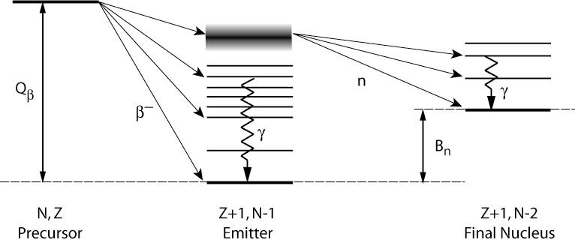

Figure 14. The beta delayed neutron and gamma ray emission process.

Beta delayed neutron emission is also important in terms of nuclear technology, since it is one of the key features for the safe operation of actual nuclear power plants. Moreover a detailed design, safety assessment and operation of more advanced reactor concepts such as Accelerator Driven Systems (ADS) or Fast Reactors, proposed for the transmutation of Nuclear Waste, will certainly benefit from improved nuclear databases. Delayed neutron data obtained at FAIR will allow us to complete the international nuclear data libraries and serve as input to more accurate delayed neutron summation calculations and more detailed Monte Carlo simulations.

As shown in Figure 14, the beta-delayed neutron emission does not necessarily leave the final nucleus in its ground state but in excited states, which immediately de-excite via gamma ray emission. Indeed, valuable and complementary information on the nuclear structure of both the final and the emitter nuclei is obtained with the combined detection of the neutron and gamma rays. Thus, the goal of an ideal beta delayed neutron experiment is to measure individual neutrons with high efficiency, good energy resolution and in coincidence with the gamma rays measured with a high resolution gamma-ray set-up. Such an experiment would allow the reconstruction of the complete energy released in the decay chain. However, experimental difficulties arrive when trying to detect neutron and measure its energy with high efficiency and low energy threshold.

Large efficiencies up to 30% can be achieved with moderation-based 4π detectors over a broad neutron energy range from meV up to MeV. They are the optimal choice for measurements of integral quantities such as the total neutron emission probability. However, they have some limitations due to the underlying detection mechanism: first a neutron is moderated inside a large volume of hydrogen-rich material (like a polyethylene matrix or a NE323/BC521 ¹⁵⁷Gd loaded liquid scintillator), then it is converted via typically ¹⁰B(n,α)⁷Li, ⁶Li(n,α)³H, ³He(n,p)³H or ¹⁵⁷Gd(n,γ)¹⁵⁸Gd reactions and last, the secondary α, p or γ particles are detected. Clearly, the information on the initial energy is lost (or highly degraded) after the moderation, with the exception of residual time/space correlations. Furthermore, the detection of the neutron takes place typically 10 to 100 μs after its emission, thus requiring the use of long coincidence time windows.

For these reasons, alternative detectors are necessary for measuring the neutron energies. A much faster setup for measuring the neutron energies can be designed with NE213/BC501 liquid scintillators. Using the detection of the beta particle as a trigger signal, the energy of the neutron is reconstructed by means of time of flight (TOF) after detecting its first elastic interaction with the detector, most likely as a proton recoil. A compromise between the flight path, the detector thickness and the solid angle covered can be found to reach acceptable energy resolution and efficiency values. Furthermore, such a setup can be easily combined with a high resolution gamma ray detection setup for measuring the complete beta-neutron-gamma (BNG) decay chain. The drawbacks are the rapid drop of the detection efficiency below neutron energies of 200 keV and the non negligible gamma ray sensitivity of the scintillators. The latter has to be suppressed by applying neutron-gamma discrimination techniques based on the pulse shape analysis.

Detectors proposed

We propose two kinds of experimental setup for performing complementary beta delayed neutron measurements:

- A moderation based 4π neutron detector for measuring neutron emission probabilities in the range between 1 meV and several tens of MeV.

We propose a setup similar to the NERO detector at MSU [http://www.nscl.msu.edu/tech/devices/nero/tech.html]. Such a system seems to be preferable to others based on NE323/BC521 liquid scintillators due to its much lower gamma-ray sensitivity, in particular, to the time related gamma ray background as well as the bremsstrahlung radiation emitted during the implantation of the ions. The system will be used for investigating very exotic species with very low production, where high efficiency is necessary. Its characteristics are described in Table 6 but basically, it will consist of three rings of position sensitive proportional counters (one of ³He and two of BF₃ tubes) around an inner longitudinal hole for the implantation/beta detector.

Table 6. Characteristics of the 4π neutron detector.
Position sensitive ³He counters 2.5 cm Φ x 100 cm length and 6 atm pressure | 16 detectors forming a ring at 15 cm radius from the center
Position sensitive BF₃ counters 5 cm Φ x 100 cm length and 1 atm pressure | 44 detectors forming two rings of 20 and 24 detectors forming two rings at 20 and 25 cm radius, respectively.
Polyethylene matrix | 80 cm x 80 cm x 100 cm with an inner hole of 25 cm Φ for the implantation setup.
Solid angle | 80% of 4π
Total efficiency (1 keV – 10 MeV) | ~30%

The neutron detector will be operated in coincidence with beta particles detected by a Double Sided Silicon Strip Detector (DSSSD) where the ions will be implanted as described earlier. The identification of the isotopic species will be based on the position where the beta particle is detected. Due to the long moderation times of the neutrons inside the detector, a large time window of 10 to 100 μs will be necessary to establish the coincidence. This introduces a limit on the acceptable average counting rates during the experiments of 10⁴ - 10⁵ disintegrations/s. Lastly, the position of the neutron interaction (radius and longitudinal coordinate) will be recorded and a gross value for the initial neutron energy based on a time/position/moderation analysis will be obtained.

Due to the 4π geometry of the setup, such a detector will not be used in combination with a gamma-ray setup.

- A 1π array of NE213/BC501 liquid scintillators for measuring the neutron emission probabilities for neutron energies in the range between 200 keV and several tens of MeV, the neutron energies by means of time of flight and gamma rays in coincidence with the 2π configuration of the Ge array discussed in this report. Same type of detectors were used in connection to the EUROBALL Ge-array (J. Ljungvall, M. Palacz, J. Nyberg, Nucl. Intr. and Meth. A528 (2004) 741; O. Skeppstedt et al. Nucl. Intr. and Meth. A421 (1999) 531).

The setup will consist of 30 NE213/BC501 liquid scintillators covering a 1π solid angle. The front face of the detectors will be placed at 70 cm from the DSSD implantation setup. The DSSD will be used for identifying the isotopic species through its implantation point as well as a start signal for the TOF neutron energy measurement. Despite the high intrinsic time resolution of both the DSSD and the liquid scintillator, variations in the flight path due to the variation in the implantation point and the interaction depth will lead to an overall neutron energy resolution of 18%.

Number of liquid scintillators and distance | 30 detectors at 70 cms
Realistic energy threshold | 200 keV (sensitivity to neutrons of 500 keV or more)
TOF 1 MeV neutrons | 51 (9) ns
TOF 10 MeV neutrons | 16 (3) ns
(TOF gammas) | 2.5 ns
Time resolution | 1 ns intrinsic, 18% due to depth of interaction
Solid angle | 25 % of 4π
Intrinsic efficiency | ~60%
Total efficiency (200 keV – 10 MeV) | ~15%
Table 7. Characteristics of the TOF neutron detection array.

It is planned to use the detector in combination with the high resolution Ge array to measure the complete BNG decay chain.

Research and Development

Detailed Monte Carlo simulations will be performed for the optimisation of the final detectors. In parallel, small scale prototypes will be built, assembled and tested at different neutron sources for the assessment of their performance, validation and benchmarking of the simulation tools and development of realistic analysis software.

In addition, alternative solutions to the commercial analogue electronics foreseen at the present time will be investigated. In particular, the development of the preamplifiers, pulse shape circuits at the laboratories involved or an innovative solution based on fast digitiser boards programmed with pulse shape analysis algorithms.

Table 5: Characteristics of the neutron detection set-up

Total Absorption Spectrometer (TAS)

The goal here is to build a spectrometer which will act as a calorimeter for the gammas emitted after the beta decay. This kind of measurement is complementary to those measured with the High Resolution Gamma Array and with the neutron and proton detectors when applicable. Far from stability, when the Q-values are very high, the high level density induce a fragmentation of the gamma deexcitation that includes not only fragmentation of the beta feeding into many levels populated in the decay but also fragmentation of the gamma intensity in many possible cascades. This, together with the limited intrinsic efficiency of the Ge detectors might cause big losses in the measurement of the beta delayed gamma intensity when only Ge detectors are used.
In order to measure the beta feeding, and consequently the beta-strength properly, one has to use a Total Absorption Spectrometer (TAS), a spectrometer sensitive to the whole gammas cascade energy rather to the individual gamma rays. The groups involved in this part of the set-up have experience in building such kinds of detectors for beta decay studies using single crystals of NaI of large dimensions, or several BaF crystals covering 4π.

However here we address a particular difficulty namely to measure the gamma cascades when the decay via beta-delayed neutrons can compete with the beta-delayed gammas, as in the example shown in the previous figure 14. In this case the neutrons will also interact with the scintillator producing in most cases gamma capture after some moderation time.

We think, however, that the timing between the prompt gamma interaction with the crystal and the neutron moderation time should allow us to discriminate between the two kinds of emitted radiation using a narrow coincidence gate. The performance of such a device can be tested with the already existing BaF (IFIC-Univ of Surrey) at present facilities such as IGISOL or ALTO.

A second difficulty arises from the fact that the gamma de-excitation after the neutron decay will be indistinguishable from the rest of the gamma rays.

This problem can be solved in the following way. We plan to measure the neutrons in coincidence with the gammas with the set-ups described above, which means that these undesired events can be measured accurately with the alternative set-up, and could be detected as a contaminant in the present measurement. This imposes another condition in the TAS, namely, it has to have enough resolution to recognise and be able to subtract these undesired gammas. An ideal new material in that respect is the new LaBr with 2% possible resolution. Moreover, this scintillator has an intrinsic time resolution < 1ns which could help to discriminate between neutrons and gammas by TOF. We are aware of the plan at R3B to construct such a calorimeter with 30 cms internal radius, discussions are in progress at the moment in order to conclude if such calorimeter could be used at both experiments setups.

In conclusion we propose a TAS of cylindrical shape of NaI crystals with a large hole to accommodate the implantation detector. Internal radius 5 cms external radius 30 cm and 50 cms length and investigate in the meantime the possible use of new materials such as the LaBr.

Electromagnetic moments of isomeric states using TDPAD set-up.

Nuclear magnetic dipole and electric quadrupole moments are very sensitive probes of the intrinsic structure of nuclear states. Nuclear moments allow the probing of the nuclear wave function, since only one state is involved in the calculation of the expectation values of these observables. Measurements of g-factors can serve as stringent tests of spin and parity assignments, especially in regions far-from-stability where such assignments are often based on systematics and theoretical predictions. On the other hand, the evolution of the shells relates closely to the nuclear deformation, as is easily seen from the Nilsson diagram. Thus the sudden appearance of low-lying intruders is usually referred to the onset of deformation and phenomena of shape coexistence. The measurement of the quadrupole moment is of particular and complementary interest since it directly probes the nuclear deformation.

Numerous new short-lived (> 100 ns) isomers in various regions of the nuclear chart have been recently discovered in heavy-ion fragmentation reactions. The super-FRS will provide the unique possibility to perform measurements of electromagnetic moments on isomeric states that are not accessible by any other means.

The goal is to build a dedicated set up for measurements of electromagnetic moments (g factors and quadrupole moments) of nuclear isomeric states, using the Time Dependent Perturbed Angular Distribution (TDPAD) method. For g-factor studies, this requires a magnet with a field of up to several Tesla and with high homogeneity in a large volume (large beam spot) + at least 8 Cluster Ge-detectors used in RISING in a ring-like structure around the magnet (see Figure 15). Pairs of detectors, placed at angles between 75° - 105° with respect to each other, will provide the R(t) signal from which the g-factor is deduced. Such a setup will be used in the stopped-beams campaign of RISING at the FRS. For quadrupole moment measurements no magnetic field is needed. Here the quadrupole interaction is induced by implanting the isomeric beam in a special stopper crystal (preferentially a large single crystal, but also polycrystals can be considered) with an electric field gradient. The R(t) function is again deduced from pairs of Ge-detectors (similar angles between the two as in previous case are needed), but now a ball-like structure could be considered. This needs further simulations, but a set-up like AGATA could be used for such measurements.

Figure 15: Artistic and technical views of the magnet and detector set-up for g-TDPAD measurements, as planned to be used at the FRS within the stopped-beams campaign of RISING.

The super-FRS at GSI will provide intense high-energy (100 – 200 MeV/u) fragment beams. With beam intensities of 100 isomers/s for exotic isomers, this will be a unique facility for studies of isomeric moments in nuclei with mass A>80. Nowadays such experiments have been successfully performed at intermediate energies (fragments ~ 50-100 MeV/u) at the LISE fragment separator at GANIL. At such energies one is limited to projectiles with mass number (A_{max} ≈ 80), because the fragments easily pick-up an electron which destroys the alignment of the fragment spins. In order to approach higher masses one needs to utilize relativistic beams. Such experiments are planned for the stopped beam campaign of RISING at the FRS at GSI (with nuclei around A~100-130). Our experience from these studies will be very valuable in optimizing the design of the set-up for the future facility.

The spin alignment of fully stripped projectiles produced in the high-energy fragmentation or fission reactions (primary beams of > 700 MeV/u are ideal for this) is a crucial ingredient of these measurements. In order to keep the fragments fully stripped up to the implantation point (after passing several degraders and particle identification detectors), it is important that the fragment beam energy remains above 80 MeV/u for nuclei around A~80, above 150 MeV/u for nuclei around A~130 and above 200 MeV/u for nuclei around A~200. Therefore, the energy buncher system, to be developed for the high-resolution measurements behind the FRS, would preferably work in an energy region up to at least 200 MeV/u. This energy buncher will not only allow us to provide a better beam quality (highly desired for angular distribution measurements), but also will also help to avoid the gamma-flash that comes with the slowing down of the high-energy fragment beam.

- Acceptance Tests
(not applicable)

f) Calibration (if needed),

Standard gamma sources will be used.

- requests for test beams

Some parts pf the setup will be tested with beams available at the current SIS-FRS. In this cintent the RISING stopped beam campaign will help also to develop parts of DESPEC. Simpler test will also be performed at stable beam facilities.

B. 2. Trigger, DACQ, Controls, On-line/Off-line Computing

The HISPEC and DESPEC experiments will have several concurrently
running data acquisition systems, each of them serving different detector
subsystems. Experiences in using data acquisition systems of this type, are currently gained at the RISING setup.

The beam tracking and identification detector subsystem, which is
part of the beam line of the Low-Energy-Branch of the Super-FRS will
use the standard NUSTAR data acquisition system (DACQ). The estimated
count rate of these detectors is up to 10 MHz, with up to 100
parameters to readout in each event.

The various detector subsystems located around and after the secondary
target position will use their own dedicated data acquisition
systems. Most of these systems will be built specifically for
HISPEC/DESPEC, while others, like the one for AGATA, will use systems
that need to be integrated into the HISPEC/DESPEC setup.

The counting rates and data rates of the detector subsystem around and
behind the secondary target will vary considerably depending on the type of
experiment. Detailed simulations of different types of experiment
and detector setups will be performed in order to get accurate
estimates of these rates, which are needed for designing adequate
electronics and data acquisition for the different detector
subsystems.

At present the plan is to have no overall common hardware trigger for
the HISPEC/DESPEC experiments. Each detector subsystem will produce an
accurate time stamp, which is used when merging the data from the
different subsystems. The possibility of using no common trigger needs
to be investigated carefully. The high rate in the up-stream beam
tracking and identification detectors would lead to very large data
rates, if no common trigger is used. llike e.g. AGATA, will not be able to deliver a signal fast enough to

Some of the detector subsystems will produce and use a local trigger
signal, which is used for that particular subsystem. Other subsystems
will run totally triggerless in so called total data readout mode. In
this case each individual detector in the subsystem will run in
singles mode and its data will contain a precise time stamp in
addition to the detector data.

Most of the front-end electronics for the various detector subsystems
will be fully digital, i.e. the preamplifier or photomultiplier
signals will be digitized and pre-processed by hardware and software
located near the detector. The digital data will then be transmitted
optically to the data acquisition systems located far away from the
detectors. Some special detector subsystems, e.g. ultra-fast timing
with BaF2 detectors, may still need to use conventional, analog front-end
electronics.

Special care must be taken in the design of the infrastructure for
the HISPEC/DESPEC detectors and front-end electronics. The various
HPGe detector subsystems used for high resolution spectroscopy
need to be carefully earthed in a noise free environment.
Adequate systems for slow control and monitoring of detector bias,
LN2 cooling, heat and power consumption of detectors and electronics, etc.
must also be designed and built.

The requirements for the on-line and off-line computing are very similar for HISPEC and DESPEC and will be coordinated within the NUSTAR analysis software group. The on-line monitoring and analysis will be almost as complex as the later off-line analysis. The basis for the on-line software has already been implemented at RISING. Multiple conditions can be set on incident beam particle, outgoing particle, timing, etc., various corrections can be made like gain matching, Doppler correction taking into account the kinematics, efficiency, etc. and the gamma-ray spectra created can be visualised and analysed on-line

B.3. Beam/Target Requirements

  - Beam specifications: (focus, intensity, halo tolerance, beam species, beam energy, Spill Length, CW or pulsed mode)

The characteristics of the beam after the energy buncher serving all experiments in the low-energy branch have been simulated. Measurements performed using the FRS confirm the accuracy of these simulations.
HISPEC/DESPEC will run in continuous beam mode. Predominantly highest primary beam intensities and duty cycles optimized for highest integral yield are required. The extraction time of the primary beam from SIS is determined by the maximum acceptable counting rate in individual detectors, therefore it is experiment dependent. We expect that it will vary between 1s and 20s.

High quality Rare Isotope Beams from the NESR: for isotopes with a half life of at least a few seconds excellent beam quality at Coulomb barrier energies is provided by deceleration and cooling in the NESR. The NESR is not optimally suited for very low energies and has a low energy limit of 4 MeV/u. Therefore it is suggested to combine the NESR and the Cryring in the FLAIR cave.
In this way beams in the energy range 3...8 MeV/u will be transmitted into the HSIPEC/DESPEC cave with a momentum definition of 10⁻⁴ and beam spot sizes of the order of a few 100 μm. To avoid a 160° bending magnet from the Cryring exit beam line to the LEB cave an additional septum magnet should be installed at the Cryring, enabling a straight beam line. This beam line would be independent of the connecting beam line from the gas cell of the low energy buncher to the FLAIR cave required for the Exo-pbar project. Since the Cryring is directly adjacent to the HISPEC/DESPEC cave the additional cost for the beam line is negligible compared to the cost of a bending magnet. Moreover, U-turn magnets for mass A≈200 nuclei with 8 MeV/u energy are rather bulky and can not be easily accommodated in the FLAIR cave.

In addition to beams in their nuclear ground states pure isomeric beams at high angular momentum can be obtained if the lifetime of the ground state is much lower than the isomer decay time. The ground state life time should be below about a minute to avoid long storage times, which reduce the possible duty cycle (effective intensity) of the isomer beams. An example of a suitable isotope is ²¹²Po with a ground-state half life of 0.3 s and an 18⁺ isomeric state with 45s half life. Assuming an initial isomeric ratio of 10% results in a high quality beam with an intensity of about 10⁵ p/s at 5 MeV/u.

  - Running Scenario including exemplary beam time planning in a year,

Due to the complexity of the setup and the fact that AGATA will not be permanently installed at the low energy beam-line, we foresee running in campaigns. Experimental campaigns with a duration of 6 to 12 months are anticipated. During these campaigns a major fraction of the available beam time will be asked for. The HYDE detector can be used in stand-alone mode for reaction studies when AGATA is not available.

The DESPEC experiments will also be grouped in campaigns according to the specific set-up, the following set-ups are expected to be used:

Neutron-high resolution gamma
Complementary neutron branching ratios
Complementary gamma Total Absorption measurements
Fast timing measurements
g-factor measurements
Q-moments measurements

All the set-ups will need the implantation DSSD detectors except for the Q-measurements which will need a special stopper crystal

B. 4 Physics Performance

The Physics performance of the different setups has been specified in the description of the two subprojects. Here a short summary is given.

Tracking array detectors are common to HISPEC and DESPEC, they should run at up to 10 MHz counting rate. The efficiency of these detectors will be ~100%. They will give a good Z separation, a time of flight FWHM~100ps, and position in x,y better than 1 mm.

HISPEC: The AGATA array will have a peak efficiency close to 40% for multiplicity one and 1 MeV . The resolution for gammas of 1 MeV emitted at zero velocity will be 2 keV. The charged particle arrays used at Coulomb barrier energies are ~4π detectors, and will have efficiencies in the order of 70-90%. They would have a sufficient position sensitivity for accurate particle tracking and be able to provide isotope identification up to A~60. At intermediate energy the efficiency of the charged particle array will be ~100% and it is expected to achieve unambiguous Z and A identification. Lifetime of excited states will be measured in the range of ~1 ps –10 ns. Plunger devices will be used for this when the gamma rays are emitted by moving nuclei. If the gamma rays are emitted by stopped ions, fast scintillator detectors (BaF2) will be employed. The efficiency of the magnetic spectrometer is very case sensitive. The two extremes are:~70-80% with the ALADIN magnet at intermediate energies, and 2-3% in the case of fusion-evaporation or deep-inelastic reactions at Coulomb barrier energies.
For the most complex experiments all these detector systems (gamma-ray, charged-particle detectors, plunger, magnetic spectrometer) can be combined together.

DESPEC: The implantation detector for DESPEC will be highly pixelated and able to count up to several times 10⁴ pps. Neutron branching ratios will be measured with an efficiency of the order of 30% and neutron spectroscopy will be possible for neutron energies higher than 200 keV with 15% efficiency. Gamma rays will be measured with efficiencies up to 15% (1 MeV and multiplicity one) and 0.2% resolution (at 1 MeV). Complementary Total Absorption measurements of the gamma cascades will be possible with 80% efficiency. Half-life measurements will be possible in the range from a few picoseconds up to several ns for isomeric levels of stopped ions. Isomeric moments of nuclei in a large range of masses will be possible using the TDPAD technique.

C Implementation and Installation
- Cave and Annex Facilities, Civil Engineering, Cranes, Elevators, Air Conditioning (Temperature and Humidity Stability requirements), Cooling, Gases
  - access, floor plan, maxim. floor loading,, beam height, crane hook height, alignment fiducials
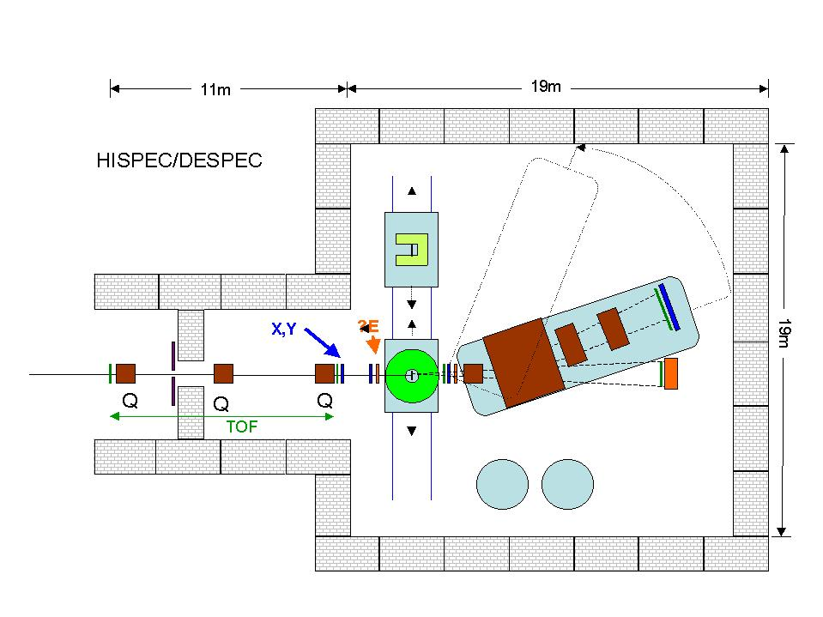
Fig. 16. Floorplan of HISPEC/DESPEC experimental hall (the beamline from the NESR is not shown).

We expect to have two different detectors setups in the experimental area. They will be installed on different platforms. The platform to be used will be moved into the beamline on tracks, as shown in figure 16.

In addition to the experimental hall a control room for 15 persons, 200 m2 laboratory and maintenance space and 200 m2 storage space is required.

  - electronic racks
  - cooling of detectors ( heat produced = heat removed!) [ * ]
  - ventilation
  - electrical power supplies
  - gas systems [ * ]
  - cryo systems [ * ]
These are similar to the existing RISING cave. The only difference is that the magnetic spectrometer will be very heavy. The ALADIN magnet is about 100 t.

- Detector –Machine Interface
  - vacuum
  - beam Pipe
  - target, in-beam monitors, in-beam detectors
  - timing
  - radiation environment
  - radiation shielding
These do not present particular problems. They are the same as at RISING.

- Assembly and installation
( Do you intend to assemble your detector/ your experiment elsewhere before the final installation in the cave? Describe the process of installing your project, including the space needed for handling, or later for repairs
  - Size and weight of detector parts, space requirements
The magnetic spectrometer is very heavy. The ALADIN magnet weighs about 100t.
  - Services and their connections
  - Installation procedure

D Commissioning
a) magnetic field measurements
b) alignment
It does not present particular problems.
c) test runs

E Operation
  - of each of the sub-projects
  - auxiliaries
  - power, gas, cryo, etc
These are all similar to the conditions in the ‘RISING’ cave.

F Safety
- General safety considerations
- Radiation Environment,
- Safety systems
Standard safety considerations apply. Hazards are: high voltage up to 5 kV, liquid nitrogen, radiation from sources and beams with intensities up to 10⁷ particle/s.

G Organisation and Responsibilities, Planning,
- WBS- work package break down structure

Table 8: Groups and scientist working on different tasks.

Cost estimate for a reduced, the described and an optimal version of the proposed array.

S |  | Task |  |  |  |  | Members (coordinators in bold)
HISPEC/DESPEC |  | Beam tracking detectors |  |  |  |  | Edinburgh (T. Davinson), Surrey (P. Sellin), Univ. Sevilla (J. Gomez-Camacho, J.M. Quesada), RISING beam detectors group (M. Gorska et al.), NUSTAR beam tracking group (R. Kruecken at el)
HISPEC |  | AGATA |  |  |  |  | AGATA collaboration
 |  | Plunger |  |  |  |  | Köln (A.Dewald, J.Jolie), Bucharest (N.V. Zamfir) et al.
 |  | HYDE (charged particle array for reaction studies) |  |  |  |  | Huelva (I.Martel, F. Perez-Bernal, J.R. Garcia-Ramos), Sevilla (J. Gomez-Camacho, J.M. Quesada), Madrid IEM-CSIC (O. Tengblad, M.J.G. Borge), GSI (Ch. Scheidenberger, J. Gerl) et al.
 |  | Charged particle array for structure studies |  |  |  |  | Lund (D.Rudolph), York (M.Bentley, B. Wadsworth) et al.
 |  | Magnetic spectrometer |  |  |  |  | GSI (D.Ackermann), Daresbury (R.Lemmon), Jyvaskyla (J. Uusitalo, M. Leino, R. Julin, P.Greenless) et al.
DESPEC |  | DSSSD implantation and decay detector |  |  |  |  | Bordeaux (B. Blank), Edinburgh (T. Davinson, P. Woods), Liverpool (R. Page), Munich (R. Kruecken), Warsaw (M. Pfutzner), Bucharest (D. Bucurescu)
 |  | DESPEC high-resolution gamma-ray detectors |  |  |  |  | Debrecen (A.Algora),  Daresbury Laboratory (J.Simpson, D.Warner, I.Lazarus, V.Pucknell and Daresbury engineers),  GSI (J. Gerl et al.),  IFIC Valencia (B. Rubio, J.L. Taín),  IRES Strasbourg (G. Duchene),  Univ. Autónoma de Madrid (A. Jungclaus),  Univ. Jyväskylä (R. Julin, J. Aysto, A. Jokinen ), Univ. Köln (P.Reiter),  Univ. Surrey (P.Walker , P.Regan , W.Gelletly, Zs.Podolyak), Univ. Liverpool (P. Nolan, A. Boston, E.Paul), Bucharest (G. Cata-Danil)
 |  | Fast Timing Array |  |  |  |  | Uppsala U. (H. Mach),  U.of Surrey (P.Walker, P.Regan, Zs.Podolyak),  U.of Guelph Canada, (  P.Garrett),  U. Tennessee (R. Grzywacz),  Univ. Jyväskylä (R. Julin),  U. Manchester (D. Cullen), Univ. Koeln (J.Jolie),  U. of Warsaw (W. Kurcewicz),  Swierk (E. Ruchowska, S. Kaczarowski),  U. of Aarhus (H. Fynbo),  U. Oslo (P.Hoff),  Bucharest (G. Cata-Danil)
 |  | Neutron Array |  |  |  |  | CIEMAT Madrid (D. Cano-Ott, E. González, T. Martínez), GSI ( M. Gorska), Jyväskylä (H. Penttilä, J. Äystö), Madrid (A. Jungclaus), St. Patersburg (I. Izosimov), Uppsala University (J. Nyberg), UPC Barcelona (F. Calviño), Valencia (J.L. Taín, B. Rubio)  , Univ. Koeln (J.Jolie)
 |  | Total Absorption Spectrometer |  |  |  |  | Debrecen (A. Algora), Gatchina (L. Batist), GSI ( J. Gerl, M. Gorska et al.), Uni. Autonoma Madrid (A. Jungclaus), St. Petersburg (I. Izosimov), Uni. Surrey (W. Gelletly, P. Regan, Z. P. Walker), IFIC Valencia (B. Rubio, J.L. Tain), Univ. Köln (P.Reiter)
 |  | Electromagnetic Moments |  |  |  |  | Sofia (G. Rainovski, S. Lalkovski, M. Danchev),  Camerino (D.L. Balabanski)  , Leuven (G. Neyens et al.), Bucharest: M. Ionescu-Bujor,  Krakow (A. Maj), RISING g-factors collaboration
HISPEC/DESPEC |  | Electronics and Data acquisiton |  |  |  |  | Uppsala (J.Nyberg), Daresbury (I.Lazarus, V. Pucknell), Jyvaskyla (P. Jones), NUSTAR EDACQ group
 |  | Analysis software |  |  |  |  | Krakow (J.Grebosz), RISING analysis software group
 |  | Simulations |  |  |  |  | Huelva and Spain (HYDE+beam detectors), Paisley (beam detectors), Debrecen (A. Algora), NUSTAR simulations group
 |  | Slowing down (within the Low Energy Branch) |  |  |  |  | GSI, Giessen, Surrey (FP6 postdoc), CAN Seville (J.A. Labrador), RISING
 |  | System integration (into the Low Energy Branch) |  |  |  |  | GSI (Ch.Scheidenberger)
AGATA collaboration: Bulgaria: Univ. Sofia; Denmark: NBI Copenhagen; Finland: Univ. Jyvaskyla; France: GANIL Caen, IPN Lyon, CSNSM Orsay, IPN Orsay, CEA-DSM-DAPNIA Saclay, IreS Strasbourg; Germany: HMI Berlin, Univ. Bonn, GSI Darmstadt, TU Darmstadt, FZ Jülich, Univ. zu Köln, LMU München, TU München; Hungary, KFKI Budapest; Italy: INFN and Univ. Firenze, INFN and Univ. Genova, INFN Legnaro, INFN and Univ. Napoli, INFN and Univ. Padova, INFN and Univ. Milano, INFN Perugia and Univ. Camerino; Poland: IFJ PAN and Univ. Krakow, Univ. Swierk, Univ. Warsaw; Romania: NIPNE Bucharest ; Sweden: Lund Univ., Royal Institute of Technology Stockholm, Uppsala Univ.; Turkey: Univ. Istanbul, Univ. Ankarra; UK: Univ. Brighton, CLRC Daresbury, Univ. Keele, Univ. Liverpool, Univ. Manchester, Univ. Paisley, Univ. Surrey, Univ. York for UK.
RISING collaboration: HMI Berlin, Germany; Univ. Bonn, Germany; NIPNE Bucharest, Romania ; GANIL, Caen, France; INFN/Univ. Camerino, Italy; NBI Copenhagen, Denmark; IFJ PAN Cracow, Poland; Univ. Cracow, Poland; CLRC Daresbury, UK; GSI Darmstadt, Germany; TU Darmstadt, Germany; Univ. Demokritos, Greece; INFN/Univ. Firenze, Italy; INFN Geneva, Italy; MPI Heidelberg, Germany; Univ. Keele, UK; Univ. Köln, Germany; INFN Legnaro, Italy; Univ. Leuven, Belgium; Univ. Liverpool, UK; Univ. Lund, Sweden; Univ. Manchester, UK;
INFN/Univ. Milano, Italy; LMU München, Germany; TU München, Germany; INFN/Univ. Napoli, Italy; Univ. Stockholm, Sweden; Univ. Surrey, UK; IPJ Swierk, Poland; Univ. Warsaw, Poland; Univ. Uppsala, Sweden; Univ. York, UK;

- Stucture of experiment management

The HISPEC and DESPEC collaborations held several meetings during the preparation of the present Technical Proposal. During this time it was decided to present a common Technical Proposal with joint spokespersons, deputy spokespersons and project managers.

The HISPEC/DESPEC collaboration will have a Management Board, a Technical Board, a Steering Committee and a Collaboration Council. The composition of these structures and the MOU will be discussed at the HISPEC/DESPEC meeting on 8th of February 2005 . The present proposition is the following:

Management Board

Spokesperson(HISPEC) | Zsolt Podolyák/Wolfram Korten
Spokesperson(DESPEC) | Berta Rubio
Deputy (HISPEC) | Jan Jolie
Deputy (DESPEC) | Phil Woods
Project manager (HISPEC) | Jürgen Gerl
Project manager (DESPEC) | Magda Gorska
Chair of technical board | (to be decided on February the 8th)

Technical Board

 | member | Affiliation
beam tracking and identification detectors | (to be decided)
AGATA | J.Simpson | Daresbury CCLRC, UK
HYDE charged particle detectors for reaction studies | I. Martel | Huelva University,  Spain
Charged particle detectors for structure studies | D. Rudolph | Lund University,  Sweden
Plunger | A. Dewald | Köln University,  Germany
Magnetic spectrometer | D. Ackermann | GSI,  Germany
DSSD implantation and decay detector | P.J. Woods | Edinburgh University, UK
DESPEC high resolution gamma detectors | A. Jungclaus | Universidad Autónoma de Madrid, Spain
Neutron detectors | D. Cano | CIEMAT Madrid,  Spain
Total absorption spectrometer | L. Batist/J.L. Taín | PNPI Gatchina, Russia / IFIC Valencia, Spain
Fast timing with  BaF2 | H. Mach | Uppsala University,  Sweden
Isomeric moments | D. L. Balabanski | Camerino University, Italy
Electronics and  Data acquisition | J. Nyberg | Uppsala University, Sweden
Simulations | (to be decided)
Analysis | (to be decided)

A Steering Committee will be established based on the drafted memorandum of Understanding. Currently the management board acts as an interim steering Committee.

Collaboration Council
Representatives from each institute being members of the collaboration (64 institutes)

- Responsibilities and Obligations ( Money/Responsibility Matrix: which institute/country intents to pay/to do what?)

The groups involved in each WBS are specified in section G. together with the coordinator of each work package. All the groups involved in the WBS have some responsibility in the design and construction of the different parts of the set-up. On top of that the signatories of the MOU will express their intention to raise the necessary funds from the various funding agencies in their home countries.

- Cost and Manpower Estimates
    - for R&D phase,
    - for Construction phase
    - for Operation phase

Estimates include only instrumentation with electronics and dedicated data acquisition. Buildings, beam lines and general infrastructure is not taken into account. For the magnetic spectrometer it is assumed that an existing dipole magnet, ALADIN, can be supplied.

Table 9: Summary of development and construction costs and ADDITIONAL (without the present researchers, faculty and PhD personnel) manpower estimates including Ph.D students.

Item | Cost (M Euro) | Manpower (manyears )
Beam tracking and identification detectors | 0.5 | 8
Active targets | 0.3 | 2
AGATA | From other resources
HYDE charged particle detectors for reaction studies | 1.5 | 9
Charged particle detectors for structure studies | 0.385 | 16
Plunger | 0.1 | 6
Magnetic spectrometer | - (ALADIN) +  3.5 (new design) | 20
DSSD implantation and decay det. | 0.975 | 12
DESPEC high resolution gamma det. | 4.9 | 32
Fast timing | 0.47 | 9
Neutron detectors | 1.064 | 16
Total absorption spectrometer | 0.5 | 4
Isomeric moments | 0.15 | 8
Total | 14.444 | 142

Similar types of detectors will be used in some cases (e.g. Si-detectors for the DESPEC active implanter and the charged particle detectors within HISPEC). This implies several items being in common in the electronics of those systems. Therefore, it is foreseen that the different groups developing the detectors will join forces on the electronics stage whenever it is possible and profitable.
ASIC (application specific integrated circuits) will be developed for the charged particle detectors using both Si and CsI as active material (HYDE, Lusia, decay detector). The groups involved (Huelva, Saclay, Lund, Edinburgh, York etc) intend to work together in order to reduce cost and effort.
The same is true for the ADC/TDC and VMEs. These have to be available for ~1500 Si channels, ~200CsI channels.

Details about the costs of the individual detectors are given below. The groups and names of scientist working on the different subprojects are given in table 8.

Reaction chamber and associated vacuum system: 0.3M€

Beam detectors for x,y,dE and TOF will cost avout 500k€. The additional manpower needed to develop such kind of detectors is estimated to be a 4 year Postdoc and 4 year PhD student, in total 8 manyears.

Active targets will cost about 0.3M€. An additional manpower of 2 year postdoc is needed. The postdoc will work closely with the group developing the beam detectors.

AGATA, in total will cost 40M€ (+ tax) of which about 5M€ is already available for the demonstrator. It will be paid by the national funding agencies of European countries. AGATA will not stay permanently at FAIR. The realisation of the AGATA project needs 140 manyear.

The cost of HYDE is detailed as follows and it covers the 3 years period of the development and construction phase. Mechanical workshop 6 k€, vacuum system 18 k€, energy loss dE-detectors 60 x 5= 300k€, total energy E detectors 60 x 4k€ = 240 k€. The dE detectors will need 48 x 32 =1536 readouts for the 2 barrels (6 sides x 4 DSSSD each). The E detectors will need 12 + 48 = 60 readouts. This means that in total 1980 signals have to be read and electronics provided for all these channels. The costs for preamplifiers is estimated to be 496k€. Multiplexing four channels 1980/4=495 electronic channels will be used. We estimate 4k€ for the timing filter amplifier and constant fraction discriminator, 12 k€ for cabling, 64 k€ for ADCs (32 channels each) and 6k€ for TDCs (128 channel each), 3k€ for scalers (32 channels each) and 90 k€ for VME. The total construction cost is 1.512 M€ (mechanics 24 k€, detectors 540 k€, electronics and data aquisiton 948 k€).
The estimated additional manpower consists of a postdoc, a technician and a PhD student for a period of 3 years each (=9 manyears).

Several institutions are involved in HYDE. The tasks connected to it are detailed below:
Coordination: Univ. Huelva and GSI.
Simulations: Univ. Huelva.
Construction: Mechanical design - National Accelerator Center, Seville; Detectors, electronics - Univ. Huelva, Univ. Seville; Dacq - CSIC Madrid; tests - Univ. Huelva + National Accelerator Center, Seville;

Cost estimates for the charged particle detectors used for nuclear structure are as follows.

Detectors to be used at intermediate energy regime: silicon detectors 64 k€ (16 DSSD with the size of 6cmx6cm and 32x32 strips), CsI detectors 20k€ (150 with the size 2cm x 2cm and thickness 3 cm. Detectors to be used at Coulomb barrier energies: silicon detectors 36k€ (20 k€ for 4 CD-type DSSD with a dimeter of 8.5 cm, with 32 rings and 64 sectors each; 16 k€ for 4 DSSD with the size of 6 cm x 6 cm and 32x32 strips), CsI detectors 25 k€ (200 with the size of 12mm x 12mm and 3-5 mm thickness). The cost of cables and mechanical workshop time is estimated to 20 k€. Therefore total cost for the detectors is 185 k€. Note that in particular the silicon detectors can be considered as consumables.
The cost for electronics: 200 k€ for the development of ASIC (application specific integrated circuit) for silicon 32 channel preamplifier, shaper, and timing, no logic and another 200 k€ for ASIC for (32 channel energy and PSD information, no logic). These are coarse estimates and do not include ADCs, TDCs, or other types of electronics for digitalization. As indicated above, these developments are similar for several detector arrangements within NUSTAR and it is planned that they will be bought/developed for other applications will be used.

The needed additional manpower to be concerned with the development and construction of the HISPEC charged-particle arrays: 4 man-year PhD position, 4 man-year PostDoc position, 1 man-year technician (Lund), and 3 man-year PhD position, 3 man-year PostDoc position,1 man-year technician (York).

Cost estimates for the plungers: mechanics 50k€, motor, controller, distance-meters, electronics: 50k€. Therefore the total is 100k€.

Estimated manpower needs: 3 years postdoc for the development of the foil holders for different foil materials and different thicknesses, design and tests; and another 3 year postdoc for the development of a dedicated data analysis system for future experiments and computer simulations. In total 6 manyears.

Cost estimates for the magnetic spectrometer: in the first phase the ALADIN spectrometer will be used. The implementation, including the improvement of some of its older detectors will cost about 100k€. The costs of the magnetic spectrometer to be used at energies of 3-100 MeV/u is estimated to be 3.5 M€. This estimate is based on the costs of state of the art spectrometers built recently (PRISMA:~2M€, VAMOS ~3-4M€ ). The design and building of such a spectrometer needs a considerable effort from the community. It is estimated that the additional mapower needed is about 20 manyears (4 people for 5 years).

DSSD cost estimates

First order cost estimates inclusive of tax. Manpower costs excluded.
ASIC design and production would require specialist expertise and
facilities - we would collaborate with the CCLRC Rutherford Appleton
and Daresbury Laboratories (UK) to achieve these goals.

Detectors:
Non-recurrent design/engineering costs 55 k€
30x DSSD (£7k per 10cm x 10cm wafer) 290 k€
48x 5cm x 5cm dE/Veto/stopping detectors 110 k€
Instrumentation:
ASIC development & production 420 k€
DACQ 100 k€

Total 0.975 M€

Groups Involved

Bordeaux, Edinburgh, Liverpool, Munich, Warsaw

DESPEC High-resolution gamma array

Table 10: Cost estimate for the described flexible high-resolution array.
Description | Cost in k€
Detector elements | 24 x 3 x 20 = 1440
Cryostats-cooling-HV | 24 x 20 = 480
Frame | 100
Pre-amplifiers | 1152 x 0.5 = 576
Digitization and DACQ | 1152 x 2 = 2304
Total | 4900

Groups involved

Univ. Autónoma de Madrid: A.Jungclaus
GSI Darmstadt: J. Gerl, I. Kojouharov …
Univ. Surrey: P.Walker , P.Regan , W.Gelletly, Z.Podolyak
Daresbury Laboratory: J.Simpson, D.Warner, I.Lazarus, V.Pucknell and Daresbury engineers
Ires Strasbourg (G. Duchene)
IFIC (CSIC) Valencia: B. Rubio, J.L. Taín
Debrecen: A.Algora
Univ. Koeln (P.Reiter)
Univ. Jyväskylä : R. Julin, J. Aysto, A. Jokinen…

Cost estimates- Fast Timing

12 cluster fast timing detectors will be used in 2 rings including 6 clusters each. Each cluster will include 4 fast timing detectors. The estimated cost of a single fast timing cluster detector is: crystals 2.4 kEuro, phototubes 5.2 kEuro, bases 2.0 kEuro, other pieces 2.8 kEuro, thus 12.4 kEuro per cluster. The total cost of 48 detectors is 150 kEuro for a complete array. An associated electronics of Constant Fractions, HV power supplies, high quality and linearity TDC or TAC’s, preamplifiers and Linear Energy Amplifiers (these depend on the type of DACQ and crystals used), is estimated at 250 kEuro, thus in total the whole array will cost about 400 kEuro. The costs of mechanical structure is 20 kEuro and the development of a wide beam test line is 50 kEuro (tests can be performed at Jyvaskyla and Warsaw).

The manpower requirements for the development and construction of cluster prototypes, development of wide beam test line and testing of the fast timing array (and development of analysis algorithms) in the wide beam measurement scenario, is 1 Postdoc (3 years with 45 kEuro/year), 1 PhD (4 years with 40 kEuro/year) and 1 technical position (2 years with 45 kEuro/year).

Although the fast timing array will not be part of a permanent setup at DESPEC or HISPEC, yet most of cluster detectors will have to be kept in a permanent pool ready for a quick deployment at FAIR lasting a substantial period of time. It is expected that those detectors (about 9-10 out of 12) and related electronics will be provided, within the Fast Timing Collaboration, mainly by GANIL, Jyvaskyla and Uppsala University. When not used at FAIR, these detectors will be used at GANIL or Jyvaskyla. The remaining detectors will be provided for fast timing campaigns by other members of the Fast Timing Collaboration including U.of Surrey, U.of Manchester, Oak Ridge National Lab., and ILL Grenoble. In the first step lasting about 1 year, only 50% of the Fast Timing Array is required.

Previously fast-timing experiments have been performed in GANIL and MSU fragmentation facilities. It is expected that a first testexperiment will be proposed soon in GSI and performed within the RISING collaboration. This will be to measure lifetimes of the 2+ states (populated in beta-decay) in a few exotic neutron rich nuclei from the 180-190 mass region. The measurement
is to be done via beta-gamma-gamma coincidences using a mixed 50%-50% Ge-BaF2 array. The BaF2 array will involve about 20
fast timing detectors.

Participants that are willing to contribute financially via additional funds (preliminary commitments): ISV-Uppsala, GANIL, Univ. of Surrey and Univ. of Manchester.

Via fast timing pool: Oak Ridge, Warsaw, Jyvaskyla

Participants in fast timing experiments: Uppsala, Surrey, U.of Tennesee, U.of Oslo, Swierk/Poland, U. of Warsaw, U. of Manchester, Koeln

Neutron array
(Rough) Cost estimates

The cost of the two type of detection setups, power supplies and associated electronics (excluding the data acquisition system) are summarised in Table 11. The amplification chain proposed is based on commercial analogue electronics and shared between the two setups.

Table 11. Summary of the cost of the two detection setups

Moderation-based neutron detection array
16 position sensitive ³He counters 1” Φ x 45” length and 6 atm pressure | 64 k€
44 position sensitive BF₃ counters 2” Φ x 45 length and 1 atm pressure | 88 k€
Polyethylene block, 1 m³ shaped | 2k€
Total | 154 k€

TOF neutron detection array
Array of 30 BC501 neutron detectors 10” Φ x 5” length  (scintillator cell + photomultplier + voltage divider) | 700 k€
Mechanical Structure (engineering + construction) | 20 k€
Total | 760 k€
Electronics and HV (the same for both setups)
Front end electronics (discriminators + preamplifiers + amplifiers) | 110 k€
HV (crate + cards + cables) | 40 k€
Total | 150 k€

Groups involved

CIEMAT Madrid (D. Cano-Ott, E. González, T. Martínez), GSI ( M. Gorska), Jyväskylä (H. Panttilä, J. Äystö), Madrid (A. Jungclaus),Uppsala University (J. Nyberg), UPC Barcelona (F. Calviño), Valencia (J.L. Taín, B. Rubio)

TAS

Table 12:
Preliminary cost estimate of a 30 cms diameter 50 cms length NaI TAS
8 crystals | 300 k€
8 pms | 100 k€
Electronics | 100 k€
Total | 500 k€

Groups involved:

Debrecen (A. Algora), GSI ( M. Gorska, J. Gerl), Madrid (A. Jungclaus), St. Petersburg (L. Batist), Surrey (W. Gelletly, P. Regan, Z.Podolyak, P. Walker), Valencia ( J.L. Tain, B. Rubio), Koeln (Jolie)

Isomeric moments

Equipment and cost estimation:

50 keuro magnet
2 x 10 keuro reaction chambers
20 keuro detector ring-support structure for g-factors
40 keuro detector ball-support structure for Q-moments
20 kEuro host materials (crystals or foils) for Q-moments

High-purity Ge-detectors from existing set-ups will be used, a minimum of 8 such detectors is needed. They will be mounted in a special configuration, depending on whether g-factors or Q-moments are being measured (the same set-up can be used, but for Q-moments one could consider a ball of detectors because no magnetic field is needed).

1PhD student
2 postdocs

Members of this collaboration (as part of the DESPEC collaboration):

Sofia: G. Rainovski, S. Lalkovski, M. Danchev
Camerino: D.L. Balabanski
Leuven: G. Neyens

- Schedule with Milestones

It is envisaged to have the whole experimental setup operational in the low energy cave when the first beams will be delivered by the Super-FRS in 2010. At that date the AGATA demonstrator will be used for gamma-ray detection in HISPEC, the full 4π AGATA array will be operational in 2012. Similarly, the magnetic spectrometer will be based on the existing ALADIN magnet suitable for intermediate beam energy experiments. A dedicated magnetic spectrometer to cover lower beam energies will replace ALADIN in 2012.

HISPEC/DESPEC meeting 8th of February 2005.
Signing the MoU before the PAC meeting which will take place in GSI 14-15st of March 2005.
Some members of the collaboration have already started to apply for funds for the R&D phase. The lion’s share of the resources will be risen starting form 2005. Simulations, design and realistic cost evaluation 2005-2006. The conclusions will be presented in the Technical Design Report. Prototypes, where needed, will be built and tested in 2006-2007.Construction phase 2007-2009. The setup will be installed in 2009. Many of the proposed detectors and setups will be tested at available facilities. In particular it is expected to test some components at the existing FRS. The proposed tests/experiments will emulate the future Super-FRS experiments, with beams closer to stability.

The list below shows the approximative schedule for the different components of the HISPEC/DESPEC setups. Both setups will be complete and installed in the low energy cave when the SIS-SFRS facility comes online (beginning of 2010).

Task/Milestone
2005 2006 2007 2008 2009 2010 2011 2012
1 2 3 4 1 2 3 4 1 2 3 4 1 2 3 4 1 2 3 4 1 2 3 4 1 2 3 4 1 2 3 4
Beam detectors | R&D for diamond det.  ------------------------------------------  tests  --------------------------  production  ---------------  R&D for Carbon foil based det. and tests  ------------------------------------------  production  -----------------
AGATA | R&D on AGATA  ----------------------------------  AGATA demonstrator tests and experiments (not only at FAIR)  -----------------------------------------------------------  4π array ready  ------------
Task/Milestone
2005 2006 2007 2008 2009 2010 2011 2012
1 2 3 4 1 2 3 4 1 2 3 4 1 2 3 4 1 2 3 4 1 2 3 4 1 2 3 4 1 2 3 4
Plungers | Development and design  ----------------------------------------  Test experiments (GSI and other places)  ---------------------------------------------------  Three plungers ready  ------------
HYDE charged particle array for reactions | Development and design  ---------------------------  Tests  -------------  Production  ----------------
Charged particle array for structure studies | Development and design  ---------------------------  Tests  -------------  Production  ----------------
Magnetic spectrometer | Installation of ALADIN  -----------  experiements using ALADIN  -----------------------------  simulation and design new magnetic spectrometer  -------------------------------------------------------------------------  production  -------------------------
DSSD implantation and decay detectors | R&D  ---------------------------------  Production  -----------------------
DESPEC high-resolution gamma array | Simulation and design  -------------------------------  Protype tests  -------------------  Production and installation  ----------------------------------
Task/Milestone
2005 2006 2007 2008 2009 2010 2011 2012
1 2 3 4 1 2 3 4 1 2 3 4 1 2 3 4 1 2 3 4 1 2 3 4 1 2 3 4 1 2 3 4
Fast timing (BaF2) | Tests and improvements at available facilities  ------------------------------------------------  Development of new detectors  -------------------------------------
Neutron detectors | Simulation and design  ------------------------------  Prototype tests  -------------  Production  ----------------------
Total absorbtion spectrometer | Simulation and design  ---------------------------------  Tests at present facilities  ----------------------------  Production  -----------------------
Electromagnetic moments | Simulation and design  --------------------------------  Test experiments  --------------------------  Production  --------------------------------
Software development | Improvement of RISING software  -------------------------------------  new software ready  ---------------
Data acquisition | Front-end electronics (ASIC developments)  --------------------------------------  integration of the different subdetectors  -----------------------------

e. Organisation

There is a joint HISPEC/DESPEC management which will be organised in the way described in section G.b. It will consist of Management board, Technical board, Steering committee, Collaboration committee.

The Management Board, the steering committee and the technical committee will meet at least twice per year. The full collaboration will meet at the regular NUSTAR meetings once per year. The co-ordinators of the different working packages will keep the technical board chairperson and the spokespersons of the HISPEC/DESPEC collaboration regularly informed of the meetings and progress achieved in their respective working groups.

H Relation to other Projects

Both HISPEC and DESPEC are part of NUSTAR. There are several working groups considering common tasks within NUSTAR. Common working groups have been formed on Electronics and Data Aquisition, Beam tracking etc. In this respect the beam tracking detectors developed for R3B will also be applicable to the beam tracking at the LEB for 100 MeV/u.

Some parts of the HISPEC/DESPEC set-ups can benefit from similar developments at other experiments and vice-versa. A clear case is the Total Absorption Spectrometer which is also proposed at R3B, EXL and NCAP.

From the physics point of view there are connections to several other activities at the LEB, particularly with the mass measurements, the direct reactions measured at other energy regimes at R3B and in the rings.

I Other issues

A Memorandum of Understanding is being prepared. It states that the collaboration will seek funds from different funding agencies in order to build and operate the setup detailed in the Technical Proposal. The MoU will be signed by a representative from each member institute involved in HISPEC/DESPEC. The MoU is not legally binding. The MoU will be discussed during the next HISPEC/DESPEC meeting and signed before the PAC meeting on March the 14th and 15th.

